

Report
2016–2019
Copyright
The Australian Political Exchange Council Report 2016–17, 2017–18 and 2018–19
is protected by copyright.
With the exception of the Australian Political Exchange Council logo,
the report is licensed under a Creative Commons Attribution 3.0 Australia licence
(http://creativecommons.org/licenses/by/3.0/au).
This document must be attributed:
Commonwealth of Australia (Australian Political Exchange Council)
Contact us
Inquiries regarding the license and any use of this document are welcome at:
Australian Political Exchange Council Secretariat
One Canberra Avenue
Forrest ACT 2600
Email: auspol.exchange@finance.gov.au

The Hon Scott Morrison MP
Prime Minister of Australia
Leader of the Liberal Party of Australia
The Hon Anthony Albanese MP
Leader of the Opposition
Leader of the Australian Labor Party
The Hon Michael McCormack MP
Deputy Prime Minister
Leader of The Nationals
Mr Adam Bandt MP
Leader of the Australian Greens
In accordance with the terms of reference of the Australian Political Exchange Council, I have pleasure in submitting the report of the Council for the 2016–2017, 2017–2018 and 2018–2019 years. The report will be presented to Parliament by the Minister for Finance.
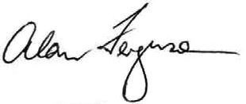
The Hon Alan Ferguson
Chairman
Contents
Message from the Chair 6
Introducing the Council 7
The Council’s purpose 8
Membership of the Council 9
Chairman of the Council 9
Members of the Council 10
Outgoing Members of the Council 12
Council activities 13
Outgoing Australian delegations 13
Incoming delegations to Australia 13
Individual study tours 13
2016–17 14
Outgoing Australian delegations for 2016–2017 14
Fifth Australian Delegation to the Republic of Korea 23 to 29 July 2016 15
Ninth Australian Delegation to the Philippines 12 to 18 November 2016 17
Eleventh Australian Delegation to New Zealand 5 to 9 December 2016 19
Thirty-second Australian Delegation to the United States of America 11 to 23 February 2017 21
Twenty-fifth Australian Delegation to Japan 11 to 17 March 2017 24
Tenth Australian Delegation to the Philippines 13 to 19 May 2017 26
Incoming delegations to Australia for 2016–2017 28
Twentieth Delegation from the Socialist Republic of Vietnam 10 to 16 September 2016 29
Tenth Delegation from the Philippines 8 to 14 October 2016 31
Twenty-fourth Delegation from the People’s Republic of China 7 to 11 November 2016 33
Eleventh Delegation from New Zealand 21 to 25 November 2016 35
Thirty-third Delegation from the United States of America 19 to 31 March 2017 37
Twenty-first Delegation from the Socialist Republic of Vietnam 20 to 26 May 2017 40
Eleventh Delegation from the Philippines 17 to 23 June 2017 42
Individual study tours for 2016–2017 44
2017–2018 49
Outgoing Australian delegations for 2017–2018 49
Thirty-third Australian Delegation to the United States of America 15 to 27 July 2017 50
Twenty-fifth Australian Delegation to the People’s Republic of China 16 to 22 September 2017 53
Twenty-first Australian Delegation to the Socialist Republic of Vietnam 4 to 10 November 2017 55
Twenty-sixth Australian Delegation to Japan 3 to 9 March 2018 57
Sixth Australian Delegation to the Republic of Korea 14 to 20 April 2018 59
Eleventh Australian Delegation to the Philippines 12 to 18 May 2018 61
Incoming delegations to Australia for 2017–2018 63
Sixteenth Delegation from Japan 3 to 9 August 2017 64
Sixth Delegation from the Republic of Korea 5 to 11 August 2017 67
Thirty-fourth Delegation from the United States of America 9 to 21 September 2017 69
Twenty-fifth Delegation from the People’s Republic of China 17 to 20 October 2017 73
Twelfth Delegation from the Philippines 24 February to 2 March 2018 75
Twelfth Delegation from New Zealand 27 May to 1 June 2018 77
Individual study tours for 2017–2018 79
2018–2019 83
Outgoing Australian delegations for 2018–2019 83
Thirty-fourth Australian Delegation to the United States of America 21 July to 1 August 2018 84
Twelfth Australian Delegation to New Zealand 5 to 10 August 2018 87
Twenty-sixth Australian Delegation to the People’s Republic of China 1 to 7 September 2018 89
Twenty-second Australian Delegation to the Socialist Republic of Vietnam 17 to 23 November 2018 91
Twenty-seventh Australian Delegation to Japan 23 February to 1 March 2019 93
Incoming delegations to Australia for 2018–2019 95
Seventeenth Delegation from Japan 11 to 17 August 2018 96
Twenty-second Delegation from the Socialist Republic of Vietnam 8 to 14 September 2018 98
Thirty-fifth Delegation from the United States of America 13 to 24 October 2018 100
Twenty-sixth Delegation from the People’s Republic of China 24 to 29 November 2018 103
Individual study tours for 2018–2019 105
Chronology of visits 109
Acknowledgements 112
Former delegates 112
Supporting organisations 112
Appendix A – Financial summary 113
Appendix B – Administrative overview 114
Chairman’s remuneration 114
Staffing 114
Freedom of information 114
Contact information 114

Message from the Chair
I am delighted to report on the activities of the Australian Political Exchange Council for the period 2016–19. It was a period of sustained activity, with the Council providing support for 17 Australian delegations, 17 visiting delegations and 13 individual study tours. In total, the Council hosted 112 visitors from its program partner countries.
Now more than ever, international understanding and political leadership are of critical importance to the global community we live in. Exchange programs, such as ours, provide a unique opportunity to promote these attributes.
I wish to extend my warmest appreciation to the Principals of the Council (the parliamentary leaders of the four main political parties), the Patrons of the Council (the Presiding Officers of the Parliament) and the Special Minister of State for their ongoing support and contribution to our programs.
I would also like to thank the members of the Council for their continuing enthusiasm and commitment to the Council’s objectives and to record my appreciation of the dedication and professionalism of the staff of the Secretariat. Additionally, I would like to personally acknowledge Suzy Domitrovic for her tireless efforts in supporting the work of the Council over many years and the professional manner in which she has conducted this work at all times.
After 38 years of operation, the Council now has a substantial list of former Australian delegates who provide tremendous support for our incoming delegations. On behalf of the Council, I would like to express my deep appreciation to the many former delegates who have assisted the Council in providing high-quality programs for our overseas visitors and who have continued to express their interest in our activities.
Alan Ferguson
February 2021
Introducing the Council
In 1981, a program for political exchanges was established by the then Prime Minister, the late Rt Hon Malcolm Fraser AC CH, with the support of the leaders of the major Parliamentary political parties, to arrange visits of young political leaders between Australia and other countries. An Interim Committee was established with the leaders of the major federal Parliamentary parties as its Principals.
The program had its genesis the previous year when the late Hon Sir Robert Cotton KCMG AO, then Australian Consul-General in New York, and Mr Tony Eggleton AO CVO, then Federal Director of the Liberal Party of Australia, discussed the concept of an Australian young political leaders’ exchange program with the American Council of Young Political Leaders.
The program of exchange visits was modelled on the system of exchanges between the United States of America and other countries, which was established in 1966 under the management of the American Council of Young Political Leaders.
With the agreement of the Principals, the Interim Committee became the Australian Political Exchange Committee in 1983 and, subsequently, the Australian Political Exchange Council in 1991.
The Council currently has exchange programs with the People’s Republic of China, Japan, the Republic of Korea, New Zealand, the Philippines, the United States of America and the Socialist Republic of Vietnam. It also sponsors delegates’ participation in a range of overseas individual study tours and international forums.
The activities of the Council are funded through an annual appropriation to the Commonwealth Department of Finance. The Minister for Finance has portfolio responsibility for the program.
The Council’s purpose
The Council’s purpose is to provide opportunities for young Australians involved in politics to study the political systems of other countries, as well as offering a unique insight into the Australian political system to young people from participating exchange countries.
The Terms of Reference governing the Council’s operations, and endorsed by the Principals of the Council, seek to:
- arrange regular exchange visits for either individuals or groups of young people, drawn from the parties of the Principals, with the potential to make a significant contribution to political life, between Australia and other countries
- provide learning experiences through study tours of Australia for young political leaders from countries important to Australia for trade or strategic reasons
- arrange related activities which provide developmental opportunities for the rising generation of Australian and other political leaders
- arrange for regular reporting on the Council’s activities to Parliament, the Principals and sponsors.
Membership of the Council
The Council comprises a Chairman and six Members nominated by the Principals of the Council.
The Principals of the Council are the Parliamentary Leaders of the four major political parties. As at 30 June 2019, these were:
- The Hon Scott Morrison MP, Prime Minister and Leader of the Liberal Party of Australia
- The Hon Anthony Albanese MP, Leader of the Opposition and Leader of the Australian Labor Party
- The Hon Michael McCormack MP, Leader of The Nationals
- Senator Richard Di Natale, Leader of the Australian Greens.
The Prime Minister and the Leader of the Opposition each nominate two Council Members and the Leader of The Nationals and Leader of the Australian Greens each nominate one Council Member. The Prime Minister also nominates an independent Chairman.
Council membership as at 30 June 2019 was as follows:
Chairman of the Council
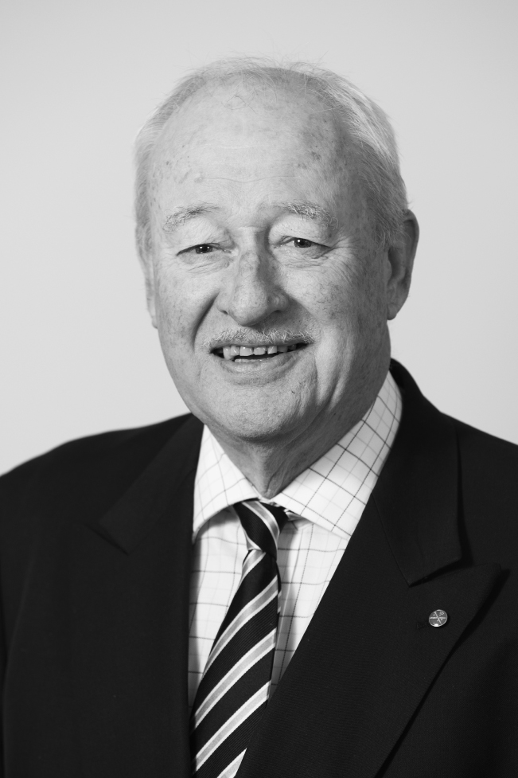
The Hon Alan Ferguson
Appointed Chairman in March 2014
Members of the Council
(in order of appointment)
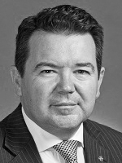
Senator Dean Smith
- Chief Government Whip in the Senate, Senator for Western Australia
- Representative of the Liberal Party of Australia
- Appointed in November 2016
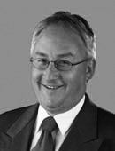
The Hon Michael Danby MP
- Federal Member for Melbourne Ports
- Representative of the Leader of the Opposition
- Appointed in January 2017
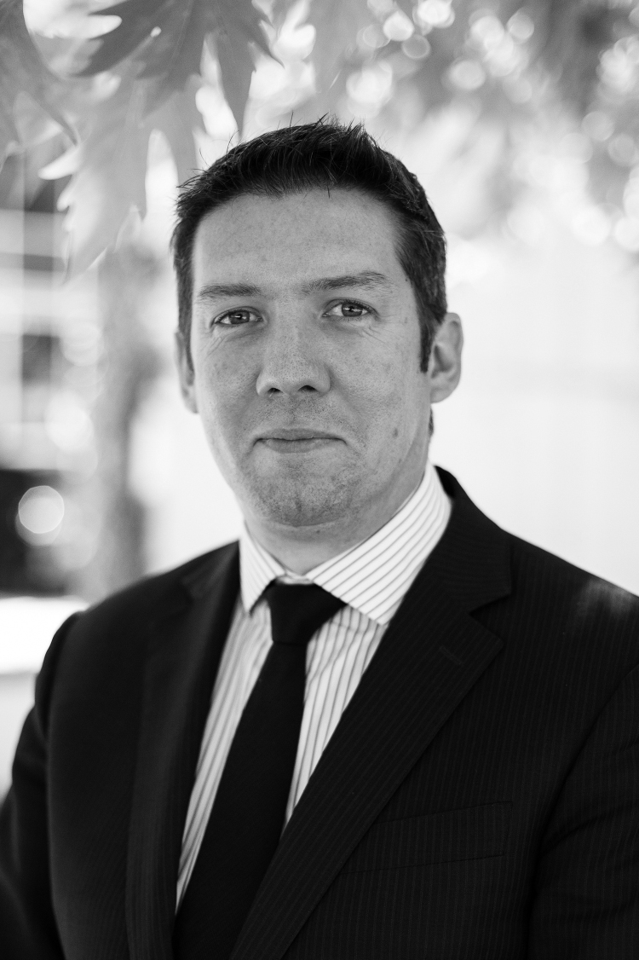
Mr Noah Carroll
- National Secretary, Australian Labor Party
- Representative of the Leader of Opposition
- Appointed in January 2017
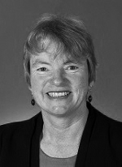
Senator Janet Rice
- Senator for Victoria
- Representative of the Leader of the Australian Greens
- Appointed in February 2017
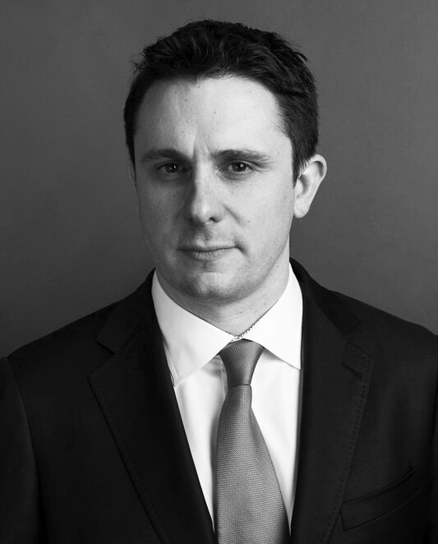
Mr Andrew Hirst
- Federal Director, Liberal Party of Australia
- Representative of the Leader of the Liberal Party of Australia
- Appointed in June 2017
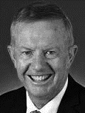
The Hon Mark Coulton MP
- Minister for Regional Services, Decentralisation and Local Government
- Assistant Minister for Trade and Investment, Federal Member for Parkes
- Representative of the Leader of the Nationals
- Appointed in September 2018
Outgoing Members of the Council
The Council thanks the following for their commitment and active participation during their appointments as Council Members:
Senator Sarah Hanson-Young
Senator Hanson-Young was appointed in 2009 and again in 2015, and served as Council Member, representing the Leader of the Australian Greens until 2016
Mr George Wright
Mr Wright was appointed in 2011 and served as Council Member,
representing the Leader of the Australian Labor Party until 2016
The Hon Gary Gray AO, MP
Mr Gray was appointed in 2015 and served as Council Member, representing the Leader of the Australian Labor Party until 2016
The Hon John Cobb MP
Mr Cobb was appointed in 2015 and served as Council Member, representing the Leader of The National Party until 2016
Senator the Hon Bridget McKenzie
Senator Bridget McKenzie was appointed in 2016 and served as Council Member,
representing the Leader of The National Party until 2018
Council activities
Outgoing Australian delegations
Each year the Council considers delegate nominations put forward by the parties of the Principals. Nominees are young Australians considered by their respective parties to have the potential to make a significant contribution to political life.
To maximise developmental opportunities, delegations comprise a representative, broadly-based group of young Australian political leaders. Delegates are selected from a range of political backgrounds including:
- members of federal and state parliaments
- party organisations, both professional and voluntary
- industry organisations
- trade unions
- ministerial and electorate staff
- local government representatives.
Delegates are required to be party members, Australian citizens and between the ages of 25 and 46 (with the exception of the exchange program with the United States of America where the age limit is 40).
All delegates are expected to continue their involvement in Council activities after their exchange visit by participating in, or assisting with, organising programs for incoming delegations and by promoting the program among colleagues and in the broader community. Former delegate participation during incoming exchanges is invaluable to the success of the programs.
At 30 June 2019, the Australian Political Exchange Council had sponsored 1053 young Australians’ participation in 164 overseas exchange delegations. Former delegates of the Council include many who are now in prominent political positions, including members of federal and state parliaments, and leaders in political and government organisations, trade unions and corporate Australia.
Incoming delegations to Australia
The Council operates a system of political exchange visits and receives delegations from its exchange partners. The Council’s aim for visiting delegations is to provide an understanding of Australia and its political system. Each itinerary is developed individually and provides the following three components:
- an overview of the Australian political system, incorporating federal, state/territory and local government
- networking through meeting high profile Australian political and business leaders, as well as former delegates of the Council’s programs
- an insight into Australian culture through community and cultural activities.
The total number of delegates hosted by the Council since its inception in 1981 was 1035 as at 30 June 2019.
Individual study tours
Each year, the Council provides developmental opportunities for young Australian political leaders through individual study tours. The total number of individuals sponsored by the Council as at 30 June 2019 was 130.
2016–17
Outgoing Australian delegations for 2016–2017
In 2016–2017, the Council sponsored 35 young Australian political leaders in overseas exchange delegations to the Republic of Korea, the Philippines, New Zealand, The United States of America and Japan as follows:
Date | Delegation
23 to 29 July 2016 | Fifth Australian Delegation to the Republic of Korea
12 to 18 November 2016 | Ninth Australian Delegation to the Philippines
5 to 9 December 2016 | Eleventh Australian Delegation to New Zealand
11 to 23 February 2017 | Thirty-second Australian Delegation to the United States of America
11 to 17 March 2017 | Twenty-fifth Australian Delegation to Japan
13 to 19 May 2017 | Tenth Australian Delegation to the Philippines

Fifth Australian Delegation to the Republic of Korea
23 to 29 July 2016
Delegates
- Ms Nikki Boyd MP (Australian Labor Party)
Delegation Leader State Member for Pine Rivers
- Ms Imogen Beynon
(Australian Labor Party)
Queensland State Lead, National Union of Workers
- Mr Martin Greenwood
(Australian Labor Party)
Adviser, Office of the ACT Chief Minister
- Miss Zoe Darling
(Liberal Party of Australia)
Media and Communications Adviser, Office of the Hon Jamie Briggs MP
- Mr Nathan Hersey
(Liberal Party of Australia)
Electorate Office Manager,
Office of the Hon Bruce Billson MP
- Mr Mitch Redford
(Liberal Party of Australia)
Campaign Manager
- Mrs Sharon Forester
– Council Representative
Director, Australian Political Exchange Council
The Fifth Australian Delegation to the Republic of Korea travelled to Seoul, Gyeonggi-do Hwaseong, Gyeonggi-do Paju, Yeouido, Gyeonggi-do and Gapyeong‑gun during the 7-day exchange hosted by The Korea Foundation.
Visit program
Seoul
- Briefing and tour of the National Assembly of the Republic of Korea
- Meeting with Mr Won Yoo Chul, Chairman, Korea-Australia Parliamentarian Friendship Association
- Briefing by the Republic of Korea National Election Commission
- Welcome dinner hosted by Mr Kim Gwang-Keun, Executive Vice President, The Korea Foundation
- Briefing and luncheon hosted by Ms Tiffany McDonald, Acting Deputy Head of Mission, Australian Embassy
- Briefing by the Youido Institute
- Dinner hosted by previous delegates to Australia
- Visit to Jinkwansa Temple
- Visit to Seoul Global Center
- Visit to Samsan Digital Media City
- Visit to Gyeongbokgung Palace
- Visit to Samcheong-dong
- Visit to Cheongwadae Sarangchae
- Visit to the National Museum of Korea
- Attended a performance of NANTA
- Dinner at the Namsan Seoul Tower
Gyeonggi-do Hwaseong
- Visit to Hyundai Motor’s Namyang R&D Center
Gyeonggi-do Paju
- Visit to The Third Tunnel
- Visit to the Dora Observatory
- Visit to Dorasan Station
Yeouido
- Briefing by the Australian Chamber of Commerce in Korea
- Meeting luncheon hosted by Mr Yu Eui-dong, Member of the National Assembly
Gyeonggi-do
- Meeting with Mr Shin Min‑cheol, Chairperson, Autonomous Administrative Committee, Namyangu City Council
- Dinner hosted by the Australian Institute of International Affairs
Gapyeong-gun
- Visit to the Monument for the Participation of Australia in the Korean War

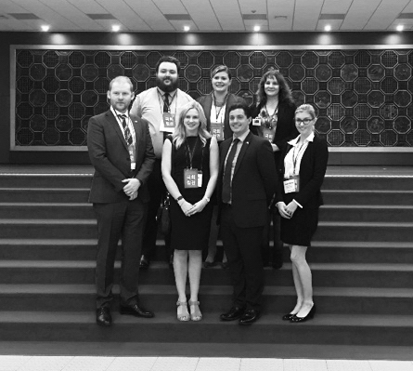
The Fifth Australian Delegation to the Republic of Korea at the National Assembly
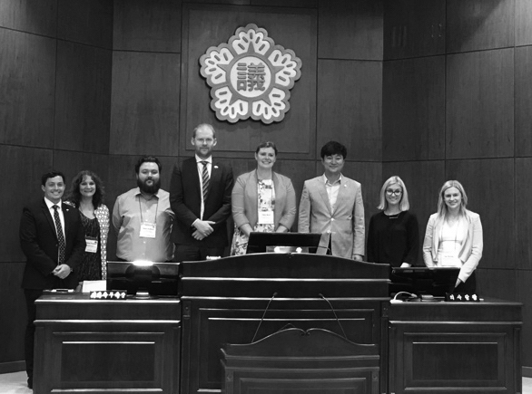
The Fifth Australian Delegation to the Republic of Korea meeting with Mr Shin Min-cheol, Chairperson, Autonomous Administrative Committee, Namyangju City Council

Ninth Australian Delegation to the Philippines
12 to 18 November 2016
Delegates
- Ms Cassandra Devine
(Australian Labor Party)
Delegation Leader
Policy and Research Officer, Australian Council of Trade Unions
- Ms Rikki Hendon
(Australian Labor Party)
Coordinator, CPSU/CSA
- Ms Donherra Walmsley
(Australian Labor Party)
Targeting and Projects Officer, Australian Manufacturing Workers’ Union, NSW
- Mr Robert (Henry) Davis
(Liberal Party of Australia)
Councillor, City of Burnside Council
- Mr Andrew Hudgson
(Liberal Party of Australia)
Communications Manager, Liberal Party of Australia, Victoria
- Ms Susan Leithhead
(Liberal Party of Australia)
Executive Director, Federal Forum and Manager Donor Clubs and Events
- Ms Victoria (Tori) Castledine
(The Nationals)
CEO, Esperance Chamber of Commerce and Industry
- Mrs Sharon Forester
– Council Representative
Director, Australian Political Exchange Council
The Ninth Australian Delegation to the Philippines travelled to Manila, Legazpi City, Ligao City, Pasig City, Quezon City, Antipolo City and San Juan City during the 7-day exchange hosted by the Philippine Center for Young Leaders in Governance.
Visit program
Manila
- Briefing and dinner hosted by Mr Rollie Fabi, Executive Director, Philippine Center for Young Leaders in Governance
- Tour of the Senate of the Philippines
- Meeting and luncheon hosted by Mr Paul Hutschcroft and Mr Ben Esguerra, Australian Embassy
- Courtesy call on Senator Joel Villanueva, Chairman, Committee on Labor
- Courtesy call on Senator Francis Pangilinan, Chairman, Committee on Agriculture, President, Liberal Party
- Meeting with Senator Leila De Lima and Senator Sherwin T Gatchalian
Legazpi City
- Welcome ceremony and luncheon hosted by Cr Robert Cristobel, Vice Mayor, Legazpi City
- Dinner hosted by Congressman Afredo Garbin, AKO BICOL Partylist Representative to the Congress
- Courtesy call on the Hon Harold O. Imperial, Vice Governor, Province of Albay
- Dinner hosted by Cr Noel Rosal, Mayor, Legazpi City
- Tour of Cagsawa Ruins
- ATV drive at Mount Mayon
Ligao City
- Courtesy call on Cr Patricia Gonzales-Alsua, Mayor, Ligao City
- Tour of Kawa-Kawa Hills and Natural Park
Pasig City
- Dinner hosted by Senator Paolo Benigno “Bam” A. Aquino IV
Quezon City
- Visit to Philippine Information Agency
- Courtesy call on the Office of the Hon Maria Leonor “Leni” Gerona Robredo, Philippine Vice President, represented by Mr Philip Dy, Undersecretary
- Visit to the House of Representatives
- Courtesy call on Congressman Pantaleon Alvarez, Speaker of the House of Representatives
- Attend a sitting of the House of Representatives, hosted by the Hon Atty. Marlyn L. Primicias-Agabas, Representative of the 6th District of Pangasinan
- Dinner hosted by Cr Christian Natividad, Maroy, Malalos City. Guests included the Hon Carlo Loreto, Vice Governor, Leyte, the Hon Kaye Revil, Vice Governor, Masbate and Philippine Center for Young Leaders in Governance Alumni
- Visit to Ateneo School of Government
- Meeting with Dean Ronald Mendoza, Mr Victor E Agbayani and Mr Isaias Ubana II, Ateneo School of Government
Antipolo City
- Courtesy call on the Hon Casimiro A Ynares III, Mayor and the Hon Ronald R Barcena, Councilor for Antipolo City
- Visit to Pinto Art Museum
- Visit to Angona-Binangonan Petroglyphs hosted by the Hon Gerardo V Calderon, Municipal Mayor, Angono, Rizal
San Juan City
- Visit to local markets in Greenhills
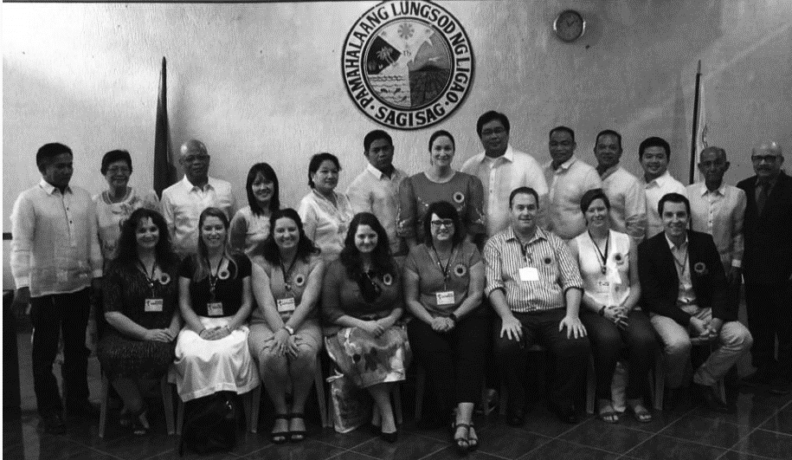
The Ninth Australian Delegation to the Philippines
Eleventh Australian Delegation to New Zealand
5 to 9 December 2016
Delegates
- Mr Sam Duluk MP
(Liberal Party of Australia)
Delegation Leader
State Member for Davenport
- Mr Andrew Hallam
(Liberal Party of Australia)
Adviser, Office of the Hon Greg Hunt MP
- Mr David Kitchen
(Liberal Party of Australia)
Staffer, Office of Senator James Paterson
- Ms Jessica Malnersic
(Australian Labor Party)
Organiser, Australian Labor Party, NSW
- Mr James Connor
(Australian Labor Party)
Electorate Officer, Office of Tim Crakanthorp MP
- Mr Nathan Ruhle (The Nationals)
Senior Policy Adviser, Queensland Leader of the Opposition
- Mrs Sharon Forester
– Council Representative
Director, Australian Political Exchange Council
The Eleventh Australian Delegation to New Zealand travelled to Auckland, Rotorua, Wellington and Christchurch during the 5-day exchange hosted by the New Zealand Parliament.
Visit program
Auckland
- Meeting and discussion with Mr Jim Quinn, Chief of Strategy, Auckland Council
- Briefing and discussion with Ms Christina Leung, Senior Economist, New Zealand Institute for Economic Research
Rotorua
- Visit to geothermal mineral pools at Polynesian Spa
- Visit to geothermal power station
- Visit to Waiotapu geothermal tourism centre
- Visit to Te Puia Whakarewarewa
Wellington
- Meeting with Mr Andrew Cumpston, Deputy High Commissioner, Australian High Commission
- Courtesy call on the Rt Hon David Carter MP, Speaker of the House of Representatives
- Tour of New Zealand Parliament
- Luncheon hosted by Mr Chris Bishop MP and Ms Denise Roche MP, Co-Chairs, New Zealand-Australia Parliamentary Friendship Group and Mr Jonathan Young MP, Chair, Transport and Industrial Relations Select Committee
- Observe Question Time in the House of Representatives
- Meeting with the Australian Division, Ministry of Foreign Affairs and Trade
- Dinner hosted by the Rt Hon David Carter MP, Speaker of the House of Representatives
- Observe meeting of the Local Government and Environment Select Committee
- Visit Pukeahu National War Museum Park
- Visit Tomb of Unknown Soldier, Hall of Memories and the Australian Memorial
- Visit to Dominion Museum to view the Great War Exhibition
Christchurch
- Meeting with Cr Deon Swiggs and Ms Linda Paterson, Civic and International Relations Coordinator, Christchurch City Council
- Briefing by Mr Ivan Iafeta, Chief Executive, Regenerate Christchurch
- Visit Margaret Mahy Playground
- Briefing by Mr Angus Bargh, Chief Transport Planner
- View Smart Cities projects hosted by Ms Teresa McCallum, Smart Cities Programme Manager
- Visit Vodafone Building

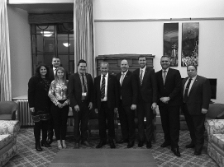
The Eleventh Australian Delegation to New Zealand meeting with the Rt. Hon David Carter MP, Speaker of the House of Representatives
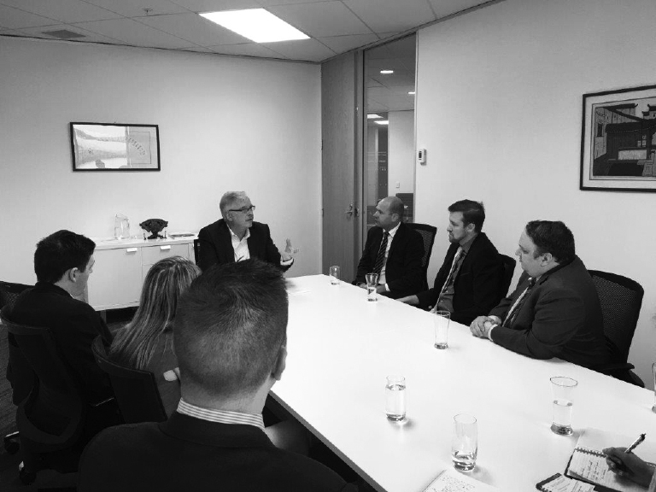
The Eleventh Australian Delegation to New Zealand meeting with Mr Stephen Jacobi, Managing Director, Jacobi Consulting and Executive Director, NZ International Business Forum

Thirty-second Australian Delegation to the United States of America
11 to 23 February 2017
Delegates
- Ms Emily Gore
(Australian Labor Party)
Delegation Leader
Ministerial Adviser, Office of the Hon Susan Close MP
- Mr Jay Suvaal (Australian Labor Party)
Country Organiser, NSW
- Mr Justin De Domenico
(Liberal Party of Australia)
Senior Consultant, Crosby | Textor Australia
- Mr Jonathan Martin
(Liberal Party of Australia)
Electorate Officer, Office of Mr Steve Irons MP
- Ms Angela McGuinness
(Liberal Party of Australia)
Chief of Staff, Office of Senator the Hon Zed Seselja
- Ms Siobhan McCarty (The Nationals)
Chief of Staff, Office of the Hon Sarah Mitchell MLC
- Mr Noah Schultz-Byard
(Australian Greens) Chief of Staff, Officer of Senator Sarah Hanson-Young
- Mrs Sharon Forester
– Council Representative
Director, Australian Political Exchange Council
The Thirty-second Australian Delegation to the United States of America travelled to Washington D.C., Columbus, Cleveland, Portland and Salem during the 12-day exchange hosted by the American Council of Young Political Leaders.
Visit program
Washington D.C.
- Tour of Washington D.C. monuments, including the White House, Jefferson Memorial, Lincoln Memorial, Korean War Memorial and Vietnam War Memorial
- Visit to the United States Botanical Gardens
- Visit to the Smithsonian Museum of American History and the Smithsonian Museum of Natural History
- Briefing by the American Council of Young Political Leaders hosted by Ms Libby Rosenbaum, Interim CEO
- Meeting with the Hon Greg Walden, Member, US House of Representatives
- Tour of the US Capitol Building
- Meeting and luncheon with representatives of the Chamber of Commerce, hosted by Mr Jared Parks, Director of Advocacy and External Affairs, Global Intellectual Property Center, Chamber of Commerce
- Meeting with His Excellency the Hon Joe Hockey, Ambassador of Australia
- Meeting with representatives from the Bureau of East Asian Affairs, US State Department including Mr Brent LaRosa, Public Diplomacy Country Coordinator, Mr Matt O’Connor, Australia Desk Officer and Mr Mike Cognato, Australia Desk Officer
- Dinner hosted by Mr Tom Foulkes, Vice President, State Government Affairs, Entertainment Software Association
- Meeting with Mr Daniel Lippman, Reporter and Co-Author of POLITICO’s Playbook
- Meeting with Mr Chuck Rocha, Founder and President, Solidarity Strategies and Mr Michael Steel, Managing Director, Hamilton Place Strategies
- Meeting and luncheon with representatives from the American Gas Association. Guests included Ms Allison Cunningham, Manager, Federal Government Affairs and PAC Administration, Spectra Energy and Mr George Lowe, Vice President, Federal Affairs, American Gas Association
- Meeting with Ms Stephanie Schriock, President, EMILY’s List
- Meeting with Mr Chris Hansen, Director, National Republican Senatorial Committee
Columbus, Ohio
- Visit and tour of Ohio Statehouse
- Observe session of the Ohio State Legislature
- Meeting with members of the Ohio State Legislature including the Hon Martin Sweeney, the Hon Stephanie Kunze, the Hon David Leland and the Hon Christina Hagan
- Breakfast meeting hosted by Mr Andy Chow, Statehouse Reporter, Ohio Public Radio’s Statehouse News Bureau. Also in attendance were Mr Matthew Carle, Legislative Director and former Campaign Manager for Governor John Kasich and Mr John Haseley, former Campaign Manager and Chief of Staff, Governor Ted Strickland
- Meeting with the Hon Maureen O’Connor, Chief Justice, Ohio Supreme Court
- Meeting with the Hon Michael Watson, Judge, United States District Court for the Southern District of Ohio
- Luncheon hosted by Ms Yvette McGee Brown, Partner, Jones Day Law Firm. Guests included Mr Terry Casey, Chairman, State of Ohio Personnel Board of Review
- Meeting with Mr Rudy Hightower, Instructor, John Glenn School of Public Affairs, Ohio State University
- Tour of Woody Hayes Athletic Complex
- Attend ice hockey game
- Attend stand-up comedy performance at Funny Bones Comedy Club
Cleveland, Ohio
- Tour of Gordon Square Arts District hosted by Ms Carrie Carpenter, President and Executive Director, Gordon Square Arts District
- Meeting and luncheon hosted by Mr Freddy Collier, Director of City Planning, City of Cleveland
- Meeting hosted by Mr Joe Cimperman, President, Global Cleveland Foundation. Also in attendance Ms Danielle Drake, Community Relations Manager, US Together and representative from US Together, US Committee for refugees and Immigrants, Global Cleveland
- Visit to Thomas Jefferson International Newcomers Academy
- Reception sponsored by Hilton Hotels and Resorts. Guests included the Hon Sandra Williams, Member, Ohio State Senate, Ms Carrie Carpenter, President and Executive Director, Gordon Square Arts District and Mr Joe Cimperman, President, Global Cleveland
- Dinner hosted by Mr Andy Tyeekrem, Brewmaster, Market Garden Brewery
- Meeting with Mr Chris Ronayne, President, University Circle Inc.
- Tour of Cleveland Museum of Art hosted by Mr Chris Ronayne
- Visit to Rock and Roll Hall of Fame
Portland, Oregon
- Meeting with Ms Sandra McDonough, President and CEO, Portland Business Alliance
- Meeting and luncheon with Mr Nico Larco PhD, Co-founder and Co-director, University of Oregon Sustainable Cities Initiative
- Meeting with Mr Bob Moore, President, Moore Information
- Walking tour of Portland city
- Visit to Powell’s bookstore
- Meeting and luncheon with representatives from Nike Inc. In attendance were Ms Susan Rohol, Director, Global Intellectual Property and Privacy Policy, Mr Sean O’Hallaren, Vice President, Government Affairs and Mr Colin Graham, Vice President, Legal Team
- Visit to Mount Hood Ski Bowl
- Visit to Nike Employee Store
- Visit to Multnomah Falls
Salem, Oregon
- Tour of Salem
- Attend opening ceremony of Oregon State House of Representatives
- Roundtable discussion with representatives from various government agencies and industry representatives
- Meeting with the Hon Tobias Read, Treasurer, Oregon Treasury
- Meeting and luncheon with Oregon State Senators including the Hon Sara Gelser, Member, Oregon Senate
- Meeting with the Hon Kate Brown, Governor, State of Oregon
- Tour of estate and wine tasting at Willamette Valley Vineyards hosted by Mr Jim Bernau, Founder and CEO, Willamette Valley Vineyards

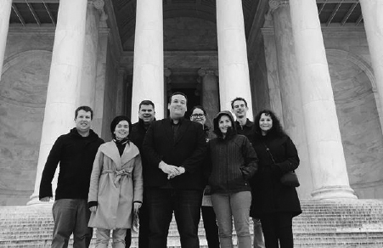
The Thirty-second Australian Delegation to the United States of America on the steps of the Lincoln Memorial
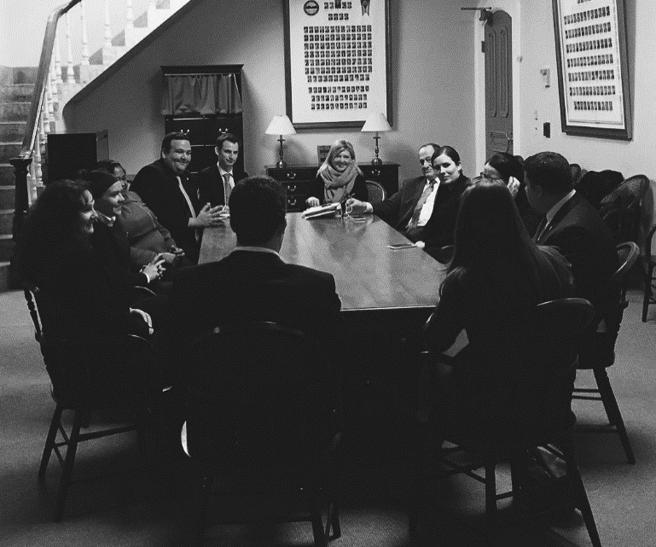
The Thirty-second Australian Delegation to the United States of America meeting with the Hon Martin Sweeney, the Hon Stephanie Kunze, the Hon David Leland and the Hon Christina Hagan of the Ohio State Legislature

Twenty-fifth Australian Delegation to Japan
11 to 17 March 2017
Delegates
- Ms Emma McBride MP
(Australian Labor Party)
Delegation Leader
Federal Member for Dobell
- Mr Luke Howarth MP
(Liberal Party of Australia)
Federal Member for Petrie
- Ms Justine Keay MP
(Australian Labor Party)
Federal Member for Braddon
- Mrs Sharon Forester
– Council Representative
Director, Australian Political Exchange Council
The Twenty-fifth Australian Delegation to Japan travelled to Kyoto, Osaka and Tokyo during the 7-day exchange hosted by the Japan Ministry of Foreign Affairs.
Visit program
Kyoto
- Briefing by officials from Ministry of Foreign Affairs
- Meeting with the Governor of Shiga Prefecture
- Visit to Biwako Hall guided by Shiga Prefecture Officials
- Meeting with a Ceramics Master
Osaka
- Visit Todaiji Temple and Nara Park joined by Japanese Diet members elected from the Nara Prefecture, Mr Iwao Horii and Mr Kei Sato, Members of the House of Councillors
- Meeting with the Governor of the Nara Prefecture
- Meeting with the Mayor of Nara City
- Visit to Heijya Park
- Meeting with Rev Ryubun Kono, Chief Abbott, Daianji Temple
- Visit Yakushiji and Toshodaiji Temples, guided by Abbott Eiin Yasuda. Joined by Mr Iwao Horii, Member, House of Councillors
- Briefing from the Nippon Lighthouse Guide Dog Training Centre
- Meeting with Mr Teruji Yamamura, CEO, DUSKIN Co
- Travel to Tokyo by Shinkansen
Tokyo
- Briefing by Ministry of Foreign Affairs
- Luncheon hosted by Members of Japanese Diet. Guests included Mr Keitaro Ohno, Member of the House of Representatives, Mr Tsuyoshi Hoshino, Member of the House of Representatives and Mr Iwao Horii, Member of the House of Councillors
- Meeting with Mr Masakazu Hamchi, Member of the House of Representatives, Komeito Party
- Dinner hosted by Mr Kenji Kanasugi, Director General, Asian and Oceanian Affairs Bureau, Ministry of Foreign Affairs
- Meeting with Dr Yasuyuki Yoshizawa, President, Tokyo Medical and Dental University. Also in attendance, Professor Yoshinobu Eishi, Department of Human Pathology and medical students
- Tour of medical laboratory, Tokyo Medical and Dental University
- Luncheon hosted by His Excellency Mr Richard Court AC, Ambassador of Australia
- Meeting with female Diet members hosted by Ms Emiko Takagai, Member of the House of Councillors, Director of Women’s Affairs Division
- Dinner with Diet members including Mr Shigeharu Aoyama, Member, House of Councillors, Ms Rui Matsukawa, Member, House of Councillors, Ms Kimi Onada, Member, House of Councillors, Mr Takashi Koyari, Member, House of Councillors and Mr Kei Sato, Member, House of Councillors
- Luncheon hosted by Mr Nobuo Kishi, State Minister of Foreign Affairs
- Tour of Japanese Diet
- Observe a Diet Plenary Session
- Meeting with Members of the Japan-Australia Parliamentarians’ Friendship League including Mr Ichiro Aisawa, Chair, Member of the House of Representatives and Mr Taku Otsuka, Member of the House of Representatives
- Dinner hosted by Professor Yoshinobu Eishi, Tokyo Medical and Dental University
- Visit to Tama Zoo and briefing by the Zoo’s General Manager
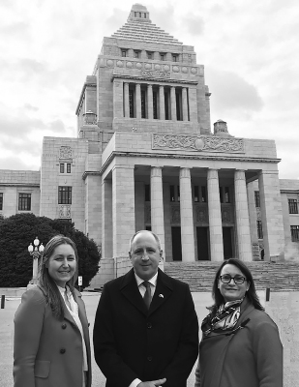
The Twenty-fifth Australian Delegation to Japan at the Japanese Diet
Tenth Australian Delegation to the Philippines
13 to 19 May 2017
Delegates
- Ms Brook Curtin
(Liberal Party of Australia)
Delegation Leader
Non-Executive Company Director
- Mr Jeremy Greenwood
(Liberal Party of Australia)
Assistant Adviser, Senator the Hon Matthew Canavan
- Mr Alexander Polson MP
(Liberal Party of Australia)
Adviser to Senator the Hon Simon Birmingham
- Mr Jason Hall (Australian Labor Party)
FSU Local Executive SA/NT
- Mr Joshua Millroy
(Australian Labor Party)
State Organiser, Qld
- Ms Christina Ong
(Australian Labor Party)
Lead Advocate / Lead Organiser, Australian Labor Party
- Mrs Sharon Forester
– Council Representative
Director, Australian Political Exchange Council
The Tenth Australian Delegation to the Philippines travelled to Manila, Cebu City, Talabay City, Quezon City, Makati City and San Juan City during the 7-day exchange hosted by the Philippine Center for Young Leaders in Governance.
Visit program
Manila
- Briefing and dinner hosted by Mr Rollie Fabi, Executive Director, Philippine Center for Young Leaders in Governance
- Briefing and luncheon hosted by the Australian Embassy
- Courtesy call on Senator Francis Pangilinan, Chairman, Committee on Agriculture and President, Liberal Party
- Meeting with Mr Jonathan Malaya, Executive Director, PDP Laban Federalism Institute
- Courtesy call on Senator Paolo Benigno “Bam” A Aquino IV
- Dinner hosted by the Hon Humerlito “Bonz” A Dolor, Vice Governor, National Chairman, League of Vice Governors of the Philippines and Treasurer, Union of Local Authorities of the Philippines
- Luncheon hosted by Philippine Center for Young Leaders in Governance Alumni
- Visit to City Hall and Session Hall hosted by Ms Princess Abante, Councilor
Cebu City
- Luncheon hosted by the Hon Hilario P Davide III, Governor, Cebu City
- Dinner hosted by Ms Victoria Corominas-Toribio, Board Member, Cebu City. Other guests included the Hon Agnew Magapole, Vice Governor, Board Member and Mr Earl Tidy H Oyas, Board Member
Talisay City
- Meeting with Members of the Talisay City Council
- Courtesy call on the Hon Eduardo Gullas, Talisay City Mayor
- Dinner hosted by Mr Earl Tidy H Oyas, Board Member
Quezon City
- Courtesy call on Ms Josefina Belmonte, Vice Mayor, Quezon City
- Courtesy call on the Office of the Hon Maria Leonor “Leni” Gerona Robredo, Philippine Vice President, represented by Mr Philip Dy, Undersecretary
- Courtesy call on Congressman Pantaleon Alvarez, Speaker of the House of Representatives
- Attend a sitting of the House of Representatives
- Dinner hosted by the Hon Casimiro A Ynares III, Mayor, Antipolo City
Makati City
- Meeting with Ms Corazon Halili-Dichosa, Director, Board of Investment
- Meeting with Ms Argee Gallardo and Mr Ariel Tanangonan, representatives of the Liberal Party of the Philippines
- Dinner reception hosted by Mr Mat Kimberley, Deputy Head of Mission, Embassy of Australia
- Fellowship night
San Juan City
- Visit to local markets in Greenhills
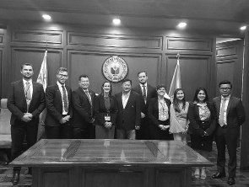
The Tenth Australian Delegation to the Philippines meeting with Congressman Pantaleon Alvarez, Speaker of the House of Representatives
Incoming delegations to Australia for 2016–2017
In 2016–2017, the Council hosted 49 participants on delegations from its exchange partners as follows:
Date | Delegation
10 to 16 September 2016 | Twentieth Delegation from the Socialist Republic of Vietnam
8 to 14 October 2016 | Tenth Delegation from the Philippines
7 to 11 November 2016 | Twenty-fourth Delegation from the People’s Republic of China
21 to 25 November 2016 | Eleventh Delegation from New Zealand
19 to 31 March 2017 | Thirty-third Delegation from the United States of America
20 to 26 May 2017 | Twenty-first Delegation from the Socialist Republic of Vietnam
17 to 23 June 2017 | Eleventh Delegation from the Philippines

Twentieth Delegation from the Socialist Republic of Vietnam
10 to 16 September 2016
Delegates
- Mr Nguyen Anh Tuan
(Ho Chi Minh Communist Youth Union) Delegation Leader
Secretary, Central Committee
- Mr Lo Quang Tu (Ho Chi Minh Communist Youth Union)
Member, Standing Committee
- Mr Giang Quoc Hung
(Ho Chi Minh Communist Youth Union)
Member, Executive Committee
- Ms Huynh Thi Hang Nga (
Ho Chi Minh Communist Youth Union)
Member, Executive Committee
- Mr Le Thanh Ha
(Ho Chi Minh Communist Youth Union)
Deputy Director-in-chief, Vietnamese Student Newspaper
- Mr Do Thanh Tam
(Ho Chi Minh Communist Youth Union)
Director General, Truong Phat Commercial Joint Company
- Ms Tran Hoai Minh
– Accompanying Officer
Youth International Cooperation Development Center
The Twentieth Delegation from the Socialist Republic of Vietnam travelled to Sydney, Canberra and Brisbane during the 6-day exchange.
Visit program
Sydney, New South Wales
- Briefing by the Australian Electoral Commission
- Meeting with the Young Socialist Left of the Australian Labor Party hosted by Ms Casey Thompson, Head, Young Socialist Left (Vietnam 2016). Also in attendance Ms Ama Somaratna, Member, Mr Matthew Campbell, Member, Mr Oliver Plunkett, Secretary, Mr David Pink, Executive Member, Ms Michelle Picone, Women’s Officer and Industrial Relations Policy Officer, Ms Alice Strauss, Former Women’s Officer, Ms Caitie McMenamin, Member, Mr Luke Chapman, Member, and Mr Declan O’Byrne, Member
- Dinner hosted by the Young Socialist Left of the Australian Labor Party. Guests included Ms Casey Thompson, Mr Matthew Campbell, Mr Oliver Plunkett, Mr David Pink, Ms Michelle Picone, Ms Alice Strauss, Ms Caitie McMenamin, Mr Luke Chapman, and Mr Declan O’Byrne
- Meeting with Ms Eleni Petinos MP, State Member for Miranda (Vietnam 2016)
- Sydney Harbour luncheon cruise
- Guided tour of the Sydney Opera House
- Visit to The Rocks markets
Canberra, Australian Capital Territory
- Briefing on the Liberal Party of Australia by Mr Bruce Edwards, International Secretary, Liberal Party of Australia (Japan 1992)
- Briefing on The Nationals by Mr Scott Mitchell, Federal Director, The Nationals (USA 2000)
- Briefing on the Australian Greens by Senator Sarah Hanson-Young, Senator for South Australia, Council Member (USA 2012)
- Briefing on the Australian Labor Party by Mr Paul Erickson, Assistant National Secretary, Australian Labor Party (USA 2011)
- Meeting with Senator the Hon Scott Ryan, Special Minister of State, Minister Assisting the Cabinet Secretary, Minister responsible for the Australian Political Exchange Program (Japan 2010)
- Meeting with Mr Pat Conroy MP, Shadow Assistant Minister for Climate Change, Shadow Assistant Minister for Infrastructure, Federal Member for Charlton (Japan 2014)
- Luncheon hosted by Ms Nguyen Dieu Linh, Counsellor, Political Affairs, Embassy of the Socialist Republic of Vietnam
- Meeting with the Hon Alan Tudge MP, Minister for Human Services, Federal Member for Aston (Vietnam 2012)
- Council luncheon hosted by the Hon Alan Ferguson, Chair, Australian Political Exchange Council. Guests included Mr Bruce Edwards representing the Liberal Party of Australia (Japan 1992)
- Observe Question Time in the House of Representatives and the Senate
- Courtesy call on Senator the Hon Stephen Parry, President of the Senate, Patron of the Council
- Courtesy call on the Hon Tony Smith MP, Speaker of the House of Representatives, Patron of the Council
- Dinner with former delegates Ms Danielle Young (Vietnam 2016) and Mr Ross Macdonald (Korea 2012, Vietnam 2014 and Philippines 2015)
- Guided tour of the Australian War Memorial
Brisbane, Queensland
- Guided tour of Queensland State Parliament
- Observe Question Time in the Legislative Assembly
- Luncheon hosted by the Hon Peter Wellington MP, Speaker of the Legislative Assembly of Queensland, State Member for Nicklin. Guests included Ms Di Farmer MP, Deputy Speaker, Legislative Assembly of Queensland, State Member for Bulimba (USA 1997)
- Briefing on Queensland’s Parliamentary System by representatives of the Parliamentary Education Unit
- Meeting with representatives of the Young Liberal National Party
- Meeting with representatives of the National Union of Workers
- Visit to Lone Pines Koala Sanctuary
- Visit to QueensPlaza
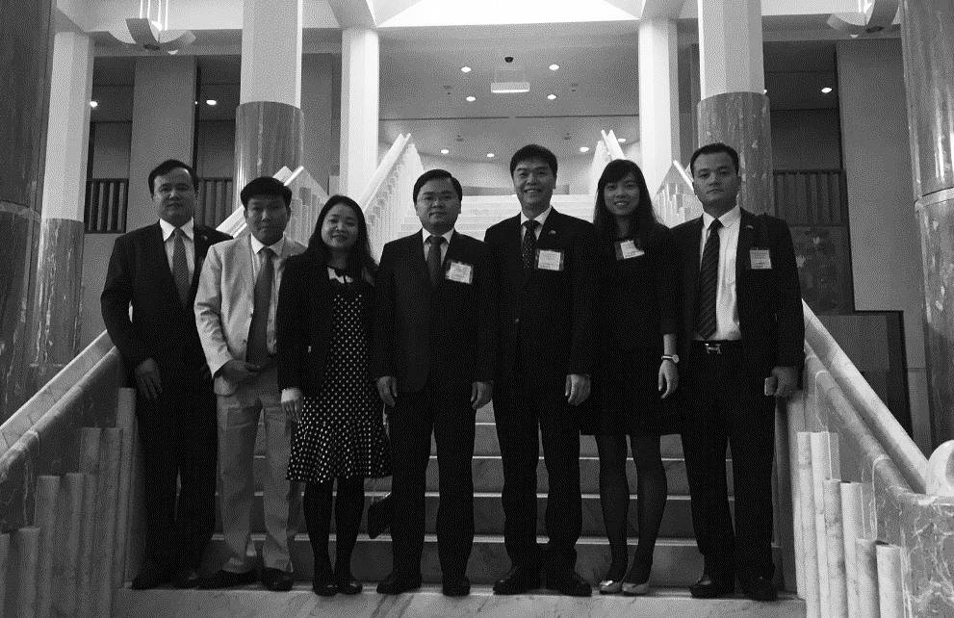
The Twentieth Delegation from the Socialist Republic of Vietnam in the Great Hall Parliament House, Canberra
Tenth Delegation from the Philippines
8 to 14 October 2016
Delegates
- The Hon Casimiro “Jun” A Ynares III
(Nationalist People’s Coalition) Delegation Leader
City Mayor, Antipolo City
- The Hon Carlo P Loreto (Liberal Party)
Vice Governor, Province of Leyte
- The Hon Jo Kristine C Revil
(PDP-LABAN)
Vice Governor, Province of Masbate
- The Hon Christian D Natividad
(Liberal Party)
City Mayor, City of Malalos
- The Hon Patricia Gonzales-Alsua (Liberal Party)
City Mayor, Ligao City
- The Hon Cezanne Fritz H Diaz
(Partido Negorense/National Unity Party)
Mayor, Municipality of Siaton
- The Hon Jennifer M Cruz
(Liberal Party)
Vice Mayor, Pola
- Mr Ares C Goyena
– Accompanying Officer
Chief of Staff, Office of Senator Paolo Benigno “Bam” A Aquino IV
The Tenth Delegation from the Philippines travelled to Sydney, Canberra and Melbourne during the 7-day exchange.
Visit program
Sydney, New South Wales
- Briefing by the Australian Electoral Commission
- Meeting with Ms Olivia Kember, Head of Policy, The Climate Institute
- Briefing by the City of Sydney Council
- Briefing by the Philippine Consulate
- High Tea hosted by Ms Anne Jalando-on Louis, Consul General, Philippine Consulate in Sydney
- Sydney Harbour luncheon cruise
- Guided tour of the Sydney Opera House
- Guided walking tour of The Rocks
- Visit to The Rocks markets
- Visit to the Sydney Tower
Canberra, Australian Capital Territory
- Briefing on the Liberal Party of Australia by Mr Bruce Edwards, International Secretary, Liberal Party of Australia (Japan 1992)
- Briefing on The Nationals by Mr Scott Mitchell, Federal Director, The Nationals (USA 2000)
- Briefing on the Australian Greens by Senator Sarah Hanson-Young, Senator for South Australia, Council Member (USA 2012)
- Briefing on the Australian Labor Party by Mr Paul Erickson, Assistant National Secretary, Australian Labor Party (USA 2011)
- Meeting with Senator the Hon Scott Ryan, Special Minister of State, Minister Assisting the Cabinet Secretary, Minister responsible for the Australian Political Exchange Program (Japan 2010)
- Meeting with the Hon Mark Butler MP, Shadow Minister for Climate Change, Federal Member for Port Adelaide (China 2006)
- Meeting with Senator the Hon Zed Seselja, Assistant Minister for Social Service and Multicultural Affairs, Senator for the Australian Capital Territory (USA 2007 and Japan 2014)
- Afternoon Tea hosted by Mrs Minda Calaguian-Cruz, Ambassador Extraordinary and Plenipotentiary, Embassy of the Philippines
- Meeting with the Hon Keith Pitt MP, Assistant Minister for Trade, Tourism and Investment, Federal Member for Hinkler
- Council luncheon hosted by Mr Andrew Laming MP, Federal Member for Bowman (Vietnam 2010 and Philippines 2012). Guests included Mr Bruce Edwards representing the Liberal Party of Australia (Japan 1992)
- Question Time in the House of Representatives and the Senate
- Courtesy call on Senator the Hon Stephen Parry, President of the Senate, Patron of the Council
- Courtesy call on the Hon Tony Smith MP, Speaker of the House of Representatives, Patron of the Council
Melbourne, Victoria
- Briefing Mr Andrew Young, Clerk, Legislative Council
- Observe Question Time in the Legislative Assembly and Legislative Council
- Luncheon hosted by the Hon Bruce Atkinson MLC, President of the Legislative Council and the Hon Telmo Languiller MLA, Speaker of the Legislative Assembly. Guests included Ms Margaret Fitzherbert MLC, State Member for Sothern Metropolitan Region and Mr Danny Pearson MLA, State Member for Essendon
- Guided tour of Parliament House
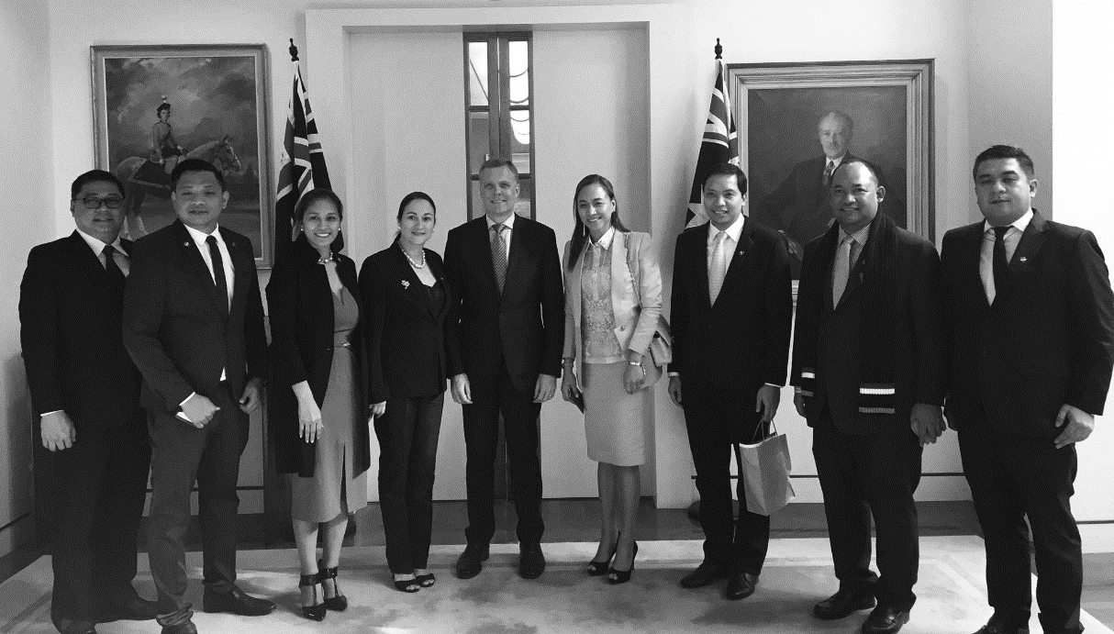
The Tenth Delegation from the Philippines with Speaker of the House of Representatives, the Hon Tony Smith, MP
Twenty-fourth Delegation from the People’s Republic of China
7 to 11 November 2016
Delegates
- Ms Wang Ting
(All-China Youth Federation)
Delegation Leader
Deputy Secretary General, All-China Youth Federation
- Ms Lui Kai (All-China Youth Federation)
Deputy Director, International Department, All-China Youth Federation
- Mr Chen Jiliang
Deputy Director, North America and Oceanic Affairs Department, Ministry of Foreign Affairs
- Mr Hou Yi
Research Fellow, Chinese Academy of Social Science
- Mr Jiang Lei
Chief Executive Officer of Innovation and Incubator Co Ltd
- Mr Wu Youjian
Founder and Chairman of Board, China Yanshang Group
The Twenty-fourth Delegation from the People’s Republic of China travelled to Sydney, Canberra and Brisbane during the 5-day exchange.
Visit program
Sydney, New South Wales
- Meeting with Mr Daryl Maguire, Chair, Asia Pacific Friendship Group, State Member for Wagga Wagga
- Briefing by Mr Jonathan Elliot, Director, Procedural Research and Protocol Unit and Ms Susan Want, Usher of the Black Rod
- Sydney Harbour dinner cruise
- Guided walking tour of NSW Parliament House
Canberra, Australian Capital Territory
- Briefing by the Australian Electoral Commission
- Former delegate dinner. Guests included Mr John Nguyen (China 2015) and Ms Kathryn Lees (China 2015)
- Briefing on the Australian Labor Party by Mr Sebastian Zwalf, Assistant Secretary and Director, Australian Labor International (USA 2011)
- Briefing on the Liberal Party of Australia by Mr Bruce Edwards, International Secretary, Liberal Party of Australia (Japan 1992)
- Briefing on The Nationals by Mr George Christensen MP, Chief Nationals Whip, Federal Member for Dawson (China 2007)
- Council luncheon hosted by Mr Milton Dick MP, Member for Oxley (South Korea 2005 and China 2014). Guests included Mr Sebastian Zwalf representing the Australian Labor Party (USA 2011)
- Observe Question Time in the House of Representatives and the Senate
- Courtesy call on Senator the Hon Stephen Parry, President of the Senate, Patron of the Council
- Courtesy call on the Hon Tony Smith MP, Speaker of the House of Representatives, Patron of the Council
- Meeting with Senator the Hon Scott Ryan, Special Minister of State, Minister Assisting the Cabinet Secretary, Minister responsible for the Australian Political Exchange Program (Japan 2010)
- Visit to Mount Ainslie Lookout
Brisbane, Queensland
- Visit to Brisbane City Council
- Courtesy call on Cr Krista Adams, Chairman, Finance and Economic Development Committee, Councillor for Holland Park, Mr Greg Bowman, Director, Strategy, Communications and Economic Development, Lord Mayor’s Office and Ms Nicole Andronicus, Manager, International Relations and Multicultural Affairs Unit, Lord Mayor’s Office
- Briefing by the Office of the Lord Mayor, Brisbane City Council
- Visit to Mt Coot-Tha Lookout
- Tour of Brisbane City
- Dinner hosted by Ms Nikki Boyd MP, State Member for Pine Rivers. Guests included Mr Mitch Redford
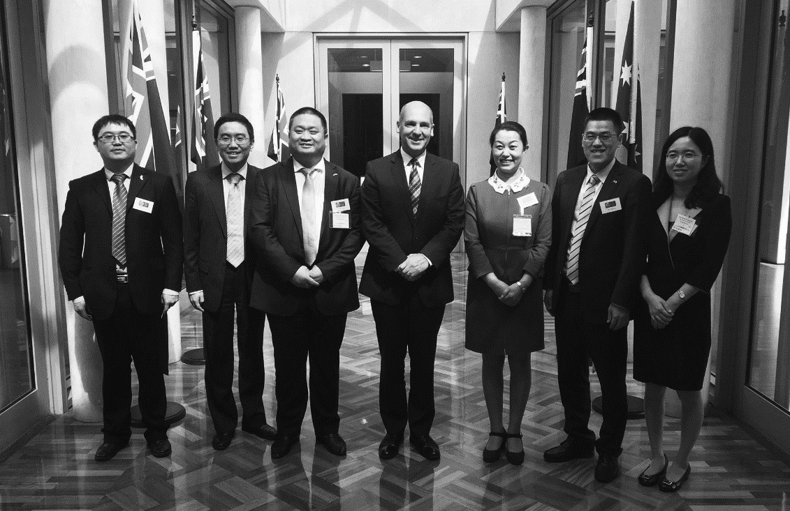
The Twenty-fourth Delegation from the People’s Republic of China with Senator Stephen Parry, President of the Senate
Eleventh Delegation from New Zealand
21 to 25 November 2016
Delegates
- Ms Fletcher Tabuteau MP
(New Zealand First) Delegation Leader
List Member
- Mr Robin Campbell (Green Party)
Political and Media Adviser, Parliamentary Office of the Green Party
- Ms Vivian Shurmer (National Party)
MP Support for Tutehounuku (Nuk) Korako and the Hon Gerry Brownlee
- Ms Bronwyn Presland (Labour Party)
Visits and Events Coordinator, Office of the Leader of the Opposition
- Mr Ben Cunliffe (Labour Party)
Research Adviser, Office of the Leader of the Opposition
- Mr Orphee Mickalad (National Party)
Executive Assistant to the Deputy Speaker
- Mr Charlie McLean
– Accompanying Officer
Parliamentary Officer, Office of the House of Representatives
The Eleventh Delegation from New Zealand travelled to Canberra and Brisbane during the 5-day exchange.
Visit program
Canberra, Australian Capital Territory
- Briefing by the Australian Electoral Commission
- Briefing on the Liberal Party of Australia by Mr Bruce Edwards, International Secretary, Liberal Party of Australia (Japan 1992)
- Briefing on the Australian Labor Party by Mr Sebastian Zwalf, Assistant Secretary and Director, Australian Labor International (USA 2011)
- Working luncheon hosted by the New Zealand High Commission
- Meeting with the Department of Foreign Affairs and Trade
- Meeting with Mr Andrew Laming MP, Federal Member for Bowman (Vietnam 2010 and Philippines 2012)
- Briefing on The Nationals by Mr Scott Mitchell, Federal Director, The Nationals (USA 2000)
- Council luncheon hosted by the Hon Alan Ferguson, Chair, Australian Political Exchange Council. Guests included Senator Dean Smith, Council Member (USA 1997, New Zealand 2012 and Japan 2016)
- Observe Question Time in the House of Representatives and the Senate
- Courtesy call on Senator the Hon Stephen Parry, President of the Senate, Patron of the Council
- Courtesy call on the Hon Tony Smith MP, Speaker of the House of Representatives, Patron of the Council
- Meeting with Senator the Hon Scott Ryan, Special Minister of State, Minister Assisting the Cabinet Secretary, Minister responsible for the Australian Political Exchange Program (Japan 2010)
- Tour of Parliament House
- Meeting with the Hon Andrew Leigh MP, Shadow Assistant Treasurer, Shadow Minister for Competition and Productivity, Shadow Minister for Charities and Not-for-Profits, Shadow Minister for Trade in Services and Federal Member for Fenner
- Meeting with Senator Murray Watt, Senator for Queensland (USA 2012 and Japan 2016)
- Guided tour of the Australian War Memorial
Melbourne, Victoria
- Briefing by Mr Andrew Young, Clerk of the Legislative Council
- Observe Question Time in the Legislative Assembly
- Guided tour of Parliament House
- Luncheon hosted by the Presiding Officers, the Hon Bruce Atkinson MLC, President of the Legislative Council and the Hon Telmo Languiller MLA, Speaker of the Legislative Assembly
- Meeting with the National Union of Workers
- Briefing on the Australian Greens by Ms Nina Springle MP, Spokesperson for Families and Children, Family Violence Prevention, Multicultural Affairs, Waste and Women, State Member for South‑Eastern Metropolitan Region
- Meeting with Banyule City Council
- Meeting with the Hon Alan Tudge MP, Minister for Human Services, Federal Member for Aston (Vietnam 2012)
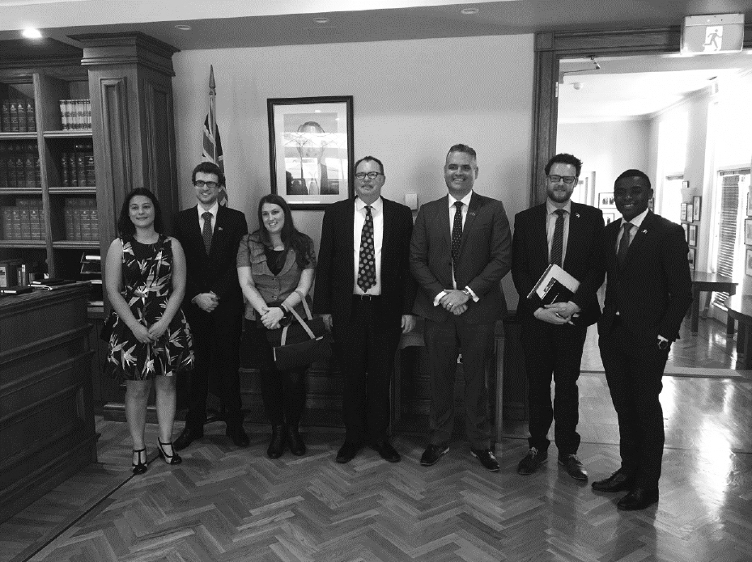
The Eleventh Delegation from New Zealand meeting with Mr Bruce Edwards, International Secretary, Liberal Party of Australia
Thirty-third Delegation from the United States of America
19 to 31 March 2017
Delegates
- The Hon Tyler August (Republican)
Speaker Pro Tempore, Wisconsin State Assembly
- The Hon Anthony Daniels (Democrat)
Member, Alabama House of Representatives
- The Hon R Lee Flowers (Republican)
Member, Gulfport City Council
- Ms Erica Jadynak (Republican)
New Jersey State Director, Americans for Prosperity
- The Hon Jaiza Page (Democrat)
Member, Columbus City Council
- Ms Kristy Tsadick (Democrat)
Associate General Counsel, The William and Flora Hewlett Foundation
- Ms Angie Welling (Republican)
Public Affairs Manager, Google
- The Hon Michael Frerichs (Democrat)
– Accompanying Officer
Treasurer, State of Illinois
The Thirty-third Delegation from the United States of America travelled to Canberra, Melbourne and Sydney during the 13‑day exchange.
Visit program
Canberra, Australian Capital Territory
- Welcome reception hosted by Mr James Caruso, Charge d’Affaires ad interim of the United States of America
- Briefing by the Australian Electoral Commission
- Briefing on the Australian Greens by Senator Janet Rice, Senator for Victoria, Council Member and Mr Samuel Drummond, Media and Communications Adviser, Office of Senator Janet Rice (USA 2016)
- Briefing on the Liberal Party of Australia by Mr Bruce Edwards, International Secretary, Liberal Party of Australia (Japan 1992)
- Briefing on the Australian Labor Party by Mr Noah Carroll, National Director, Australian Labor Party (UK 2010 and New Zealand 2012) and Mr Elias Hallaj, International Project Officer, Australian Labor Party (New Zealand 2002)
- Meeting with Mr Milton Dick MP, Member for Oxley (South Korea 2005 and China 2014)
- Meeting with Senator the Hon Zed Seselja, Assistant Minister for Social Services and Multicultural Affairs, Senator for the Australian Capital Territory (USA 2007 and Japan 2014)
- Meeting with the Hon Anthony Albanese MP, Shadow Minister for Infrastructure, Transport, Cities and Regional Development, Federal Member for Grayndler (Vietnam 2007)
- Briefing on The Nationals by Mr Ben Hindmarsh, Federal Director, The Nationals (USA 2010) and Mr Jeff McCormick, Political and Key Strategy Adviser (USA 2016)
- Former delegate dinner joined by Mr Robert Curtain, Adviser, Office of Dan Tehan MP (USA 2015)
- Council luncheon hosted by the Hon Alan Ferguson, Chair, Australian Political Exchange Council. Guests included Councils Members Senator Janet Rice, Senator Dean Smith (USA 1997, New Zealand 2012 and Japan 2016), Senator Bridget McKenzie (Japan 2016) and the Hon Michael Danby MP, Mr Bruce Edwards representing the Liberal Party of Australia and Mr Elias Hallaj representing the Australian Labor Party
- Observe Question Time in the House of Representatives and the Senate
- Courtesy call on Senator the Hon Stephen Parry, President of the Senate, Patron of the Council
- Courtesy call on the Hon Tony Smith MP, Speaker of the House of Representatives, Patron of the Council
- Meeting with Senator the Hon Scott Ryan, Special Minister of State, Minister Assisting the Cabinet Secretary, Minister responsible for the Australian Political Exchange Program (Japan 2010)
- Tour of Old Parliament House
- Meeting with the Hon Andrew Leigh MP, Shadow Assistant Treasurer, Shadow Minister for Competition and Productivity, Shadow Minister for Charities and Not-for-Profits, Shadow Minister for Trade in Services and Federal Member for Fenner
- Meeting with Senator Murray Watt, Senator for Queensland (USA 2012 and Japan 2016) and Senator Sam Dastyari, Deputy Opposition Whip in the Senate, Senator for New South Wales
- Meeting with the Advisory Team from the Office of Senator the Hon Simon Birmingham, including Mr Darren Brown, Senior Adviser, Higher Education, Dr Scott Prasser, Senior Adviser, Schools and Mr Alex Polson, Adviser, International Education and Research
- Meeting with the Hon David Gillespie MP, Assistant Minister for Health, Member for Lyne
- Panel event hosted by the Australian National University
- Guided tour of the Australian War Memorial
Melbourne, Victoria
- Meeting with Mr David Livingstone, Head, Global Engagement, Business Council of Australia
- Courtesy call on the Rt Hon Robert Doyle AC, Lord Mayor of Melbourne (Japan 1996)
- Briefing on local government with Mayor Tom Melican, Cr Rick Garotti (Philippines 2012), Cr Peter Castaldo, Cr Alison Zandegu, Cr Craig Langdon and Mr Simon McMillan, Chief Executive Officer, Banyule City Council
- Meeting with the Australian Securities and Investment Commission
- Meeting with Mr Kane Thornton, Chief Executive, Clean Energy Council of Australia
- Meeting with Daniela Traino, Business Leader, Cyber Security at Data61
- Meeting with Mr Jason Aldworth, Director, The Civic Group (Vietnam 2004 and South Korea 2005) and Mr Andreas Puig, Director, The Civic Group
- Tour of Melbourne Town Hall
- Attend Australian rules football match
- Guided Tour of Healesville Sanctuary
- Tour of De Bortoli Winery
Sydney, New South Wales
- Meeting with Mr Ivailo Arsov, Section Head, Economic Analysis Department, Reserve Bank of Australia
- Meeting with Mr Matthew Hingerty, Chief Executive Officer and Managing Director of Barton Deakin and Mr Andrew Humpherson, Director, Barton Deakin
- Meeting with the Hon Patricia Forsythe, Executive Director, Sydney Business Chamber (Canada 1987)
- Young Political Leaders networking night hosted by the US Consulate and partnered by the Commonwealth Bank of Australia
- Meeting with Mr Edward Santow, Human Rights Commissioner
- Meeting with Mr Robert Hardie, Policy Director, Cropping and Horticulture, Mr Ash Salardini, Chief Economist and Ms Adair Moar, Policy Director at NSW Farmers’ Federation
- Meeting with Ms Olivia Kember, A/g Chief Executive Officer and Ms Kate Mackenzie, Investment and Governance Manager, The Climate Institute
- Meeting with representatives from Unions NSW, Health Services Union, NSW Nurses and Midwives Association and the Australian Salaried Medical Officers’ Federation of NSW
- Guided tour of Parliament House
- Meeting with members of the USA Parliamentary Friendship Group hosted by the Hon Natasha McLaren Jones MLC, Chair
- Observe Question Time in the Legislative Assembly and Legislative Council
- Meeting with representatives of the Barangaroo Delivery Authority hosted by Ms Amber Cameron, Community Engagement Manager, Mr David McCracken, Development Advisor and Mr Tim Robertson, Executive Director, Strategy and Operations
- Barangaroo cultural tour
- Guided tour of the Sydney Opera House
- Walking tour of The Rocks
- Visit The Rocks market
- Driving tour of Sydney, including visit to Bondi Beach
- Former delegate dinner. Guests included Mr Jay Suvaal (USA 2017) and Mr Justin De Domenico (USA 2017)
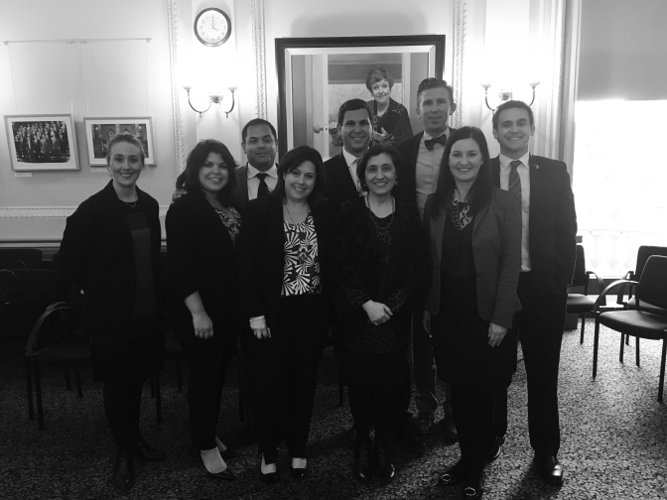
The Thirty-third Delegation from the United States of America meeting with the Hon Lily D’Ambrosio MP and Ms Gabrielle Williams MP
Twenty-first Delegation from the Socialist Republic of Vietnam
20 to 26 May 2017
Delegates
- Mr Nguyen Ngoc Luong
(Ho Chi Minh Communist Youth Union) Delegation Leader
Secretary of the Central Committee
- Mr Lam Dinh Thang
(Ho Chi Minh City Youth Union)
Member of the National Assembly
- Mr Le Van Trung
(Thanh Hoa Provincial Youth Union)
Member, Thanh Hoa Province’s People Council
- Mr Le Trung Ho
(Kien Giang Provincial Youth Union)
Member, Kien Giang Province’s People Council
- Mr Bui Quoc Bao
(Long An Provincial Youth Union)
Member, Long An Province’s People Council
- Mr Nguyen Huu Trung
– Accompanying Officer
Youth International Cooperation Development Center
The Twenty-first Delegation from the Socialist Republic of Vietnam travelled to Melbourne, Canberra and Hobart during the 7-day exchange.
Visit program
Melbourne, Victoria
- Visit to Skydeck 88
- Melbourne walking tour
- Guided tour of Healesville Sanctuary
- Tour of De Bortoli Wines
- Former delegate dinner hosted by Mr Matthew Merry (Vietnam 2015)
- Briefing by the Australian Electoral Commission
- Meeting with Mr Matthew Merry and Ms Susie Allison, National Union of Workers
Canberra, Australian Capital Territory
- Briefing on the Liberal Party of Australia by Mr Bruce Edwards, International Secretary, Liberal Party of Australia (Japan 1992)
- Briefing on the Australian Labor Party by Mr Paul Erickson, Assistant Secretary, Australian Labor Party
- Briefing on The Nationals by Mr Damian Drum MP, Chief Nationals Whip and Federal Member for Murray
- Council luncheon hosted by Council Members Senator Dean Smith and the Hon Michael Danby MP. Guests included Mr Bruce Edwards representing the Liberal Party of Australia
- Observe Question Time in the House of Representatives
- Courtesy call on Senator the Hon Stephen Parry, President of the Senate, Patron of the Council
- Courtesy call on the Hon Tony Smith MP, Speaker of the House of Representatives, Patron of the Council
- Meeting with Senator the Hon Scott Ryan, Special Minister of State, Minister Assisting the Cabinet Secretary, Minister responsible for the Australian Political Exchange Program (Japan 2010)
- Dinner hosted by the Embassy of the Socialist Republic of Vietnam
Hobart, Tasmania
- Briefing on the Australian Greens by Mr Andrew Perry, Adviser, Office of Senator McKim
- Former delegate dinner joined by Mr Brett Maryniak (Vietnam 2016) and Mr James Weld (Vietnam 2016)
- Meeting with the Hon Elise Archer MP, Speaker of the House of Assembly
- Meeting with the Hon Jim Wilkinson MLC, President of the Legislative Council and Mr David Pearce, Clerk of the Council
- Observe Question Time in the House of Assembly
- Meeting with Ms Madeleine Ogilvie MP, Federal Member for Denison
- Tour of Parliament House
- Luncheon hosted by the Presiding Officers, the Hon Jim Wilkinson MLC, President of the Legislative Council and the Hon Elise Archer MP, Speaker of the House of Assembly

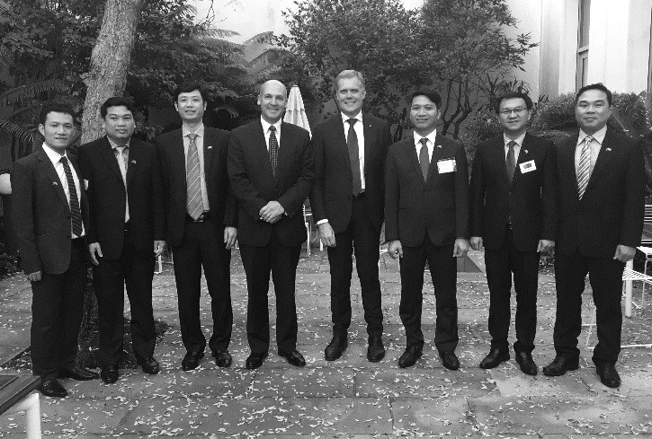
The Twenty-first Delegation from the Socialist Republic of Vietnam meeting with Senator the Hon Stephen Parry, President of the Senate, Patron of the Council and the Hon Tony Smith MP, Speaker of the House of Representatives, Patron of the Council
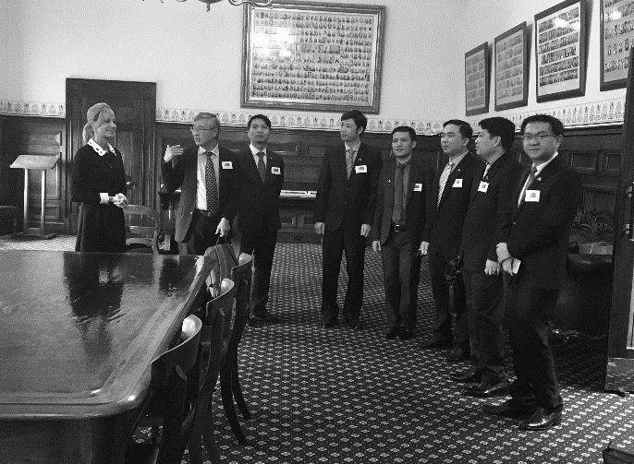
The Twenty-first Delegation from the Socialist Republic of Vietnam meeting with the Hon Elise Archer MP, Speaker of the Tasmanian House of Assembly

Eleventh Delegation from the Philippines
17 to 23 June 2017
Delegates
- The Hon Bernard Faustion M Dy
(Nationalist People’s Coalition) Delegation Leader
Mayor, Cauayan City
- The Hon Kristine Alexie Besas-Tutor (Liberal Party)
Board Member, Province of Bohol
- The Hon Samuel Nantes (Liberal Party)
Vice Governor, Quezon Province
- The Hon Alan Ranola (PDP - Laban)
City Councillor, Legazpi City
- The Hon Miguel Antonio Magale (BAKUD)
Board Member, Province of Cebu
- Mr Simon Javier Aquino Valencia
– Accompanying Officer
Political Officer, Office of Senator Paolo Benigno Aquino IV
- Ms Rachel Gillego
– Accompanying Officer
Chief Political Officer, Office of Senator Francis Pangilinan
The Eleventh Delegation from the Philippines travelled to Brisbane, Canberra and Sydney during the 7-day exchange.
Visit program
Brisbane, Queensland
- Former delegate dinner with Ms Christine Ong (Philippines 2017) and Mr Josh Millroy (Philippines 2017)
- Breakfast meeting with Mr Milton Dick MP, Federal Member for Oxley (South Korea 2005 and China 2014)
- Guided tour of Lone Pine Koala Sanctuary
- Brisbane River cruise
- Briefing by the Australian Electoral Commission including Mr Adrian McCabe, Director Operations, Mr Gordon Marshall, Operations Manager, Mr Cameron Stakes, Operations Manager and Mr Thomas Ryan, State Manager
- Courtesy call on Cr Angela Owen, Chair, Calamvale City Council
Canberra, Australian Capital Territory
- Briefing on the Liberal Party of Australia by Mr Bruce Edwards, International Secretary, Liberal Party of Australia (Japan 1992)
- Briefing on the Australian Labor Party by Mr Elias Hallaj, International Project Officer, Australian Labor Party (USA 2011)
- Briefing on The Nationals by Mr Ben Hindmarsh, Federal Director, The Nationals (USA 2000)
- Council luncheon hosted by the Hon Alan Ferguson, Chair, Australian Political Exchange Council. Guests included Council Members Senator Bridget McKenzie and the Hon Michael Danby MP, Mr Andrew Bragg representing the Liberal Party of Australia and Mr Paul Erickson representing the Australian Labor Party
- Observe Question Time in the Senate and the House of Representatives
- Courtesy call on Senator the Hon Stephen Parry, President of the Senate, Patron of the Council
- Courtesy call on the Hon Tony Smith MP, Speaker of the House of Representatives, Patron of the Council
- Briefing on the Australian Greens by Ms Claire O’Halloran, Policy Adviser, Office of Senator Di Natale
- Meeting with Mr Stephen Jones MP, Shadow Minister for Regional Affairs, Territories and Local Government, Federal Member for Whitlam (Japan 2011)
- Guided tour of Parliament House
- Luncheon hosted by the Embassy of the Philippines
Sydney, New South Wales
- Meeting with Ms Elaine Schofield, Acting Clerk-Assistant, Table and Assistant Serjeant-at-Arms, Legislative Assembly and Ms Rhia Victorino, Principal Council Officer, Legislative Council
- Guided tour of Parliament House
- Meeting with members of the Parliamentary Friends of Asia Pacific Group hosted by Mr Daryl Maguire MP, Chair, Ms Sonia Hornery MP, Mr Jonathan O’Dea MP and Mr Mark Coure MP
- Luncheon hosted by the Hon Shelley Hancock, Speaker of the Legislative Assembly and the Hon John Ajaka, President of the Legislative Council. Guests included the Hon David Clarke MLC, Mr Daryl Maguire MP, Mr Edmond Atalla MP, Mr Kevin Francis Conolly MP and Mr Steven Reynolds, Deputy Clerk of the Legislative Assembly and Mr Leslie Gonye, Deputy Clerk of the Legislative Assembly
- Observe Question Time in the Legislative Assembly and Legislative Council
- Briefing by Mr Spiro Kavadias, Manager, Tourism Sector Links, Australian Trade and Investment Commission and Ms Karla Juranek, Assistant Director, Services and Tourism Exports Section, Department of Foreign Affairs and Trade
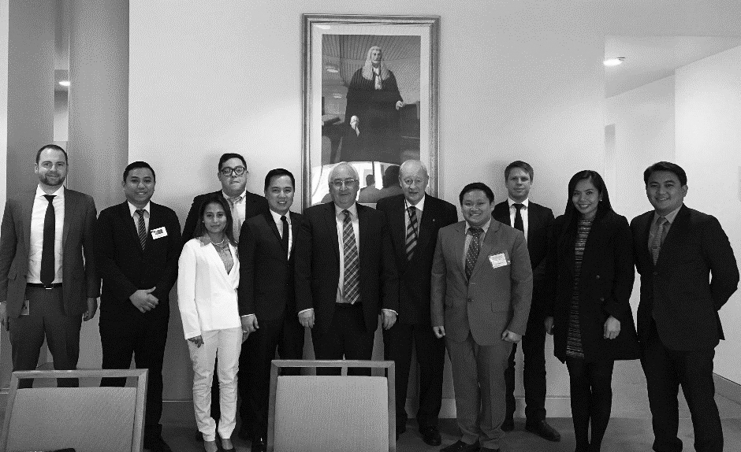
The Eleventh Delegation from the Philippines attending the Council luncheon hosted by the Hon Alan Ferguson
Individual study tours for 2016–2017
Five young Australians participated in individual study tours to India, the United States of America and the United Kingdom in 2016–2017. This included one attending the Asian Forum on Global Governance in India.
Mr Duncan Pegg MP (Australian Labor Party) – India
Asian Forum on Global Governance
State Member for Stretton, Queensland
16 to 25 October 2016
The 2016 Asian Forum on Global Governance (the forum) was the sixth of its kind, and took place in New Delhi, India from 16 October to 25 October 2016. The theme for the Forum was ‘NAVIGATING THE NEW NORMAL: Making Multilateralism Work with Multipolarity’. This year’s focus was how to implement strategies of multilateralism to overcome these challenges. There were 49 participants altogether from 30 different countries from a range of fields including government, NGOs and the private sector. The forum provided Mr Pegg with the opportunity to discuss, debate and challenge some of the complex global issues we are currently experiencing, with talks ranging from terrorism to climate change to managing growth.
The opportunity to attend the Asian Forum on Global Governance 2016 enabled me to gain valuable skills and have interesting experiences that I will be able to transfer to my work as a Member of the Queensland Parliament. The forum was an exceptional opportunity to learn and debate issues facing Australia in today’s rapidly changing world with experts and other young professionals around the world.
The speakers were excellent, the topics were stimulating and I would recommend this to any future young professional considering attending the forum. I want to thank the Observer Research Foundation, ZEIT–Stiftung Ebelin und Gerd Bucerius and the Australian Political Exchange Council for facilitating the opportunity to attend the forum as a delegate representing the Labor Party and Australia.
Mr Jeffrey McCormack (The Nationals) – United States of America
Regional Coordinator
17 October to 11 November 2016
Mr McCormack’s study tour aimed to understand how the new digital mediums for campaigning were being utilised in regional areas of the United States during the 2016 Presidential Election. Due to the vast geography of the USA, Mr McCormack decided to focus his study trip in the states of Virginia, Pennsylvania and New York. All with a mix of industry, agriculture and large metropolitan areas. Similarities could be drawn between the significant population imbalance of regional and metropolitan Australia.
The scale of the political industry in the USA makes for both higher economies of scale in the development of technology, but also leads to the increased cost in administering them. As such, it was interesting to see how, in true capitalist fashion, so much of the campaigning was taken out of the hands of on the ground volunteers and staff, and placed under the responsibility of professional contractors. Masters of email marketing campaigns, graphic designers, marketers, what we would consider spin‑doctors and an army of paid staff (who may have little or no affinity to the candidates or region), played a critical role. The continual electoral cycle of the United States supports this industry, which would be harder to support in the 5-year cycle of the United Kingdom or sporadic electoral cycle of Australia.
The three states visited during my study tour all had one major similarity, being that the large built up metropolitan areas were strong Democrat areas, while the regional areas were what we would consider in Australia to be swing seats, or more variable congressional districts.
Mr Samuel Drummond (Australian Greens) – United States of America
Staffer, Senator Janet Rice
10 to 19 November 2013
Mr Drummond’s study tour aimed to see what Australia can learn when it comes to disability activists and policymaking. On the brink of the 25th anniversary of the Disability Discrimination Act (DDA) in Australia, of particular relevance was why the Americans with Disabilities Act (ADA) appears to have more of an impact than the DDA. During his visit, Mr Drummond had meetings with activists, advocates, policy-makers, academics and people working on the ground in San Francisco, Washington D.C., Baltimore and New York City.
Perhaps the most important lesson of the tour was the distinction between the disability rights movement trying to emulate other movements and the disability rights movement working together with other movements.
The systemic indicators of disadvantage are most often realised when factors of disadvantage are combined. For example, a white man with a disability is much less likely to be homeless than a person of colour with a disability.
So if civil rights movements work together, they can more easily achieve common goals.
Mr Ben Coates (Australian Labor Party) – United States of America
National Organiser, the Australian Labor Party
23 October to 21 November 2016
Mr Coates’ study tour aimed to observe the final stages of the 2016 Presidential Election on the ground as it happened and to be around following the election to de-brief with campaign managers. His visit had a focus on the operational side of US elections, particularly on field organising, digital campaigning, third-party campaigning and data. During his trip, Mr Coates visited Dallas, Texas; Phoenix, Arizona; San Francisco, California; Las Vegas, Nevada; and Washington D.C.
The 2016 Presidential campaign was one of the most disruptive events in modern United States politics. Donald Trump, a controversial Republican outsider prevailed, despite the overwhelming majority of the Democratic and Republican establishment, along with the mainstream media, rejecting him as completely unelectable.
Donald Trump led a Republican Party into the campaign with almost no institutional support against Hillary Clinton, a candidate whose ascendancy to being President of the United States was widely regarded as a fait accompli against such an unconventional candidate. Clinton herself faced an unexpected challenge from Bernie Sanders who, like Donald Trump, was written-off early as an irrelevant candidate but became serious with his campaign and challenged the orthodoxy of establishment Democratic politics.
My visit wasn’t largely focused on the rise of Donald Trump and Bernie Sanders in American politics, however learning how two unorthodox candidates ran two very unorthodox campaigns certainly was one of the most interesting parts of my visit to the United States.
Mr Thomas Aubert (The Nationals) – United Kingdom
Deputy State Director, The Nationals, NSW
23 May to 16 June 2016
Mr Aubert’s study tour aimed to observe the United Kingdom General Election held in June 2016 and bring his experiences and key learnings back to Australia to influence his future work in campaigns. Over the course of his visit to the United Kingdom, Mr Aubert travelled to Conservative campaigns in the constituencies of Lancaster and Fleetwood, City of Chester, Bristol East, Dagenham East, and Hampstead and Kilburn. He also spent several days in Edinburgh with various local campaigns. Aside from the significant time he spent observing and participating in the usual mechanisms of key seat campaigning, he also took the opportunity to speak to prominent academics at Kings College, the University of Oxford and the University of Edinburgh.
The key observations and learnings that I have taken away from the study tour relate to the nature of local on-the-ground campaigning in the United Kingdom, the impact and nature of electoral regulation, social media use, data use and some key aspects to the national campaign and narrative.
Overall, the study tour was a wonderful and valuable experience to learn and observe an historic election as it unfolded. The fundamental lessons I have taken away from the 2017 General Election are simple. First, the electorate must be respected. That means engaging with them on a genuine basis, having conversations rather than slogans, and being relatable.
The second is that local campaigns matter. “Cookie-cutter” campaigns, where there is little differentiation in messaging and activity across electorates just is not good enough in the highly connected world in which we now live. Different communities have different needs and concerns and an election campaign must reflect this.
2017–2018
Outgoing Australian delegations for 2017–2018
In 2017–2018, the Council sponsored 33 young Australian political leaders in overseas exchange delegations to the United States of America, the People’s Republic of China, the Socialist Republic of Vietnam, Japan, the Republic of Korea, and the Philippines as follows:
Date | Delegation
15 to 27 July 2017 | Thirty-third Australian Delegation to the United States of America
16 to 22 September 2017 | Twenty-fifth Australian Delegation to the People’s Republic of China
4 to 10 November 2017 | Twenty-first Australian Delegation to the Socialist Republic of Vietnam
3 to 9 March 2018 | Twenty-sixth Australian Delegation to Japan
14 to 20 April 2018 | Sixth Australian Delegation to the Republic of Korea
12 to 18 May 2018 | Eleventh Australian Delegation to the Philippines

Thirty-third Australian Delegation to the United States of America
15 to 27 July 2017
Delegates
- Ms Melanie Gibbons MP
(Liberal Party of Australia)
Delegation Leader
State Member for Holsworthy, New South Wales
- Ms Sheridan Ingram
(Liberal Party of Australia)
Secretary, Liberal Women’s Council WA
- Ms Laura Gowdie
(Australian Labor Party)
Commonwealth Games Project Team, Queensland Rail
- Ms Gabrielle Williams MP
(Australian Labor Party)
State Member for Dandenong, Victoria
- The Hon Martin Aldridge MLC
(The Nationals)
State Member for the Agricultural Region, WA
- Ms Nadine Walker (Australian Greens)
Media Adviser, Office of Senator Rachel Siewert
- Ms Suzy Domitrovic
– Council Representative
Executive Officer, Australian Political Exchange Council
The Thirty-third Australian Delegation to the United States of America travelled to Washington D.C., Newark, Morristown, New York City, Colorado Springs and Denver during the 13-day exchange hosted by the American Council of Young Political Leaders.
Visit program
Washington D.C.
- Meeting with Mr Skyler Minke, Program Officer, American Council of Young Political Leaders
- Tour of Washington monuments including Jefferson Memorial, Martin Luther King Jr Memorial and the Vietnam War Memorial
- Visit to the Smithsonian Museums including National Museum of American History, National Gallery of Art, National Museum of Natural History, National Museum of African Art and the Hirshhorn Museum
- Meeting with Ms Libby Rosembaum, Chief Executive Officer, American Council of Young Political Leaders
- Meeting with Ms Shiela Shamber, Program Officer, Bureau of Educational and Cultural Affairs, US Department of State
- Luncheon hosted by Mr Damon Porter, Director of State Government Affairs, Global Automakers
- Meeting with Ms Kate Black, Chief of Staff, EMILY’s List
- Meeting with His Excellency Peter Heyward, Chief Congressional Liaison, Embassy of Australia
- Meeting with Ms Samantha Davis, Founder, Black Swan Academy
- Luncheon hosted by Mr Chris Toth, Deputy Director, National Association of Attorney’s General
- Meeting with Ms Allison Cunningham, Director, Federal Government Affairs, NGV America. Also attending Ms Kim Jaworski, Director of Government Relations, National Association of Manufacturers
- Tour of US Capitol building
- Meeting with Mr Andrew Dugan, Political Analyst, The Gallup Organisation
Newark, New Jersey
- Meeting with Mr Jorge Santos, Vice President, Newark Community Economic Development Corporation
- Meeting with the Hon Ugo Nwaokoro, Deputy Mayor, City of Newark
- Meeting with Mr George Helmy, State Director, Office of the Honorable Cory Booker, US Senator
Morristown, New Jersey
- Tour of Nokia Bell Labs
- Meeting and luncheon with Mr Peter Palmer, Chairman, New Jersey Transportation Planning Authority
- Roundtable discussion with the Hon Christine Whitman, Former Governor, State of New Jersey
- Meeting with Mr Kurt Alstede, Vice President, Highlands Council
- Dinner hosted by Mr Mike Inganamort, Managing Principal, ASG Advisors
- Meeting with the Hon Ann Grossi, County Clerk, Morris County. Also in attendance Ms Laura Roberts, Elections Supervisor, Morris County and Mr John Wojtaszek, Deputy Clerk, Morris County Clerk’s Office
- Meeting with the Hon James Gannon, Sheriff, Morris County
- Working luncheon hosted by Atlantic Health
- Meeting with Mr Hans Dekker, President, Community Foundation of New Jersey
- Attend Morris County 4-H Agricultural Fair
- Meeting with Ms Erica Jedynak, New Jersey State Director, Americans for Prosperity
New York City
- Visit to Ellis Island and the Statue of Liberty
- Dinner hosted by Ms Leslie Fox, Chief of Staff, International Council of Shopping Centers
Colorado Springs, Colorado
- Tour of the Garden of the Gods
- Reception hosted by Mr Mike Buth, Vice President El Pomar Foundation
- Meeting the Hon John Suthers, Mayor, City of Colorado Springs. Also in attendance the Hon Merv Bennett, Member, Colorado Springs City Council
- Luncheon hosted by Mr Frank Caris, President and CEO, dpiX. Also in attendance Mr Kyle Hybl, Chief Operations Officer, El Pomar Foundation
- Meeting with Ms Electra Johnson, Chair, El Paso County Democrats
- Meeting with the Hon Mark Waller, County Commissioner, El Paso County
- Dinner hosted by Mr Trevor Diedorff, Chair, El Paso County Republicans
- Meeting with the Hon Will Bain, Chief Judge, El Paso County
- Court observation
- Meeting with the Root 9B National Cybersecurity Center
- Meeting and luncheon hosted by the El Paso County Clerk and Recorder’s Office
Denver, Colorado
- Meeting with the Hon Suzanne Staiert, Deputy Secretary of State, State of Colorado
- Meeting with representatives of the St Francis Center
- Courtesy call on the Hon Crisanta Duran, Speaker of the House, Colorado House of Representatives
- Meeting with the Hon Michael Hancock, Mayor, City of Denver
- Meeting with Ms Lilly Marks, Vice President for Health Affairs, University of Colorado
- Tour of the University of Colorado Health/Anschutz Medical Campus
- Visit to Denver Art Museum
- Tour of Colorado State Capital
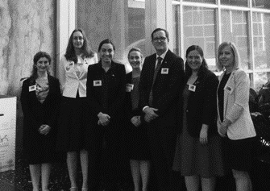
The Thirty-third Australian Delegation to the United States at the US State Department
Twenty-fifth Australian Delegation to the People’s Republic of China
16 to 22 September 2017
Delegates
- Mrs Hollie Hughes
(Liberal Party of Australia)
Delegation Leader
Country Vice-President, Liberal Party of Australia, NSW Division
- Mr Peter Hosking
(Liberal Party of Australia)
Finance Director, Liberal Party of Australia, ACT Division
- Ms Jessica Malnersic
(Australian Labor Party)
Organiser, Liquor and Hospitality Division, United Voice
- Ms Lucy Morrison
(Australian Labor Party)
Field Director, WA Labor
- Mr James Sullivan
(Australian Labor Party)
Chief of Staff, Office of Queensland Attorney General and Minister for Justice
- Ms Suzy Domitrovic
– Council Representative Executive Officer, Australian Political Exchange Council
Executive Officer, Australian Political Exchange Council
The Twenty-fifth Australian Delegation to the People’s Republic of China travelled to Beijing, Wuhan and Shanghai during the 7-day exchange hosted by the All-China Youth Federation.
Visit program
Beijing
- Welcome by Ms Liu Xiaoqi, Deputy Director, International Department, All-China Youth Federation
- Courtesy call on Ms Wu Zeng, Director, National Law Office, Legislative Affairs Commission. Also in attendance, Mr Chen Yunxin, Director, Criminal Law Office
- Courtesy call on Mr Fang Hao, Director, 5th Office, Department of Americas and Oceanian Affairs, Ministry of Commerce. Also in attendance Mr Wu Wei, Deputy Secretary General, All-China Youth Federation
- Meeting with Ms Wang Honyan, Vice President, All-China Youth Federation. Also in attendance Mr Wu Wei, Deputy Secretary General, All-China Youth Federation
- Welcome dinner hosted by Mr Wu Wei, Deputy Secretary General, All‑China Youth Federation
- Visit to the Great Wall
- Visit to the Palace Museum
- Visit to Silk Street markets
- Visit to Tian’anmen Square
Wuhan
- Welcome by Ms Cheng Huifang, Deputy Secretary General, Hubei Youth Federation
- Meeting with Ms Chen Lulu, Secretary, Communist Youth League, Wuchung District and Mr Yi Zhenbo, Director, Nanhu Street Office
- Visit to Community Innovation Center, Nanhu Street, Wuchung District
- Visit to Hubei Museum
- Welcome dinner hosted by Mr Zhang Shu, Vice President, Hubei Youth Federation
- Visit to Zingguang Village
- Meeting with Ms Zuo Shaoping, Secretary, Party Committee, China Star Group. Also in attendance Mr Tian Linsai, Deputy Secretary, Party Committee, Caiden Economic Development Zone Management Committee
- Visit to Yellow Crane Tower
- Visit and tour of Huazhong Agricultural University hosted by Mr Zhang Yongjun, Mr Liu Sanbao and Ms Peng Xiaochuan, Secretary and vice Secretaries, Communist Youth League Committee of Huazhong Agricultural University
Shanghai
- Welcome by Mr Chen Hangbin, Officer, Cooperation and Exchange Department, Shanghai Youth Federation
- Visit to Caohejing Hi-Tech Park hosted by Mr Zhang Xiuyun, Secretary, Communist Youth League, Caohejong New Technology Development Zone
- Visit to Oriental Pearl TV Tower and the Shanghai Urban History Development Exhibit
- Visit and tour of Fudan University Campus hosted by Ms Sun Bingxin, Vice Secretary, Communist Youth League Committee, Fudan University
- Discussions with teachers and students of Fudan University hosted by Prof Guo Dingping, Director, World Political Parties, Research Center, Fudan University
- Visit to Yu Garden

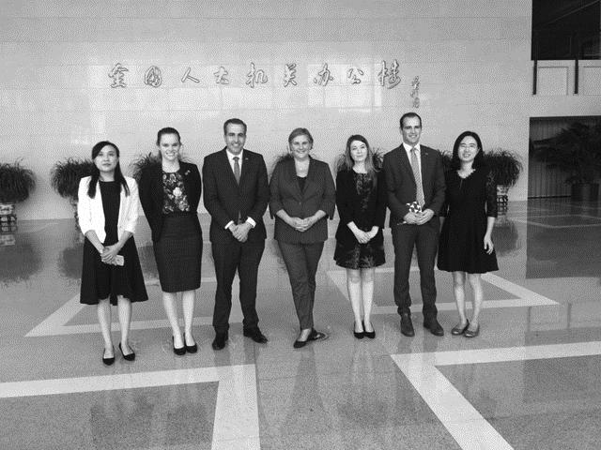
The Twenty-fifth Australian Delegation to the People’s Republic of China visiting the National People’s Congress
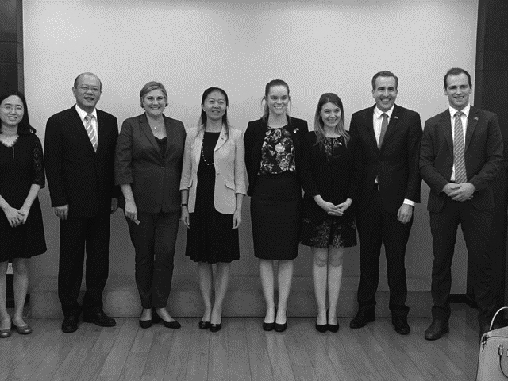
The Twenty-fifth Australian Delegation to the People’s Republic of China meeting with Ms Wang Honyan, Vice President, and Mr Wu Wei, Deputy Secretary General, All-China Youth Federation

Twenty-first Australian Delegation to the Socialist Republic of Vietnam
4 to 10 November 2017
Delegates
- Mrs Angie Drake
(Australian Labor Party)
Delegation Leader
Senior Adviser, Office of Yvette Berry, MLA
- Mr Jake Araullo
(Australian Labor Party)
Field Organiser, Queensland Division
- Ms Cecilia Burgman
(Australian Labor Party)
Party Member, Australian Labor Party
- Mr Christian Hayes
(Liberal Party of Australia)
Adviser, Office of the Hon Peter Dutton MP
- Mr Jackson Whiteley
(Liberal Party of Australia)
Campaign Strategist, Victorian Division
- Ms Rebecca Treloar (The Nationals)
Electoral Officer, Office of Mr Andrew Broad MP
- Ms Suzy Domitrovic
– Council Representative
Executive Officer, Australian Political Exchange Council
The Twenty-first Australian Delegation to the Socialist Republic of Vietnam travelled to Hanoi and Ho Chi Minh City and Shanghai during the 7-day exchange hosted by the Youth International Cooperation Development Centre.
Visit program
Hanoi
- Meeting with Quang Ninh province’s Youth Union
- Welcome luncheon hosted by Quang Ninh province’s Youth Union
- Meeting with Leaders and Representatives of the Commission for Foreign Relations, Party Central Committee
- Meeting with Leaders and Representatives of the Central Committee, Ho Chi Minh Communist Youth Union
- Welcome luncheon hosted by the Ho Chi Minh Communist Youth Union
- Meeting with Leaders and Representatives of the External Affairs Committee, National Assembly
- Meeting with Leaders and Representatives of the Ministry for Agriculture and Rural Development
- Meeting with Leaders and Representatives of the Ministry of Information and Communications
- Meeting with Leaders and Representatives of the Vietnam Women’s Union
- Meeting with Leaders and Representatives of the Vietnam General Confederation of Labour
- Meeting with Leaders and Representatives of the Ministry of Public Security
- Watch Water Puppet Show
- Visit to Ha Long Bay
Ho Chi Minh City
- Meeting with Leaders and Representatives of the Ho Chi Minh City’s Youth Union
- Courtesy call on the Leader of Ho Chi Minh City
- Welcome luncheon hosted by Ho Chi Minh City Youth Union
- Meeting with Leaders and Representatives of the Thanh Nien newspaper
- Visit to War Remnants Museum and Reunification Palace
- Visit to Ho Chi Minh Memorial complex and Ho Chi Minh Museum
- Visit to Temple of Literature
- Visit to Museum of Ethnology
- Visit to Cu Chi Tunnels
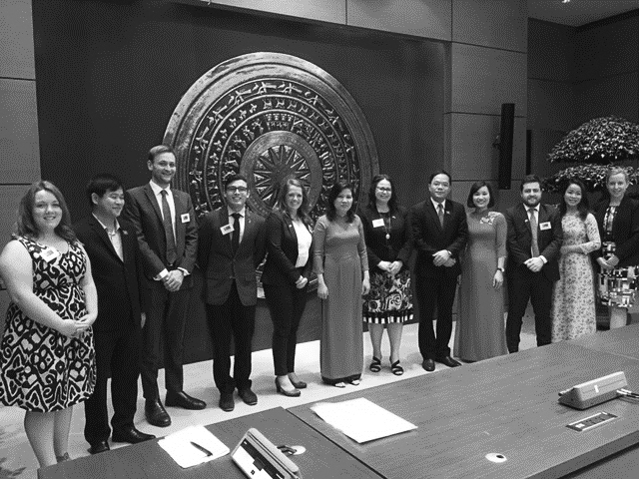
The Twenty-first Australian Delegation to the Socialist Republic of Vietnam
Twenty-sixth Australian Delegation to Japan
3 to 9 March 2018
Delegates
- Mr Timothy (Tim) Wilson MP
(Liberal Party of Australia)
Delegation Leader
Federal Member for Goldstein
- Mr Andrew Wall MLA
(Liberal Party of Australia)
Member for the ACT Legislative Assembly
- Mr Julian Hill MP
(Australian Labor Party)
Federal Member for Bruce
- Ms Madeleine King MP
(Liberal Party of Australia)
Federal Member for Brand
- Ms Suzy Domitrovic
– Council Representative
Executive Officer, Australian Political Exchange Council
The Twenty-sixth Australian Delegation to Japan travelled to Hiroshima, Kyoto, Nagoya and Tokyo during the 7-day exchange hosted by the Ministry of Foreign Affairs.
Visit program
Hiroshima
- Guided tour of Hiroshima Peace Memorial Museum by Mr Shuichi Kato, Deputy Director, Hiroshima Peace Memorial Museum
- Placing of wreath at cenotaph
- Talk by Ms Keiko Ogura, atomic bomb survivor
- Meeting with Mr Kazumi Matsui, Mayor, Hiroshima City
- Visit to Miyajima
Kyoto
- Luncheon hosted by Mr Shogo Arai, Governor of Nara Prefecture
- Visit to Todaiji Temple
- Meeting with Mr Motonobu Nakagawa, Mayor, Nara City
- Visit to Yakushiji Temple
- Meeting with Mr Kunio Iwata, Chairman, Nara Prefecture
Nagoya
- Meeting with Mr Harumi Nakano, Chairman and Mr Osamu Mineno, Vice Chairman, Aichi Prefecture Assembly
- Visit Toyota Plant at Takaoka
- Visit Toyota Museum at Kaikan
- Meeting with Mr Hideaki Omura, Governor, Aichi Prefecture
Tokyo
- Luncheon hosted by Mr Kazuyuki Nakane, State Minister for Foreign Affairs
- Meeting with Ms Noriko Miyagawa, Parliamentary Vice Minister for Education, Culture, Sports, Science and Technology
- Meeting with members of the New Komei Party including Mr Mitsunari Okamoto, Parliamentary Vice-Minister for Foreign Affairs, Mr Masakazu Hamachi, Member of the House of Representatives, Mr Shinichi Isa, Member of the House of Representatives, Ms Toshiko Takeya, Member of the House of Councillors and Ms Hiromi Takase, Member of the House of Councillors
- Dinner hosted by Mr Kenji Kanasugi, Director General, Asian and Oceania Affairs Bureau, Ministry of Foreign Affairs
- Meeting with Mr Maskai Ogushi, Parliamentary Vice Minister for Economy, Trade and Industry
- Dinner hosted by Japanese Diet Members including Ms Rui Matsukawa, Member of the House of Councillors, Mr Shigeharu Aoyama, Member of the House of Councillors, Mr Kei Sato, Member of the House of Councillors, Ms Kimi Onoda, Member of the House of Councillors and Mr Takashi Koyari, Member of the House of Councillors
- Visit to Kawasaki Heavy Industry Plant
- Meeting with Mr Keitaro Ohno, parliamentary Vice Minister for Defence
- Luncheon hosted by Japanese Diet Members Mr Ichiro Aizawa, President of the League, Member of House of Representatives and Mr Taku Otsuka, Member of the House of Representatives
- Luncheon hosted by His Excellency the Hon Richard Court AC, Ambassador for Australia
- Visit to Meiji Shrine
- Visit to Terra-Drone
- Tour of Tokyo
- Visit to NEC Corporation
- Visit to National Museum of Modern Art and Miraikan
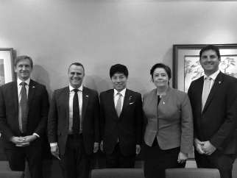
The Twenty-sixth Australian Delegation to Japan meeting with Mr Kazuyuki Nakane MP, State Minister for Foreign Affairs
Sixth Australian Delegation to the Republic of Korea
14 to 20 April 2018
Delegates
- Mr Jon Krause MP
(Liberal National Party)
Delegation Leader
State Member for Scenic Rim
- Mr Luke Edmunds
(Australian Labor Party)
Office of the Leader of the Opposition, Ms Rebecca White MP
- Ms Isabelle Gillespie (The Nationals)
Digital Communications Manager, NSW Nationals
- Ms Sheena Watts
(Australian Labor Party)
Deputy Convenor, National Indigenous Labor Network
- Ms Gemma Whiting
(Liberal Party of Australia)
Government Relations Manager, AUSTAL
- Mr Liam Moloney
(Australian Labor Party)
Electorate Officer, Office of Lizzie Blandthorn MP
- Ms Suzy Domitrovic
– Council Representative
Executive Officer, Australian Political Exchange Council
The Sixth Australian Delegation to the Republic of Korea travelled to Seoul and Suwon during the 7-day exchange hosted by The Korea Foundation.
Visit program
Seoul
- Visit to the War Memorial of Korea
- Visit to Gyeongbokgung Palace
- Visit to Samcheong-dong area
- Visit to National Museum of Korean Contemporary History
- Temple Stay at Jingwansa Temple
- Meeting with Mr Geunhyung Lee, CEO of Wingkorea Consulting
- Visit to and luncheon hosted by Gangdong District Council, Vice President Ms Myeonghwa Song, and Mr Minho Do.
- Visit to the Korea Foundation
- Dinner hosted by Mr Jungsok Song, Director-General of International Cooperation Bureau, Korea Foundation
- Briefing from the Australian Chamber of Commerce in Korea
- Luncheon hosted by Mr Yucheol Won, Chairman of the Australia-Korea Parliamentarian Friendship Association
- Meeting with His Excellency Mr James Choi, Australian Ambassador to the Republic of Korea
- Attended a NANTA show, a traditional South Korean comedy show
- Briefing and tour of the National Assembly of Korea
- Luncheon hosted by Mr Yongjin Park, Member of the National Assembly
- Briefing from the Korea Dairy Committee
- Visit to Lotte World Tower
- Visit to Joint Security Area, Korean Demilitarized Zone
Suwon
- Visit to Samsung Innovation Museum
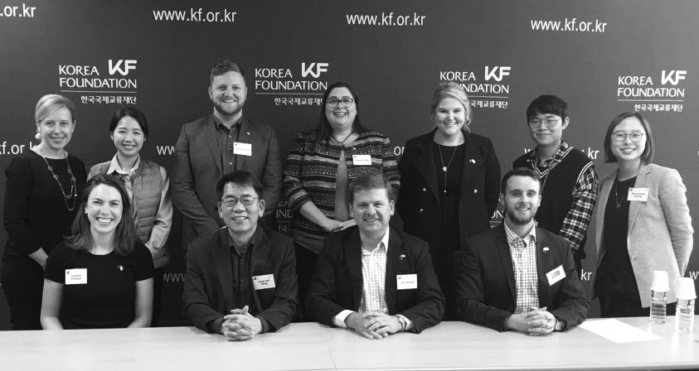
The Sixth Australian Delegation to the Republic of Korea meeting with staff of the Korea Foundation
Eleventh Australian Delegation to the Philippines
12 to 18 May 2018
Delegates
- Ms Imogen Sturni
(Australian Labor Party)
Delegation Leader
Organiser, Australian Services Union
- Mr Wade McInerney
(Liberal Party of Australia)
Electorate Manager, Office of Senator the Hon Concetta Fierravanti-Wells
- Ms Clare Burns
(Australian Labor Party)
Political Organiser, Victorian Trades Hall Council
- Mrs Andrea Hoy
(Liberal Party of Australia)
Electorate Officer, Office of the Hon Michael Sukkar MP
- Mr Samuel Edwards (The Nationals)
Media Advisor, Office of the Hon Michael McCormack MP
- Mr Ben Coates
(Australian Labor Party)
Senior Advisor, Office of the Hon Annastacia Palaszczuk MP
- Ms Suzy Domitrovic
– Council Representative
Executive Officer, Australian Political Exchange Council
The Eleventh Australian Delegation to the Philippines travelled to Manila, Cavite, Quezon City, and Bohol during the 7-day exchange hosted by the Philippine Center of Young Leaders in Governance.
Visit program
Manila
- Dinner hosted by Mr Rollie Fabi, Director of Philippine Center of Young Leaders in Governance
- Dinner hosted by Mr Zenen Renan B. Dalisay, former NFA Administrator
- Meeting with the Hon Senator Paolo Benigno Aquino IV
- Meeting with the Hon Senator Francis Pangilinan
Quezon City
- Briefing by the Australian Embassy to the Philippines
- Meeting with the Hon Charisse Marie Abalos-Vargas, Councillor of Mandaluyong City
- Meeting with Attorney Herminio Bagro III, Professor, University of the Philippines College of Law
- Meeting with Attorney Angelo A. Jimenez, Member, Board of Regents, University of the Philippines
Cavite
- Meeting with Councillor Kerby Salazar
Bohol
- Meeting with Provincial Administrator Alfonso Damalerio II
- Visit to Loboc River and Chocolate Hills
- Meeting with the Hon Antonio Jumawid, Mayor of Batuan
- Dinner hosted by the Hon Kristine Alexie B. Tutor, Board Member of the 3rd District of Bohol
- Meeting with elected representatives from Valencia
- Visit to the Can Umantad Falls and the Candijay Rice Terraces
- Dinner hosted at the Bohol Bee Farm
- Visit to Tarsier Sanctuary
- Meeting with Governor Edgar M. Chatto
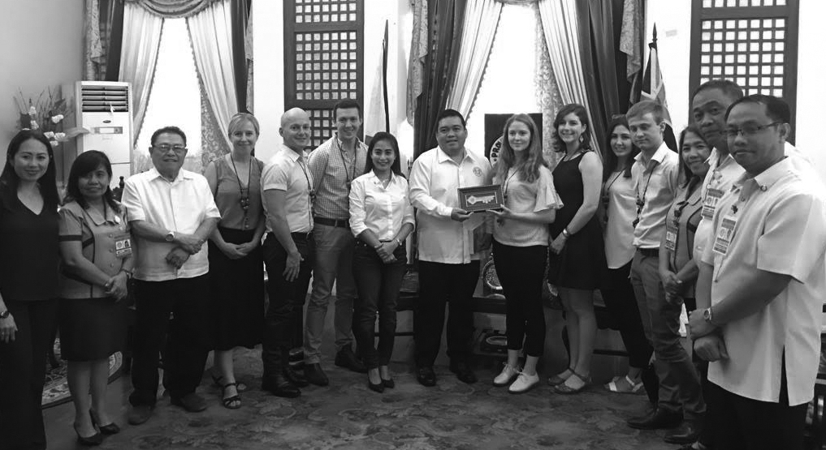
The Eleventh Australian Delegation to the Philippines
Incoming delegations to Australia for 2017–2018
In 2017–2018, the Council hosted 38 participants on delegations from its exchange partners as follows:
Date | Delegation
3 to 9 August 2017 | Sixteenth Delegation from Japan
5 to 11 August 2017 | Sixth Delegation from the Republic of Korea
9 to 21 September 2017 | Thirty-fourth Delegation from the United States of America
17 to 20 October 2017 | Twenty-fifth Delegation from the People’s Republic of China
24 February to 2 March 2018 | Twelfth Delegation from the Philippines
27 May to 1 June 2018 | Twelfth Delegation from New Zealand

Sixteenth Delegation from Japan
3 to 9 August 2017
Delegates
- Mr Taskashi Uto
(Liberal Democratic Party)
Delegation Leader
Member of the House of Councillors
- Ms Toshiko Takeya (Komeito)
Member of the House of Councillors
- Mr Hiroyuki Kinishi (Democratic Party)
Member of the House of Councillors
- Mr Go Shinohara (Democratic Party)
Member of the House of Representatives
- Mr Shuichi Yamashita
– Accompanying Officer Secretary, Office of Dr Kiyohiko Yoyama, Ph.D, Member of the House of Councillors
The Sixteenth Delegation from Japan travelled to Sydney, Brisbane and Canberra during the 7-day exchange.
Visit program
Sydney, New South Wales
- Briefing by Ms Cheryl Samuels, Deputy Serjeant-at-Arms, Parliament of New South Wales
- Meeting with Members of the Parliamentary Friends of Asia-Pacific including Mr Daryl Maguire MP, Member for Wagga Wagga and Chair, Asia Pacific Friendship Group, Mr Jonathan O’Dea MP, Member for Davidson, Parliamentary Secretary, Mr Glenn Brookes MP, Member for East Hills, Ms Sonia Hornery MP, Member for Wallsend, Dr Geoff Lee MP, Member for Parramatta, Parliamentary Secretary and the Hon Shaoquett Moselmane MLC, Opposition Whip in the Legislative Council
- Luncheon hosted by the Presiding Officers the Hon John Ajaka MLC, President of the Legislative Council and the Hon Shelley Hancock MP, Speaker of the Legislative Assembly. Guests included the Hon Natasha Maclaren-Jones MLC, Government Whip in the Legislative Council, Mr Daryl Maguire MP, Member for Wagga Wagga, Mr John Sidoti MP, Member for Drummoyne, Parliamentary Secretary, Ms Nicole Nasr, Chief of Staff to The President, Ms Helen Minnican, Clerk of the Legislative Assembly and Mr Steven Reynolds, Deputy Clerk of the Legislative Assembly
- Observe Question Time in the Legislative Assembly
- Meeting with representatives from the NSW Farmers’ Federation including Ms Kathleen Curry, Director, Public Affairs, Mr Ash Salardini, Chief Economist, Ms Dominca Hannaford, Policy Adviser, Environment and Ms Kiara Drinan, Policy Adviser, Livestock
- Attend performance at the Sydney Opera House accompanied by Mr Keizo Takewaka, Consul General, Sydney Consulate General of Japan and Mr Koichi Tsuchida, Political Consul
- Dinner hosted by Mr Keizo Takewaka, Consul General, Sydney Consulate General of Japan and Mr Koichi Tsuchida, Political Consul
- Briefing by representatives from the Australian Electoral Commission including Mr Warwick Austin, Acting State Manager, NSW State Office and Ms Kathy Mitchell, National Director Industrial and Commercial Elections
- Tour of Sydney Town Hall
- Courtesy call on Cr Robert Kok, Member, City of Sydney Council, accompanied by Mr Keizo Takewaka, Consul General, Sydney Consulate General of Japan
- Sydney Harbour luncheon cruise
Brisbane, Queensland
- Dinner hosted by Mr John Krause MP, Shadow Minister for Tourism, Sports and Racing, State Member for Beaudesert
- Guided tour of Witches Falls Winery by Mr Peter Jones, Vineyard Operator
- Guided tour of Fortitude Brewing Company
- Guided tour of Witches Chase Cheese Factory by Mr Michael Mills, Cheesemaker
- Guided tour of Heritage Wines by Mr Peter and Ms Karen Rae, Vineyard Owners
- Visit to Hang-Gliders Lookout, Tamborine Mountain
- Dinner hosted by Ms Keiko Yanai, Consul General, Brisbane Consulate General of Japan. Also attending Mr Norihiko Nakajima, Consul and Mr Daisuke Miyake, Vice Consul
- Guided tour of the Lone Pine Koala Sanctuary
- Former delegate luncheon hosted by Ms Terri Butler MP, Federal Member for Griffith, (Japan 2015)
Canberra, Australian Capital Territory
- Briefing on the Liberal Party of Australia by Mr Bruce Edwards, International Secretary, Liberal Party of Australia (Japan 1992)
- Briefing on the Australian Labor Party by Mr Sebastian Zwalf, Assistant National Secretary, Australian Labor Party (UK 2013)
- Briefing on The Nationals by Mr Ben Hindmarsh, Federal Director, The Nationals
- Council luncheon. Guests included Mr Andrew Laming MP, Mr Elias Hallaj, representing the Australian Labor Party and Mr Bruce Edwards representing the Liberal Party of Australia
- Observe Question Time in the House of Representatives and the Senate
- Courtesy call on Senator the Hon Stephen Perry, President of the Senate, Patron of the Council
- Courtesy call on the Hon Tony Smith MP, Speaker of the House of Representatives, Patron of the Council
- Dinner hosted by Mr Brendan Smyth, Commissioner of International Engagement, Australian Capital Territory
- Guided tour of the Australian War Memorial by Ms Di Mitchell
- Luncheon hosted by His Excellency the Hon Sumio Kuakas, Ambassador Extraordinary and Plenipotentiary to Australia. Other guests included Minister Takashi Katae, Minister Tadayuki Miyashita and First Secretary Mahito Yamamoto
- Meeting with Senator the Hon Zed Seselja, Assistant Minister for Social Services and Multicultural Affairs, Senator for the Australian Capital Territory (Japan 2014)
- Meeting with Ms Gai Brodtmann MP, Shadow Assistant Minister for Cyber Security and Defence Personnel, Member for Canberra
- Former delegate dinner including Ms Emma McBride MP, Federal Member for Dobell (Japan 2017), Ms Justine Keay MP, Federal Member for Braddon (Japan 2017), Mr Luke Howarth MP, Federal Member for Petrie (Japan 2017), Mr Ross Hart MP, Federal Member for Bass, Mr Andrew Laming MP, Federal Member for Bowman and Mr Rowan Ramsey MP, Federal Member for Grey
- Briefing on the Australian Greens by Senator Janet Rice, Senator for Victoria, Council Member
- Tour of Parliament House
- Courtesy call on Mr Luke Howarth MP, Federal Member for Petrie (Japan 2017)
- Briefing by the Department of Foreign Affairs and Trade. Attendees included Mr Graham Fletcher, First Assistant Secretary, North Asia Branch, Ms Nancy Gordon, Assistant Secretary, North East Asia Branch, Mr Sam Beever, Director, Japan Section, Ms Lucy Marshall, Japan Section, Ms Liza Watts, Japan Section and Mr Francis Wong, Japan Section
- Morning tea hosted by the Hon Warren Entsch MP, Chairman, the Japan-Australia Parliamentary Friendship Group
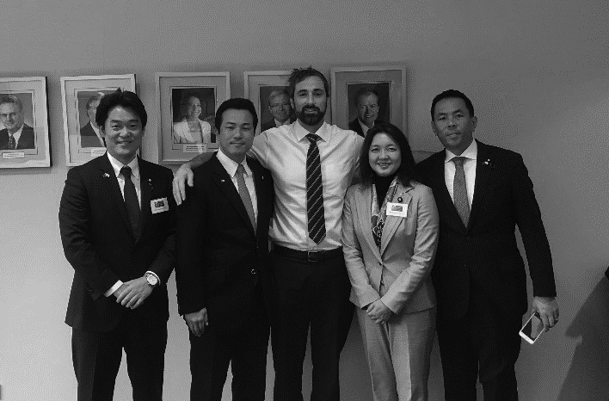
The Sixteenth Delegation from Japan meeting with Mr Sebastian Zwalf, Assistant National Secretary, Australian Labor Party
Sixth Delegation from the Republic of Korea
5 to 11 August 2017
Delegates
- The Hon Shinhwan Oh
(The Bareun Party) Delegation Leader
Member of the 20th National Assembly
- Mr Minho Do (Democratic Party)
Director of Education and Training, Policy and Planning Office,
Seoul Metropolitan City party of the Democratic Party
- The Hon Yong-jin Park (Democratic Party)
Member of the 20th National Assembly
- Ms Myunghwa Song (Democratic Party)
Vice Chairman, the Gangdong-gu Council of Seoul Metropolitan City
- The Hon Kumju Son (The People’s Party)
Member of the 20th National Assembly
- The Hon Sung-won Kim (Liberty Korea Party)
Member of the 20th National Assembly
- Mr Changshik Yoon
– Accompanying Officer
The Korea Foundation
The Sixth Delegation from the Republic of Korea travelled to Sydney, Brisbane and Canberra during the 7-day exchange.
Visit program
Sydney, New South Wales
- Dinner hosted by Mr Sang Soo Yoon, Consul General, Sydney Consulate General of the Republic of Korea
- Breakfast with the koalas at Sydney Zoo
- Guided tour of Sydney Opera House
- Visit to Mrs Macquarie’s Point
- Aboriginal cultural tour
- Sydney Harbour luncheon cruise
Brisbane, Queensland
- Meeting with Mr Jarrod Bleijie MP, Shadow Minister for Employment, Industrial Relations, Skills and Training and Shadow Minister for Fair Trading
- Meeting with the Hon Graham Quirk, Lord Mayor of Brisbane
- Tour of Brisbane City Hall
- Meeting with Mr Mitchell Redford, Manager, Strategy and Insights, Brisbane City Council
- Meeting with Mr Mitchell Collier, President, Young Liberal National Party and Mr Roderick Schneider, Business Manager, Tanda
- Former delegate dinner. Guests included Ms Nikki Boyd (Korea 2016), Mr Mitchell Redford (Korea 2016), Ms Imogen Beynon (Korea 2016), Mr Roderick Schneider (Korea 2014) and Mr Henry Pike (Korea 2014)
- Guided tour of Queensland Parliament
- Briefing by Mr Brett Nutley, Indigenous Liaison Officer and Mr Zac Dadic, Team Leader, Communications, Queensland Parliament
- Luncheon hosted by the Hon Peter Wellington, Speaker of the Legislative Assembly, State Member for Nicklin and Ms Dianne (Di) Farmer, Deputy Speaker of the Legislative Assembly, State Member for Bulimba
- Visit to Southbank Parklands
- Visit to Mount Coot-Tha Lookout
Canberra, Australian Capital Territory
- Dinner hosted by His Excellency Kyoung-ha Woo, Ambassador of the Republic of Korea. Guests included Ms Elizabeth Lee MLA, Assistant Speaker, Shadow Minister for Disability and Shadow Minister for the Environment, Member for Kurrajong, Australian Capital Territory
- Meeting with Mr Milton Dick MP, Member for Oxley (South Korea 2005 and China 2014)
- Briefing on the Liberal Party of Australia by Mr Andrew Hirst, Federal Director and Mr Bruce Edwards, International Secretary, Liberal Party of Australia (Japan 1992)
- Briefing on the Australian Labor Party by Mr Elias Hallaj, International Officer, Australian Labor Party
- Briefing on The Nationals by Mr Jeff McCormack, Assistant Adviser and Ms Elizabeth Mitchell, Assistant Adviser, Office of the Member and Senator Support Unit
- Council luncheon hosted by the Hon Alan Ferguson, Chair, Australian Political Exchange Council. Guests included Senator Janet Rice, Council Member, Mr Elias Hallaj representing the Australian Labor Party and Mr Bruce Edwards representing the Liberal Party of Australia
- Observe Question Time in the House of Representatives and the Senate
- Courtesy call on Mr John Haydon, Advisor, Office of Senator the Hon Stephen Parry, President of the Senate, Patron of the Council
- Courtesy call on the Hon Tony Smith MP, Speaker of the House of Representatives, Patron of the Council
- Courtesy call on the Hon Scott Buchholz, Federal Member for Wright (Korea 2014)
- Luncheon hosted by Mr Brendan Smyth,
Commissioner of International Engagement, Australian Capital Territory and Mr Martin Greenwood, Senior Adviser, Office of the Chief Minister (Korea 2016). Guests included Mr Chris Steel MLA, Australian Labor Party Caucus Secretary, Member for Murrumbidgee, Australian Capital Territory and Ms Elizabeth Lee MLA, Assistant Speaker, Shadow Minister for Disability and Shadow Minister for the Environment, Member for Kurrajong, Australian Capital Territory
- Briefing on the Australian Electoral Commission by Ms Sarah Gowty, Director, International Services, Mr Jiv Sekhon, Assistant Director, International Services and Ms Bernadette O’Meara, Assistant Commissioner, Education and Communications Branch
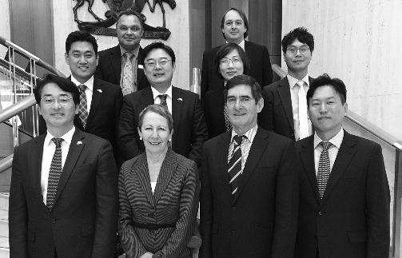
The Sixth Delegation from the Republic of Korea meeting with Speaker the Hon Peter Wellington, the Hon Dianne Farmer MP, Mr Brett Nutley and Mr Zac Dadic
Thirty-fourth Delegation from the United States of America
9 to 21 September 2017
Delegates
- The Hon Sarah Benator (Democrat)
Treasurer, Coconino County, Arizona
- Mr Ryan Boyce (Republican)
Legal and Communications Counsel, Supreme Court of North Carolina
- Ms Leah Garner (Republican)
Director of Governmental Affairs and Advocacy, Business Council of Alabama
- Mr Ivan Jaime (Independent)
Director of Public Affairs, Texas and New Mexico, Union Pacific
- Mr Michael Jacobson (Independent)
Director of Industrial Relations and Political Engagement, US Travel Association
- Ms Jessica Post (Democrat)
Executive Director, Democratic Legislative Campaign Committee
- The Hon Ryan Williams
– Accompanying Officer
Member, Tennessee House of Representatives
The Thirty-fourth Delegation from the United States of America travelled to Sydney, Canberra, Perth and Melbourne during the 13-day exchange.
Visit program
Sydney, New South Wales
- Observe the Randwick Council Elections accompanied by Mr Pat Garcia, Assistant General Secretary, NSW Labor
- Meeting with Mr Paul Whittaker, Editor-in-Chief, The Australian, Mr Campbell Reid, Director of Corporate Affairs and Editorial Management, News Corp Australia and Ms Georgia-Kate Schubert, Head of Policy and Government Affairs, News Corp Australia
- Briefing by Mr Julian Cabarrus, Director, External Affairs and Strategy and Mr Andrew Craston, Senior Research Adviser, The Association of Superannuation Funds of Australia
- Meeting with Mr Peter Gibbs, Aboriginal Affairs Advisor, Office of the Hon Sarah Mitchell MLC and Ms Siobhan McCarthy, Chief of Staff, Office of the Hon Sarah Mitchell MLC (USA 2016)
- Meeting with Tourism Australia including Mr Tim Mahony, General Manager, Government Relations, Ms Hayley Taylor, Manager, Government Relations and Ms Erin Forster, Government Communications Executive
- Meeting with representatives from the Health Services Union, NSW Nurses and Midwives’ Association, the Australian Salaried Medical Officers’ Federation and Unions NSW
- Attend Australian rules football match accompanied by Ms Sheree Lineham, Electorate Office Manager, Office of the Hon Tony Abbott MP and Ms Siobhan McCarthy, Chief of Staff, Office of the Hon Sarah Mitchell MLC
- Aboriginal cultural tour
- Guided tour of Sydney Opera House
Canberra, Australian Capital Territory
- Briefing on the Australian Electoral Commission by Ms Sarah Gowty, Director and Mr Jiv Sekhon, Assistant Director, International Services Section
- Dinner hosted by His Excellency Kyoung-ha Woo, Ambassador of the Republic of Korea. Guests included Ms Elizabeth Lee MLA, Assistant Speaker, Shadow Minister for Disability and Shadow Minister for the Environment, Member for Kurrajong, Australian Capital Territory
- Meeting with Mr Milton Dick MP, Member for Oxley (South Korea 2005 and China 2014)
- Briefing on the Liberal Party of Australia by Mr Bruce Edwards, International Secretary, Liberal Party of Australia (Japan 1992)
- Briefing on the Australian Labor Party by Mr Sebastian Zwalf, Assistant Secretary and Director of Labor International (UK 2013)
- Briefing on The Nationals by Mr Ben Hindmarsh, Federal Director, The Nationals
- Council luncheon hosted by the Hon Michal Danby MP, Council Member, Australian Political Exchange Council. Guests included Senator Bridget McKenzie, Council Member and Mr Bruce Edwards representing the Liberal Party of Australia
- Observe Question Time in the House of Representatives and the Senate
- Courtesy call on Senator the Hon Stephen Parry, President of the Senate, Patron of the Council
- Courtesy call on the Hon Tony Smith MP, Speaker of the House of Representatives, Patron of the Council
- Dinner hosted by Ms Angela McGuinness,
Chief of Staff, Office of Senator the Hon Zed Seselja (USA 2016)
- Courtesy call on Mr Josh Zwar, Adviser, Office of Senator the Hon Scott Ryan, Special Minister for State, Minister with responsibility for the Australian Political Exchange Program
- Meeting with Mr Nicholas Hudson, Sports Adviser, Office of the Hon Greg Hunt MP
- Meeting with Senator Patrick Dodson, Shadow Assistant Minister for Indigenous Affairs and Aboriginal and Torres Strait Islanders
- Dinner hosted by Mr Brendan Smyth, Commissioner of International Engagement, Australian Capital Territory
- Meeting with Mr James Caruso, Charge d’Affaires ad interim of the United States of America
- Guided tour of the Australian War Memorial by Ms Di Mitchell
- Tour of the High Court of Australia
- Visit to the Museum of Australian Democracy
- Tour of Parliament House
- Visit to Weston Park, Yarralumla
- Visit to Mount Ainslie Lookout
Perth, Western Australia
- Meeting with Cr Phil Marks, Mayor, City of Belmont and Mr Robin Garrett, Acting Chief Executive Officer, City of Belmont
- Meeting with Ms Rikki Hendon, Branch Assistant Secretary, Community and Public Sector Union (Philippines 2016)
- Former delegate luncheon with Ms Nadine Walker, Media Adviser, Office of Senator Rachel Siewert (USA 2017) and Ms Rikki Hendon, Branch Assistant Secretary, Community and Public Sector Union (Philippines 2016)
- Meeting with the Hon Timothy (Tim) Clifford MLC, State Member for the East Metropolitan Region, (USA 2017)
- Meeting with ARC Infrastructure hosted by the Hon Martin Aldridge MLC, State Member for the Agricultural Region (USA 2017). Guests included Mr Paul Lareson, Chief Executive Officer, Ms Megan McCracken, General Manager, Safety, People and Corporate Affairs, Ms Melanie Henley, Manager, Corporate Affairs and Ms Claire Walker, Senior External Affairs Adviser
- Attend ‘Heart of WA 2017’ event hosted by Western Australian Farmers Federation
- Visit to Bindoon Bakehaus
- Attend official opening of Moora Agricultural Show including a meeting with the President followed by a luncheon
- Visit to the Pinnacles accompanied by Ms Kerry Rodan, Business Manager, Pinnacles Desert Discovery Centre and Mr Brad Rushforth, Coordinator, Moora District Parks and Visitor Services, Department of Biodiversity, Conservation and Attractions
- Guided tour of Caversham Wildlife Park
Melbourne, Victoria
- Tour of the Federal Division of Melbourne Ports hosted by local Member the Hon Michael Danby MP, Council Member
- Luncheon hosted by the Hon Michael Danby MP, Member for Melbourne Ports, Council Member
- Meeting with the Rt Hon Robert Doyle AC, Lord Mayor of Melbourne (Japan 1996)
- Tour of Melbourne Town Hall
- Meeting with Mr Tom Rosewall, Senior Representative, Victorian Office, The Reserve Bank of Australia
- Meeting with Ms Helen Kroger, Chairman, Liberal Women’s Council Victoria (USA 1999 and Japan 2006)
- Meeting and breakfast with the Hon Bruce Atkinson MLC, President of the Legislative Council
- Briefing by Mr Andrew Young, Clerk of the Legislative Council
- Tour of Parliament House hosted by Mr Patrick Boribon, Parliamentary Attendant
- Observe Question Time in the Legislative Assembly
- Luncheon hosted by Mr Andrew Young, Clerk of the Legislative Council and Mr Keir Delaney, Assistant Clerk, Committee of the Legislative Assembly
- Briefing by Mr Keir Delaney, Assistant Clerk, Committee of the Legislative Assembly
- Courtesy call on the Hon Liliana (Lily) D’Ambrosio MLA, Minister for Energy, Environment and Climate Change, Minister for Suburban Development, State Member for Mill Park
- Dinner hosted by Ms Gabrielle Williams MLA, Parliamentary Secretary for Health, Parliamentary Secretary for Carers and Volunteers and Member for Dandenong (USA 2017)
- Meeting with Ms Lisa Carey, National Coordinator, EMILY’s List Australia
- Experience ‘Melbourne by Foot’ laneways tour hosted by Mr Dave Carswell
- Meeting with Ms Jessica Bishop, Manager and Ms Judy McDougall, Senior Project Worker, Migrant Information Centre, East Melbourne
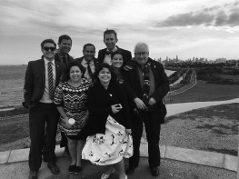
The Thirty-fourth Delegation from the United States of America on a tour of the Melbourne Ports electorate with the Hon Michael Danby MP, Member for Melbourne Ports, Council Member
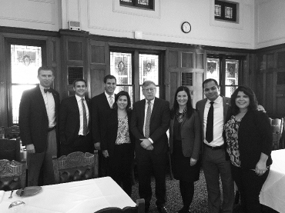
The Thirty-fourth Delegation from the United States of America meeting with the Hon Bruce Atkinson MLC, President of the Legislative Council
Twenty-fifth Delegation from the People’s Republic of China
17 to 20 October 2017
Delegates
- Mr Guo Meijian
(All-China Youth Federation) Delegation Leader
Deputy Secretary General, All-China Youth Federation
- Mr Zhang Guolai
(All-China Youth Federation)
Deputy Director of International Development, All-China Youth Federation
- Ms Cong Yuhua
(China Youth Daily)
Deputy Editor, Bingdian Weekly
- Mr Zhao Zhiqiang
(Dongda Mongolia King Group)
Deputy Secretary and President, Dongda Mongolia King Group
- Mr Shi Zehua
(Beijing International Studies University)
Dean and Associate Professor, Political Science Department
The Twenty-fifth Delegation from the People’s Republic of China travelled to Sydney, Canberra and Adelaide during the 4-day exchange.
Visit program
Sydney, New South Wales
- Visit to Mrs Macquarie’s Point
- Welcome dinner and program briefing
Canberra, Australian Capital Territory
- Briefing on the Liberal Party of Australia by Mr Bruce Edwards, International Secretary, Liberal Party of Australia (Japan 1992)
- Briefing on the Australian Labor Party by Mr Sebastian Zwalf, Assistant Secretary and Director of Labor International (UK 2013)
- Briefing on The Nationals by Mr Ben Hindmarsh, Federal Director, The Nationals
- Council luncheon hosted by Senator Bridget McKenzie, Council Member, Australian Political Exchange Council. Guests included Senator Janet Rice, Council Member, Senator the Hon Jacinta Collins, Mr Luke Howarth MP, and Ms Claire O’Halloran representing The Nationals
- Observe Question Time in the House of Representatives and the Senate
- Courtesy call on Mr John Haydon, Adviser, Office of Senator the Hon Stephen Parry, President of the Senate, Patron of the Council
- Dinner hosted by Mr Brendan Smyth, Commissioner of International Engagement, Australian Capital Territory
Adelaide, South Australia
- Meeting with Ms Brigid Delaney, President, Australian-China Youth Association, Adelaide Chapter. Guests included Mr Angus Heida, Vice President, P2P and Mr Andy Hu, Vice President, Education
- Guided tour of the University of Adelaide hosted by Ms Suzanne Layton
- Luncheon hosted by the Hon Michael Atkinson MP, Speaker of the House of Assembly, State Member for the District of Croydon. Guests included Mr Cai Siping, Consul General, Consulate General of the People’s Republic of China in Adelaide, Ms Ying Ying, Director, China Strategy, International Business and Government Relations, Ms Chen Zin, Vice Consul, Consulate General of the People’s Republic of China in Adelaide and Mr Ryan Cunningham, Graduate Officer, International Relations and Protocol
- Tour of Parliament House hosted by Ms Vasiliki Antoniou
- Informal discussion with Mr Cai Siping, Consul General, Consulate General of the People’s Republic of China in Adelaide
- Guided tour of Cleland Wildlife Park
- Former delegate dinner hosted by Ms Beverly Barber, Director, PwC (China 2011)
- Briefing on the Australian Electoral Commission by Mr Paul Hawes, Director, Operations and Ms Rosie Bolingbroke, Manager, SA State Office
- Meeting with Mr Michael Seeliger, Senior Manager, Eastern Hemisphere, South Australian Tourism Commission
- Luncheon hosted by Mr Peter Carey, Chief Executive Officer, Youth Opportunities South Australia. Guests included Mr Gavin Turner, Training Manager
- Meeting with Mr Peter Willmott, Agribusiness Adviser, Department of Primary Industries and Regions SA, Mr Michael Blake, Livestock Account Manager, Ms Sharon Matthews, Market Development Adviser and Ms Elena Anear, Assistant Director, Agriculture Food and Wine
- Winery Tour Magill Estate Cellar Door and Penfolds Wines
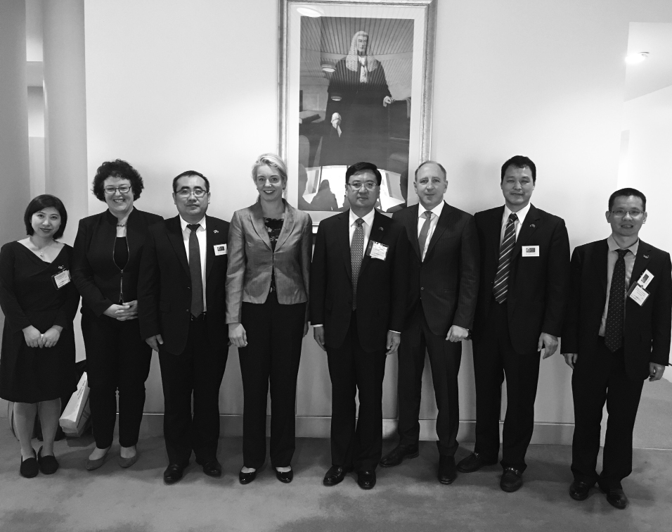
The Twenty-fifth Delegation from the People’s Republic of China meeting with Senator the Hon Bridget McKenzie, Senator the Hon Jacinta Collins and Mr Luke Howarth MP
Twelfth Delegation from the Philippines
24 February to 2 March 2018
Delegates
- Atty. Kristine Vanessa Chiong
(Alayon - PDP) Delegation Leader
Mayor, Naga City, Cebu
- Atty. Jason John Joyce
(National People’s Coalition)
Vice Mayor, Jose Abad Santos, Davao Occidental
- The Hon Kerby Salazar
(National Unity Party)
Councilor, General Trias, Cavite
- Atty. Mary Marjorie Martin-Chan (Liberal Party)
Councilor, Tuguegarao, Cagayan
- The Hon Justin Dominic Gatuslao (Liberal Party)
Councilor, Himamaylan, Negros Occidental
- Atty. Maria Charis Kay Ilagan
(National People’s Coalition)
Councilor, Cainta, Rizal
- Ms Vina Vivien Vargas-Enriquez
– Accompanying Officer
Chief Information and Operations Officer, Liberal Party
The Twelfth Delegation from the Philippines travelled to Sydney, Canberra and Melbourne during the 7-day exchange.
Visit program
Sydney, New South Wales
- Visit to Bondi Pavilion Community Cultural Centre hosted by Mr Dominic Wy Kanak, Deputy Mayor, Waverley Council
- Aboriginal cultural tour
- Dinner hosted by Mr Daniel Barber (Philippines 2015)
- Guided tour of Wild Life Sydney Zoo including Koala Encounter
- Visit to The Rocks markets
- Sydney Harbour luncheon cruise
- Meeting with Mr Stephen Bali MP, Mayor of Blacktown City
- Guided tour of Council Chambers
Canberra, Australian Capital Territory
- Dinner hosted by Her Excellency Minda Calauian-Cruz, Ambassor to Australia, Philippine Embassy
- Meeting with Mr Craig Wallace, Policy Manager, ACT Council of Social Services Inc
- Briefing on the Liberal Party of Australia by Mr Bruce Edwards, International Secretary, Liberal Party of Australia (Japan 1992)
- Meeting with the Hon David Coleman MP, Assistant Minister for Finance, representing the Special Minister of State, Minister responsible for the Australian Political Exchange Program
- Briefing on the Australian Labor Party by Mr Elias Hallaj, International Officer, Australian Labor Party (New Zealand 2002)
- Briefing on The Nationals by Mr Ben Hindmarsh, Federal Director, The Nationals (USA 2000)
- Council luncheon hosted by the Hon Alan Ferguson, Chair, Australian Political Exchange Council. Guests included Council Members Senator Dean Smith, The Hon Michael Danby MP and Senator Janet Rice and Mr Simon Berger representing the Liberal Party of Australia
- Observe Question Time in the House of Representatives
- Courtesy call on Senator the Hon Scott Ryan, President of the Senate, Patron of the Council
- Courtesy call on the Hon Tony Smith MP, Speaker of the House of Representatives, Patron of the Council
- Briefing on the Australian Greens by Senator Janet Rice, Senator for Victoria, Council Member
- Briefing on the Australian Electoral Commission by Ms Sarah Gowty, Director, International Services and Mr Jiv Sekhon, Assistant Director, International Services
- Meeting with Ms Patricia Turner, Chief Executive Officer, the National Aboriginal Community Controlled Health Organisation
Melbourne, Victoria
- Dinner hosted by Cr Rick Garotti, Councillor for Banyule, Grimshaw Ward (Philippines 2012). Guests included Cr Mark Di Pasquale, Banyule City Mayor, Cr Craig Langdon, Councillor for Banyule, Olympia Ward, Cr Tom Melican, Councillor for Banyule, Ibbott Ward and Cr Peter Castaldo, Councillor for Banyule, Griffin Ward
- Meeting with Ms Jodi Peskett, Women’s Co-Lead Organiser and Ms Pia Cerveri, Women’s and Equality Co-Lead Organiser, We are Union Women
- Briefing by Mr Andrew Young, Clerk of the Legislative Council
- Guided tour of Parliament House
- Luncheon hosted by the Hon Colin Brooks, Speaker of the Legislative Assembly (Japan 2010) and the Hon Bruce Atkinson MLC, President of the Legislative Council
- Meeting with Mr Paul Turner, Youth Services Strategy Manager, YMCA Victoria
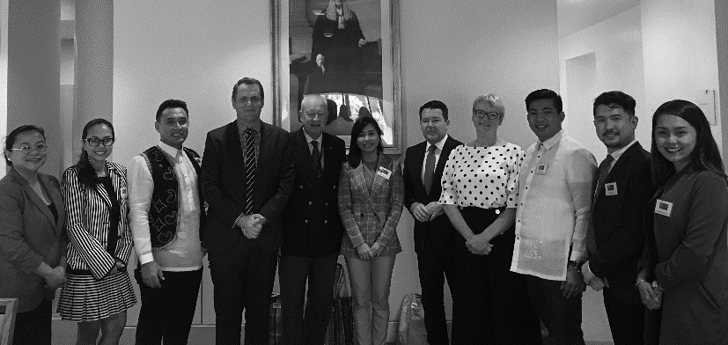
The Twelfth Delegation from the Philippines meeting with Hon Alan Ferguson, Chair, Australian Political Exchange Council, Council Members Senator Dean Smith and Senator Janet Rice and Mr Simon Berger representing the Liberal Party of Australia
Twelfth Delegation from New Zealand
27 May to 1 June 2018
Delegates
- Simon O’Connor
(National Party) Delegation Leader
Member of Parliament for Tāmaki
- The Hon Paul Goldsmith
(National Party)
List Member of Parliament, based in Epsom
- Jo Luxton (Labour Party)
List Member of Parliament
- Jamie Strange (Labour Party)
List Member of Parliament
- Gareth Hughes (Green Party)
Chief Musterer (Whip)
- Kelly Boxall (National Party)
List Member of Parliament
- Charlotte Dawber-Ashley
– Accompanying Officer
Inter-Parliamentary Relations Officer, Parliament of New Zealand
The Twelfth Delegation from New Zealand travelled to Canberra and Adelaide during the 6-day exchange.
Visit program
Canberra, Australian Capital Territory
- Tour of the Australian War Memorial
- Last Post Ceremony at the Australian War Memorial
- Dinner hosted by Mr Andrew Wall MLA and Ms Elizabeth Lee MLA
- Meeting with the Hon Wesley Fang MLC, Talbingo Power Station
- Dinner hosted by His Excellency Mr Chris Seed, High Commissioner, New Zealand High Commission
- Briefing by the Australian Electoral Commission by Mr Tom Rogers, Electoral Commissioner and Ms Skye Rogers, Director of International Services
- Briefing on the Liberal Party of Australia by Mr Bruce Edwards, International Secretary, Liberal Party of Australia (Japan 1992)
- Briefing on the Australian Labor Party by Mr Sebastian Zwalf, Assistant National Secretary, Australian Labor Party (UK 2013)
- Meeting with Senator the Hon Scott Ryan, President of the Senate, Patron of the Council
- Meeting with Mr Brendan Smyth, Commissioner for International Engagement, Australian Capital Territory
- Meeting with Councillor Tim Overall, Mayor of Queanbeyan-Palerang Regional Council
- Briefing on the Australian Greens by Senator Janet Rice, Senator for Victoria
- Meeting with the Hon David Coleman MP, Assistant Minister for Finance, representing the Special Minister of State, Minister responsible for the Australian Political Exchange Program
- Council luncheon hosted by Senator Dean Smith, Council Member, Australian Political Exchange Council. Guests included Council members The Hon Michael Danby MP, Member for Melbourne Ports, Senator Janet Rice, Senator for Victoria, and Mr Bryce Roney representing the Australian Labor Party
- Observe Question Time in the House of Representatives
- Courtesy call on Senator Sue Lines, Deputy President of the Senate
- Courtesy call on the Hon Tony Smith MP, Speaker of the House of Representatives, Patron of the Council
- Meeting with members of the Australian-New Zealand Parliamentary Friendship Group, chaired by Mr Bert van Manen MP
Adelaide, South Australia
- Tour of the South Australian Parliament by Mr Antoni Rejman
- Briefing on the role of State Government by Ms Ruth Ambler, Executive Director, Cabinet Office, Department of the Premier and Cabinet
- Lunch hosted by the Hon Vincent Tarzia MP, Speaker of the House of Assembly
- Observe Question Time
- Meeting with Councillor Martin Haese, Lord Mayor of the City of Adelaide
- Dinner hosted by the Hon Alan Ferguson, Chairman of the Australian Political Exchange Council, and Mr Sam Duluk MP, State Member for Davenport
- Meeting with His Excellency the Hon Hieu Van Le AC, Governor of South Australia
- Meeting with Mr Philip Benwell MBE, National Chairman of the Australian Monarchist League
- Meeting with the Hon Corey Wingard MP, Minister for Police, Emergency Services, Correctional Services, Recreation, Sport and Racing, Mr David Brown and Ms Kylie Taylor
- Attended a cultural tour and lunch
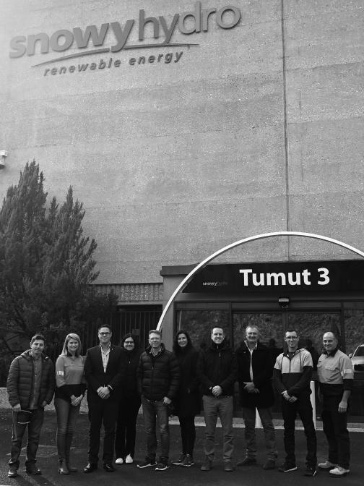
The Twelfth Delegation from New Zealand with Mr Wes Fang MLC at the Snowy Hydro Tumut 3 Power Station
Individual study tours for 2017–2018
Four young Australians participated in individual study tours to the United States of America, the United Kingdom and India in 2017–2018. This included one attending the Asian Forum on Global Governance in India.
Mr Simon Frost (Liberal Party of Australia) – United States of America
State Director, Liberal Party of Australia, Victorian Division
7 to 27 July 2017
Mr Frost’s study tour aimed to help him determine how he could better target undecided voters through the use of new techniques, systems and processes, as well as assess new electoral trends and patterns of behaviour emerging following the 2016 Presidential, Congressional, Gubernatorial and State election races.
The trip reinforced my belief in data driven field campaigns as the best way for parties to narrowcast their messages to the voters who matter. In the United States, it is persuading those people to vote - the so-called ‘get out the vote’ campaign, and in Australia it revolves around undecided voters. Those voters who are either disengaged or genuinely haven’t made up their minds as to who will receive their first preference and ultimately which party their vote will flow to under compulsory preferential voting.
With the media and election cycle completely tipped on its head over the last 10–15 years, we have seen a revolution in how people receive and act on information and ideas in the lead up to casting their vote. Factual information, received from an authentic voice about an issue that motivates a voter will be the only way in which to shift a vote in the time ahead. This may be received via a phone canvassing operation, door-to-door, a targeted social media tile or a narrowcast message on a Pay-TV channel.
This is time consuming and costly for political parties to pursue, but I am convinced more than ever that this will be the way of the future, as broad scale, mass market TV, newspaper and radio advertising, as well as non-targeted mail pieces reach their use by date. The only disclaimer to my conclusion is field and data analytics can help you craft your message and locate who your target audience might be, but the most important ingredient to winning a local campaign is to have a candidate with real life experience, who is prepared to fight for their community and have a vision for a better future.
Mr Jay Tilley (The Greens) – United Kingdom
Senior Policy Adviser, Office of Senator Richard Di Natale
31 October to 12 November 2017
Mr Tilley’s study tour aimed to examine the politics of intergenerational inequality in the UK and compare it with the Australian context. During his tour, Mr Tilley travelled to England, Scotland and Ireland, and met with representatives of political parties and intergenerational policy institutions.
The demographic trends for young people are very similar between the United Kingdom and Australia. Assets are largely owned by older generations while younger folk predominately draw their income from wages, which are flat and lower than what they were for the generation before.
Rents are overwhelming incomes and as a result, home ownership is largely beyond reach for most younger people. Student debts have ballooned, reducing discretionary income and the imminent challenges of supporting the massive baby boomer cohort in retirement, with their expanded life expectancy looms large on public budgets and future taxation from a shrinking workforce who will have to support them.
While these trends are very similar across Australia, England, Scotland and Ireland, what separates Australia from the UK is that the UK is having a very visible debate about intergenerational issues and their Governments and Parliaments are responding as a result.
Mr Benjamin Rillo (ALP) – United Kingdom
Adviser – Senator Don Farrell’s Office
30 May to 29 June 2018
Mr Rillo’s study tour aimed to provide a comparison of contemporary political issues between the United Kingdom to the current state of affairs in Australia.
Together with a summary of contemporary political issues facing the United Kingdom, the broad theme of this report is the protection and strengthening of democratic integrity, with particular focus on the following areas:
- the conduct of elections and the maintenance of the electoral roll
- the evolution of non-traditional media and methods of communication
- the protection and regulation of data and technology
- the perception and operation of the parliament and parliamentary procedure
- the regulation and administration of parliamentary expenses and entitlements.
Each of the aforementioned topics forms part of an overarching issue facing established democracies around the world, namely the preservation of public faith in the democratic system in the face of major challenges and ongoing erosion.
The issues and themes explored in this report, and throughout the interview and research process in the United Kingdom, go to the preservation of public faith in the democratic system. Each of the themes discussed has an effect, however unnoticed, on the public perception of their system, their representatives, their government, and their own voice within the society.
Noting the widespread and comprehensive issues that affect public perception of democracy, the recommendations expressed by the author reflect the broad and somewhat diverse considerations required to preserve and rebuild faith in the system.
In a democracy of millions, the challenge to ensure each individual voter or elector feels heard and validated is near impossible. However, if constant consideration and vigilance is maintained across the areas discussed; conduct of the elections, changing forms of communication and media, the protection of individual data, perception of the parliament, and the administration of the expenses required to run the system – then it is possible to maintain a level of public faith in the democratic system. The alternative, a falling public perception, does not just lead to smaller turnouts and less engagement –‑but a fracturing of the system itself.
It was a privilege to be able to travel and interview those listed for this report and the author remains eternally grateful for the opportunity provided by both his employer, and the Australian Political Exchange Council.
Mr Joshua Morris MP (Liberal Party) – India
Asian Forum on Global Governance
State Member for Western Victoria
12 to 21 January 2018
The Asian Forum on Global Governance was held in New Delhi from 12–21 January 2018, attracting 49 participants from 28 countries and featured many speakers from around the world. The forum takes a close look at the Asia region and at the challenges facing the global community.
The primary objective of this forum is to provide an instructional and networking platform for young professional leaders to discuss, debate and challenge conventional interpretations of complex contemporary realities.
The theme for the 2018 forum was “Managing Disruptive Transitions: Ideas, Institutions and Idioms”
The 2018 Asian Forum on Global Governance provided all participants with an exceptional opportunity to delve into and examine an interesting and engaging breadth of topics that are shaping our collective futures. The forum participants came from a wide variety of both professional, ideological and geographic backgrounds and this added interesting nuance to the many discussions and debates that occurred throughout the forum.
I am extremely grateful to the Observer Research Foundation, ZEIT-Stiftung Ebelin und Gerd Bucerius, and the Australian Political Exchange Council for the opportunity to attend such an exemplary forum.
Not only was the entire forum exceptionally well organised and conducted, the quality and impressive line-up of speakers and contributors to the forum added interesting and unique perspectives that participants enthusiastically engaged with.
I would whole-heartedly encourage other young politicians to apply for the forum in the future. It has certainly has not only provided me with many new perspectives on international politics and other topical issues but also provided me with the opportunity to connect with dozens of young leaders, form many different fields of expertise, from around the world.
2018–2019
Outgoing Australian delegations for 2018–2019
In 2018–2019, the Council sponsored 27 young Australian political leaders in overseas exchange delegations to the United States of America, New Zealand, the Socialist Republic of Vietnam, the People’s Republic of China and Japan as follows:
Date | Delegation
21 July to 1 August 2018 | Thirty-fourth Australian Delegation to the United States of America
5 to 10 August 2018 | Twelfth Australian Delegation to New Zealand
1 to 7 September 2018 | Twenty-sixth Australian Delegation to the People’s Republic of China
17 to 23 November 2018 | Twenty-second Australian Delegation to the Socialist Republic of Vietnam
23 February to 1 March 2019 | Twenty-seventh Australian Delegation to Japan

Thirty-fourth Australian Delegation to the United States of America
21 July to 1 August 2018
Delegates
- Ms Anika Wells
(Australian Labor Party)
Delegation Leader
Lawyer, Maurice Blackburn Lawyers
- Mr Andrew Bragg
(Liberal Party of Australia)
Executive Director, Business Council of Australia
- Ms Ruby Cameron (The Nationals)
Senior Advisor, Office of Senator the Hon Bridget McKenzie
- Ms Megan Purcell
(Liberal Party of Australia)
Senior Advisor, Office of Senator the Hon Michaelia Cash
- Mr Shaun Crowe
(Australian Labor Party)
Research Assistant, Parliamentary Library, Department of Parliamentary Services
- Mr Alex Mills (Australian Greens)
Data & Systems Officer
- Mrs Sharon Forester
– Council Representative
Director, Australian Political Exchange Council
The Thirty-fourth Australian Delegation to the United States of America travelled to Washington, D.C., Milwaukee, Wisconsin, Madison, Wisconsin and Los Angeles, California during the 12-day exchange hosted by the American Council of Young Political Leaders.
Visit program
Washington, D.C.
- Tour of Washington, D.C. including Jefferson Memorial, Lincoln Memorial, Martin Luther King Jr. Memorial and Vietnam Memorial
- Visit to Smithsonian Museums
- Visit to Eastern Market
- Visit to Southwest Waterfront
- Meeting with the American Council of Young Political Leaders
- Meeting with the United States Department of State
- Meeting with the American Gas Association
- Tour of Capitol Hill including Speaker’s Balcony
- Meeting with Congressman Tom Cole
- Meeting with the Embassy of Australia in the United States of America
- Dinner hosted by the Auto Care Association
- Meeting with Caplin & Drysdale on US Campaign Finance Law
- Meeting on the US political landscape with New Paradigm Strategy Group
- Lunch hosted by Feld Entertainment
- Meeting with the Democratic Legislative Campaign Committee
- Meeting with the National Republican Senatorial Committee
Milwaukee, Wisconsin
- Meeting with the Honorable Chris Larson, Member, Wisconsin Senate, and the Honorable Tyler August, Speaker pro tempore, Wisconsin State Assembly
- Attended Washington Nationals vs Milwaukee Brewers Major League Baseball Game
- Meeting with the November Project
- Tour of UW-Milwaukee School of Freshwater Science and discussion with Dean of School
- Meeting with Milwaukee Labor Unions
- Attended Edelweiss’ Historic Milwaukee Boat Tour
- Meeting with American Federation for Children
- Meeting with Citizen Action of Wisconsin
- Meeting with the Honorable Christine Sinicki, Member, Wisconsin State Assembly
- Attended monthly Community Barnstorming
Madison, Wisconsin
- Tour of Wisconsin State Capitol and meeting with the Honorable Katrina Shankland
- Meeting with officials from the Wisconsin Democratic Party
- Meeting and lunch with Mr Jeremy Tunis, JDT Consulting
- Meeting with Wisconsin Department of Public Instruction
- Meeting with the Honorable Daniel Kelly, Justice, Supreme Court of Wisconsin
- Meeting with officials from the Republican Party of Wisconsin
Los Angeles, California
- Starline Tour of Los Angeles
- Dinner hosted by AG Business Services
- Meeting with the Honorable Ardy Kassakhian, Clerk, City of Glendale
- Tour of Jet Propulsion Laborary
- Meeting with LA2028 (Los Angeles Olympic Committee)
- Meeting with Heal the Bay
- Tour of Warn Bros Studios
- Meeting with University of South California, School of Public Policy, including the Honorable Frank Zerunyan
- Meeting with the Honorable Rob Portantino, Member, California State Senate
- Meeting with the Mayor’s Office of Immigrant Affairs
- Meeting and lunch with the President of the Los Angeles Community College Board
- Visit to Ronald Reagan Presidential Museum and Library
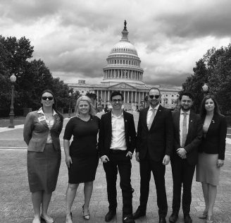
The Thirty-fourth Australian Delegation outside the United States Capitol
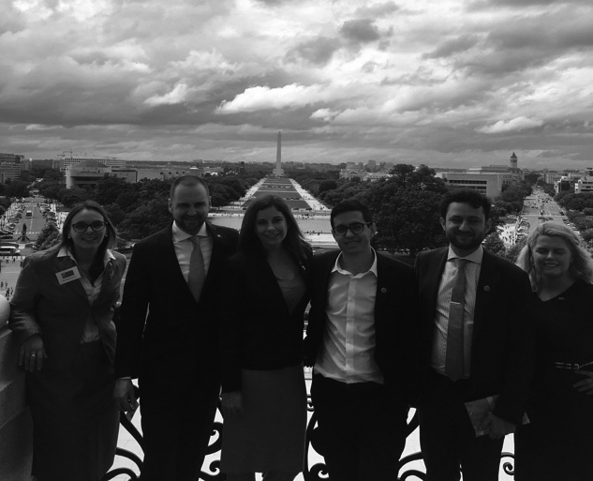
The Thirty-fourth Australian Delegation on the Speaker’s Balcony overlooking the Washington Monument
Twelfth Australian Delegation to New Zealand
5 to 10 August 2018
Delegates
- Ms Sarah Coward
(Australian Labor Party)
Delegation Leader
NSW Labor Fundraising and Business Communications Director
- Mr Christopher Ireland
(Liberal Party of Australia)
Advisor, Coalition Members and Senators Support Unit
- Ms Rosemarie Sitorus
(Australian Labor Party)
Advisor, Office of Dr Anne Aly MP
- Mr Matthew Nesham
(Australian Labor Party)
Senior Advisor, Office of Senator Anne Urquhart
- Mrs Louise De Domenico
(Liberal Party of Australia)
Senior Electorate Officer, Office of the Hon Scott Morrison MP
- Mr Douglas Rodgers
(Liberal National Party)
Media and Policy Advisor,
Office of Michelle Landry MP
- Ms Suzy Domitrovic
– Council Representative
Executive Officer, Australian Political Exchange Council
The Twelfth Australian Delegation to New Zealand travelled to Wellington and Auckland during the 6-day exchange hosted by the New Zealand Parliament.
Visit program
Wellington
- Visited the Great War Exhibition
- Meeting with the Ministry of Foreign Affairs and Trade
- Meeting hosted by Deidre Brookes, Manager International, New Zealand Electoral Commission
- Visited Zealandia Econsanctuary
- Attended of Treaty of Waitangi claims and process
- Visit hosted by Mr Paul Riley, Curator, Pukeahu War Memorial
- Attended Last Post Ceremony
- Attended VIP tour of the New Zealand Parliament
- Meeting with Speaker the Rt Hon Trevor Mallard MP, Speaker of the House of Representatives
- Visited ‘He Tohu: Signatures that shape New Zealand’ Exhibition
- Lunch with Parliamentary Engagement and Education teams
- Observe Question Time in the House of Representatives
- Political calls
- Te Papa Tongarewa
- Attended drinks hosted by Speaker the Rt Hon Trevor Mallard MP
- Observed Select Committee in session
- Attended round table discussion with Miles Sutton, Deputy Clark, Māori Affairs Select Committee and Maika Te Amo, Kaiwhakamaori (translator), Select Committee Services on the preservation and revitalisation of Māori Language
Auckland
- Briefing on Dairy Industry Developments at Fonterra Centre
- Tour of Māori Court and Māori Cultural Performance
- Visit to Devonport and exploration of historic suburban centre
- Presentation by Thomas Hyde, Group Director, Defence and Advisory, Beca Grou
- Tour of and lunch at Villa Maria Winery
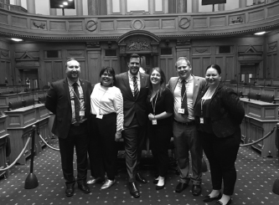
The Twelfth Australian Delegation to New Zealand in the New Zealand Parliament
Twenty-sixth Australian Delegation to the People’s Republic of China
1 to 7 September 2018
Delegates
- Mr Mathew Howard
(Australian Labor Party)
Delegation Leader
Senior Electorate Officer,
Office of Jo Haylen MP
- Ms Margaret Forrest
(Liberal Party of Australia)
Barrister, 31 West Chambers
- Mr Zachary Lombardo
(Liberal Party of Australia)
Assistant Advisor, Office of the Hon Alan Tudge MP
- Ms Sabina Husic
(Australian Labor Party)
Director, PremierNational
- Ms Rhiannon Newman
(Australian Labor Party)
Electorate Officer, Office of the Hon Irene Pnevmatikos MLC
- Mr Christopher Redman
(Australian Greens)
Digital Communications Advisor, Office of Senator Richard Di Natale
- Ms Suzy Domitrovic
– Council Representative
Executive Officer, Australian Political Exchange Council
The Twenty-sixth Australian Delegation to the People’s Republic of China travelled to Beijing, Shijiazhuang and Shanghai, during the 7-day exchange hosted by the All-China Youth Federation.
Visit program
Beijing
- Visit to the Great Wall of China
- Visit to the Forbidden City
- Visit to the Department of North America and Oceania Affairs, Ministry of Foreign Affairs
- Visit to the National People’s Congress
- Visit to the Soong Ching Ling Foundation
- Visit to the Association of Global System for Mobile Communications
- Attended welcome banquet hosted by Mr Wu Wei, Deputy Secretary-General of All-China Youth Federation
- Meeting with Li Keyong, leading official of the All-China Youth Federation
- Visit to the China Global Philanthropy Institute
- Visit to the National Institute of International Strategy, Chinese Academy of Social Sciences
Shijiazhuang
- Visit to Xibaipo Village, Shijiazhuang
- Visit to Environmental Protection Organsiation-Cabin
- Visit to Zhengding Village
Shanghai
- Visit to Elite Union
- Visit to Ants Innovation Town
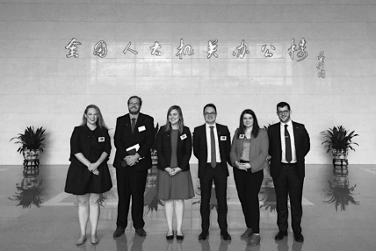
The Twenty-sixth Australian Delegation to the People’s Republic of China visiting the National People’s Congress
Twenty-second Australian Delegation to the
Socialist Republic of Vietnam
17 to 23 November 2018
Delegates
- Mrs Elizabeth Kikkert MLA
(Liberal Party of Australia)
Delegation Leader
Member for Ginninderra, ACT Legislative Assembly
- Ms Alexandra Manning
(Australian Labor Party)
Deputy Director of Target Seats, ALP National Secretariat
- Ms Brigid Meney
(Liberal Party of Australia)
Policy and Media Manager, Australasian Institute of Mining and Metallurgy
- Ms Keelia Fitzpatrick
(Australian Labor Party)
Director and Solicitor, Young Workers’ Centre, Victorian Trades Hall Council
- Mr Andrew Hamilton
(Liberal Party of Australia)
Office Manager, Office of Senator the Hon Arthur Sinodinos AO
- Ms Victoria Robertson
(Australian Labor Party)
Chief of Staff, Office of Gai Brodtmann MP
- Mrs Sharon Forester
– Council Representative
Director, Australian Political Exchange Council
The Twenty-second Australian Delegation to the Socialist Republic of Vietnam travelled to Hanoi, Ninh Binh Province and Ho Chi Minh City during the 7-day exchange hosted by the Youth International Cooperation Development Centre.
Visit program
Hanoi
- Tour of Hanoi City and visit to Water Puppet Show
- Meeting with the Australian Embassy in Hanoi
- Meeting and welcome lunch with the Ho Chi Minh Communist Youth Union
- Meeting with the Leaders and Representatives of the Commission for Foreign Relations of the Party Central Committee
- Meeting with the Leaders and Representatives of External Affairs Committee of the National Assembly
- Meeting with the Ministry of Industry and Trade
- Meeting with Vietnam General Confederation of Labour (Trade Union)
- Meeting with the Ministry of Health
- Meeting with the Ministry of Natural Resources and Environment
- Visit to Ho Chi Minh Memorial Complex
- Meeting with Leaders and Representatives of Vietnam Women’s Union
Ninh Binh Province
- Visit to Trang An Scenic Landscape Complex
- Meeting with Youth Union of Ninh Binh Province
Ho Chi Minh City
- Meeting with Leaders and Representatives of Ho Chi Minh City’s Youth Union
- Visit to Cu Chi Tunnel
- Courtesy call to the Leader of Ho Chi Minh City
- Meeting with Leaders and Representatives of Tuoi Tre Newspaper
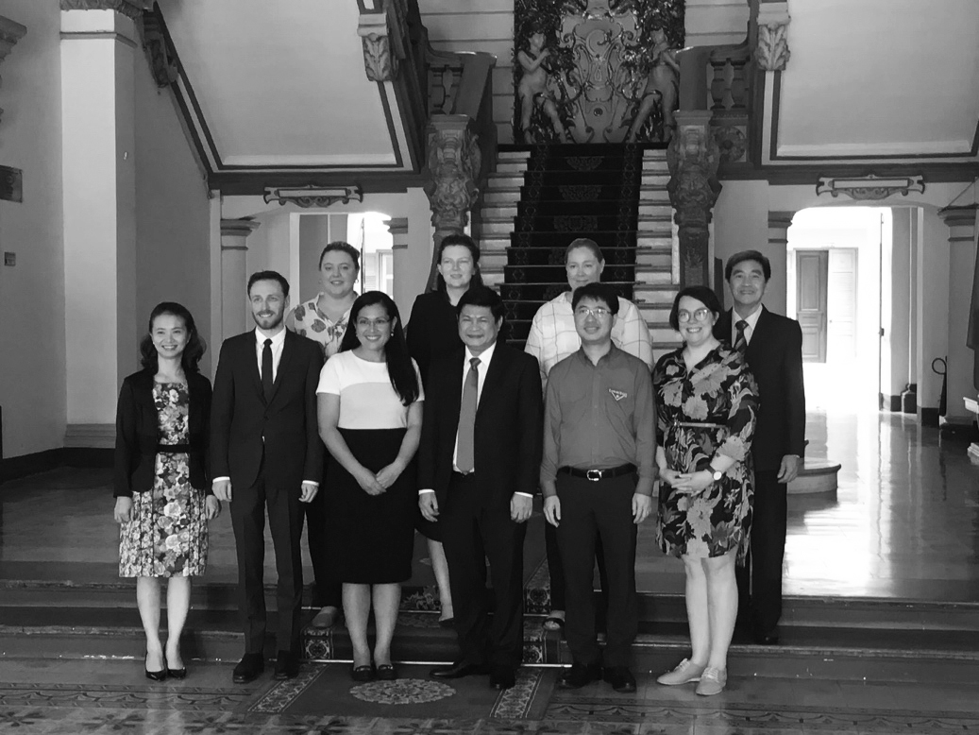
The Twenty-second Australian Delegation meeting with the leader of Ho Chi Minh City
Twenty-seventh Australian Delegation to Japan
23 February to 1 March 2019
Delegates
- Ms Ella Haddad MP
(Australian Labor Party)
Delegation Leader
State Member for Clark,
Tasmanian Parliament
- Mrs Elizabeth Kikkert MLA
(Liberal Party of Australia)
Member for the ACT Legislative Assembly
- The Hon. Mr Matthew Swinbourn MLC
(Australian Labor Party)
Member of Legislative Council of Western Australia
- Ms Tiff Dufty
– Council Representative
The Twenty-seventh Australian Delegation to Japan travelled to Nara, Himeji, Hiroshima and Tokyo during the 7-day exchange hosted by the Ministry of Foreign Affairs.
Visit program
Nara
- Visit to Todaiji Temple
- Meeting with Mr Gen Nakagawa, Mayor of Nara City, Mr Yoshihiro Umemori, Mr Toshihiko Okazaki and Mr Toshikazu Oka.
Himeji
- Visit Himeji Castle
Hiroshima
- Visit Miyajima
- Guided tour of Hiroshima Peace Memorial Museum by Mr Shuichi Kato, Deputy Director, Hiroshima Peace Memorial Museum
- Placing of wreath at cenotaph
- Talk presented by Atomic Bomb survivor Keiko Ogura
- Meeting with Mr Kazumi Matsui, Mayor of Hiroshima at Hiroshima City Hall
- Meeting with Mr Shin Uda and Ms Mayumi Ito, Members of the Hiroshima Prefectural Assembly
Tokyo
- Meeting with Mr Shintani, Ministry of Health
- Tour of Tama Zoo with General Curator, Mr Yasumasa Tomita
- Visit to the Metropolitan Area Outer Underground Discharge Channel with Mr Ryozo Ishikawa, Mayor of Kasukabe City, Mr Takahisa Tanemura, Vice Mayor and Mr Hiroshi Ikegai, Vice Mayor.
- Lunch hosted by Mr Norikazu Suzuki, Parliamentary Vice Minister for Foreign Affairs
- Meeting with Diet Members of the Japan-Australia Parliamentary Friendship League with Mr Ichiro Aisawa, Chairperson and Mr Taku Otsuka, Chief Secretary of the Japan-Australia Parliamentary Friendship League
- Meeting with the Japan Australia Business Co-operation Committee hosted by Mr Nobuyoshi Aoyama, Director General of the Japan Australia Business Co-operation Committee
- Dinner hosted by Mr Toshihide Ando, Deputy Director-General, Asian and Oceanian Affairs Bureau and Southeast and Southwest Asian Affairs Department, MOFA and Maya Hamada, Principal Deputy Director, Oceania Division, Asian and Oceanian Affairs Bureau
- Meeting with Mr Minoru Kiuchi and Mr Tukasa Akimoto, State Ministers of the Environment
- Tour of the National Diet of Japan
- Visit Shinagawa Incineration Plant
- Lunch at the Australian Embassy in Tokyo hosted by Mr Robert Tranter, Deputy Head of Mission
- Tour of Tokyo
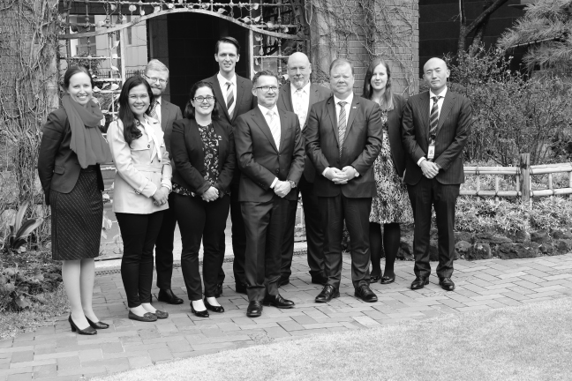
The Twenty-seventh Australian Delegation to Japan at the Australian Embassy
Incoming delegations to Australia for 2018–2019
In 2018–2019, the Council hosted 25 participants on delegations from its exchange partners as follows:
Date | Delegation
11 to 17 August 2018 | Seventeenth Delegation from Japan
8 to 14 September 2018 | Twenty-second Delegation from the Socialist Republic of Vietnam
13 to 24 October 2018 | Thirty-fifth Delegation from the United States of America
24 to 29 November 2018 | Twenty-sixth Delegation from the People’s Republic of China

Seventeenth Delegation from Japan
11 to 17 August 2018
Delegates
- Mr Masakazu Hamachi (Komeito)
Delegation Leader
Member of the House of Representatives
- Mr Takeshi Saiki
(Democratic Party for the People)
Member of the House of Representatives
- Ms Kanako Otsuji
(Constitutional Democratic Party) Member of the House of Representatives
- Mr Taro Honda
(Liberal Democratic Party) Member of the House of Representatives
- Ms Kimi Onoda
(Liberal Democratic Party)
Member of the House of Councillors
- Mr Daisuke Akimoto (Komeito)
– Accompanying Officer
Second Secretary to Dr Kiyohiko Toyama
The Seventeenth Delegation from Japan travelled to Melbourne, Canberra and Sydney during the 7-day exchange.
Visit program
Melbourne, Victoria
- Meeting and lunch with Mr Julian Hill MP
- Attend Australian rules football game at Melbourne Cricket Ground
- Dinner hosted by Mr Kazuyoshi Matsunaga, Consul-General of Japan in Melbourne
- Tour of the Ian Potter Centre: NGV Australia
- Visit to Eureka Sky Deck
Canberra, Australian Capital Territory
- Dinner hosted by Mr Brendan Smyth, Commissioner for International Engagement, Australian Capital Territory
- Briefing by the Australian Electoral Commission by Mr Tom Rogers, Electoral Commisioner, Mr Jeff Pope, Deputy Electoral Commissioner and Mr Paul Pirani, Chief Legal Officer.
- Briefing on the Liberal Party of Australia by Mr Bruce Edwards, International Secretary, Liberal Party of Australia (Japan 1992)
- Briefing on the Australian Labor Party by Mr Elias Hallaj, International Project Officer, Australian Labor Party (New Zealand 2002)
- Meeting with Ms Tania Constable PSM, CEO, Minerals Council of Australia
- Dinner hosted by Ambassador Sumio Kusaka, Japanese Ambassador to Australia
- Courtesy call on Mr Luke Howarth MP
- Briefing on the National Party by the Hon Mark Coulton MP, Assistant Minister for Trade, Tourism and Investment
- Briefing on the Australian Greens by Senator Peter Whish-Wilson, Senator for Tasmania
- Meeting with Council Member Senator Dean Smith (Japan 2016)
- Observe Question Time in the Senate and House of Representatives
- Meeting with Ms Emma McBride MP and Ms Justine Keay MP (Japan 2017)
- Courtesy call on the Hon Tony Smith MP, Speaker of the House of Representatives, Patron of the Australian Political Exchange Council
- Courtesy call on Senator the Hon Scott Ryan, President of the Senate, Patron of the Australian Political Exchange Council
- Dinner hosted by Ms Vicki Dunne MLA
- Meeting with Mr Pat Conroy MP (Japan 2014)
- Meeting with Ms Terri Butler (Japan 2015)
- Meeting with the Hon David Coleman MP, Assistant Minister for Finance, representing the Special Minister of State, Minister responsible for the Australian Political Exchange Program
- Meeting with Mr Tim Wilson MP (Japan 2018)
- Meeting with Mr Julian Hill and Ms Madeleine King MP (Japan 2018)
- Visit to the Australian War Memorial
Sydney, New South Wales
- Dinner hosted by the Hon David Elliot MP, Minister for Counter Terrorism, Corrections and Veterans’ Affairs (Japan 2013)
- Briefing on the structure and role of the NSW Parliament
- Luncheon hosted by the Hon John Ajaka MLC, President of the Legislative Council and the Hon Thomas George MP, Deputy Speaker of the Legislative Assembly.
- Observe Question Time in the Legislative Assembly
- Visited Barangaroo Reserve for Aboriginal Cultural Tour
- Dinner hosted by Mr Keizo Takewaka, Consul-General of Japan to Sydney
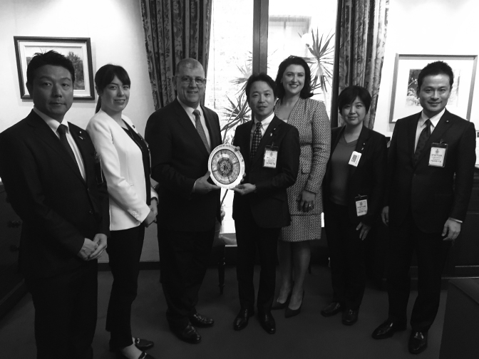
The Seventeenth Delegation from Japan meeting with the Hon John Ajaka MLC, President of the NSW Legislative Council
Twenty-second Delegation from the Socialist Republic of Vietnam
8 to 14 September 2018
Delegates
- Mr Bui Quang Huy
(Ho Chi Minh Communist Youth Union) Delegation Leader
Secretary of the Central Committee of the Ho Chi Minh Communist Youth Union
- Mr Nguyen Phi Long (People’s Committee of Binh Dinh Province)
Vice Chairman of People’s Committee of Binh Dinh Province
- Ms Dinh Thi Phuong
(Ninh Binh Provincial Youth Union)
Secretary of Ninh Binh Provincial Youth Union
- Ms Nguyen Thi Thanh Huyen
(Tuyen Quang Provincial Youth Union)
Secretary of Tuyen Quang Provincial Youth Union, Member of Kien Giang Province’s People Council
- Mr Nguyen The Hoan
(Ha Tinh Provincial Youth Union)
Secretary of Ha Tinh Provincial Youth Union
- Mr Nguyen Huu Trung
(Communist Party of Vietnam)
– Accompanying Officer
Program Official
The Twenty-second Delegation from the Socialist Republic of Vietnam travelled to Sydney, Canberra and Brisbane during the 7-day exchange.
Visit program
Sydney, New South Wales
- Tour of the Sydney Opera House
- Visited Barangaroo Reserve for Aboriginal Cultural Tour
- Visited Mrs Macquarie’s Chair Lookout
- Lunch hosted by Ms Casey Thompson, Electorate Officer, Office of Senator Jenny McAllister (Vietnam 2016)
- Visit to the Rocks Markets
- Dinner on Sydney Harbour Cruise with Mr Daniel Barbar, Chief of Staff, Office of Sophie Cotsis MP
- Tour of Cabravale Ward and lunch hosted by Ms Dai Le, Councillor, Fairfield City Council
Canberra, Australian Capital Territory
- Dinner hosted by Mr Brendan Smyth, Commissioner for International Engagement, Australian Capital Territory
- Briefing by the Australian Electoral Commission by Mr Jeff Pope, Deputy Electoral Commissioner and Mr Paul Pirani, Chief Legal Officer.
- Briefing on the Australian Labor Party by Mr Paul Erickson, Assistant National Secretary (United States of America 2011)
- Meeting with Ms Pham Thuy Nga, Political Counsellor, Embassy of the Socialist Republic of Vietnam
- Briefing on the Liberal Party of Australia by Mr Bruce Edwards, International Secretary, Liberal Party of Australia (Japan 1992)
- Dinner hosted by Ms Angela Drake, Senior Advisor to Minister Yvette Berry (Vietnam 2017) and attended by Ms Suzanne Orr MLA and Mr Matt Byrne representing ACT Labor
- Briefing on the National Party by Mr Ben Hindmarsh, Federal Director, The Nationals
- Meeting with Mr Andrew Wallace MP, Chair of the Vietnam-Australia Parliamentary Friendship Group
- Briefing on the Australian Greens by Council Member Senator Janet Rice
- Council Luncheon including Council Members the Hon Michael Danby MP, Senator Janet Rice and Mr Bruce Edwards
- Observe Question Time in the Senate and House of Representatives
- Courtesy call on the Hon Tony Smith MP, Speaker of the House of Representatives, Patron of the Australian Political Exchange Council
- Courtesy call on Senator the Hon Scott Ryan, President of the Senate, Senator for Victoria, Patron of the Australian Political Exchange Council
Brisbane, Queensland
- Tour of Queensland State Parliament
- Attended morning tea with the Speaker of the Legislative Assembly, the Hon. Curtis Pitt MP
- Briefing on Queensland’s parliamentary system
- Meeting with Councillor Angela Owen, Calamvale Ward, Brisbane City Council
- Meeting with Mr Matt Keally and Mr Burn Ashburner of the Queensland Cane Growers Organisation
- Meeting with Dr Jessica Gallagher, Director, Global Engagement and Entrepreneurship and Ms Rachael Kelly, International Visits and Events Officer, University of Queensland Global Engagement and Entrepreneurship
- Meeting with Mr Jimmy Jin, Vice President, Campus Culture, Mr Paul Taylor, Vice President, Student Rights and Mr Samuel Ngugi, Treasurer, University of Queensland Union
- Visit to and lunch at Mt Coot-tha Lookout
- Tour of Lone Pine Koala Sanctuary
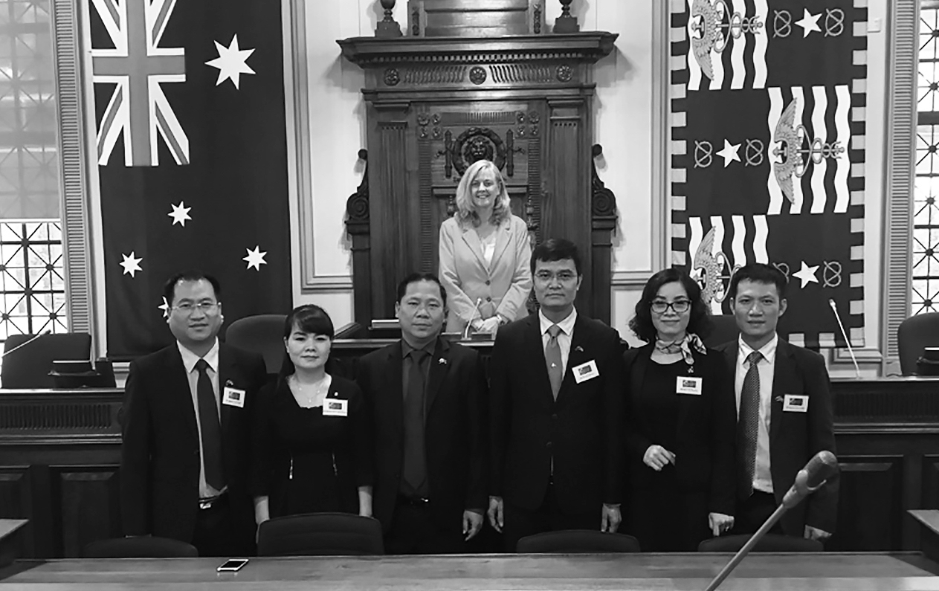
The Twenty-second Delegation from Vietnam meeting with Councillor Angela Owen at Brisbane City Council
Thirty-fifth Delegation from the United States of America
13 to 24 October 2018
Delegates
- Ms Amanda Brown
(Democratic Party) Delegation Leader
Chief of Staff, Boise City Council
- The Honorable Micah Caskey (Republican Party)
Member, 89th District, South Carolina House of Representatives
- The Honorable Ian Conyers (Democratic Party)
Member, 4th District, Michigan State Senate
- Ms Mary Claire Couch
(Republican Party) Manager of State Affairs, American Gas Association
- The Honorable Sonia Lopez (Democratic Party) Member, Compton Community College District, Board of Trustees
- Mr Joe Vidulich (Republican Party)
Senior Manager of Government Relations, Capital One Financial
- Dr Judithanne Scourfield McLauchlan (Democratic Party)
– Accompanying Officer
Associate Professor of Political Science, University of South Florida, St. Petersburg
The Thirty-fifth Delegation from the United States of America travelled to Brisbane, Canberra, Bendigo and Melbourne during the 12-day exchange.
Visit program
Brisbane, Queensland
- Travel to Nudgee Waterholes and Aboriginal Cultural Tour
- Breakfast with Senator Murray Watt (USA 2012)
- Tour of the Gold Coast including Burleigh Heads National Park and Coolangatta
- Dinner hosted by Ms Anika Wells (USA 2018) and attended by Mr Bart Mellish MP (Vietnam 2013)
- Courtesy call on the Right Honourable the Lord Mayor of Brisbane, Councillor Graham Quirk
- Courtesy call on Councillor Angela Owen
- Meeting with Mr Paul Stewart, Acting Commissioner, Queensland Corrective Services
- Meeting with Commissioner Scott McDougall and Deputy Commissioner Neroli Holmes, Anti-Discrimination Commission Queensland
- Meeting with the Queensland Resources Council
- Dinner hosted by Mr Jonathan Krause MP (South Korea 2018)
- Tour of Queensland Parliament House
- Lunch hosted by the Hon Curtis Pitt MP, Speaker of the Queensland Legislative Assembly
Canberra, Australian Capital Territory
- Briefing by the Australian Electoral Commission by Mr Jeff Pope, Deputy Electoral Commissioner and Mr Paul Pirani, Chief Legal Officer
- Briefing on the Liberal Party of Australia by Mr Bruce Edwards, International Secretary (Japan 1992)
- Lunch hosted by Penten
- Briefing on the Australian Labor Party by Mr Sebastian Zwalf, Assistant Secretary and Director of Australian Labor International (UK 2013)
- Round table hosted by the Australian Strategic Policy Institute
- Dinner hosted by Ms Angela Inglis, Chief of Staff to Senator the Hon Zed Seselja (USA 2017) and Mr Andrew Wall MLA
- Briefing on The Nationals by Mr Ben Hindmarsh, Federal Director
- Briefing on the Australian Greens by Senator Peter Whish-Wilson
- Courtesy call on the Hon Alex Hawke MP, Special Minister of State, Minister responsible for the Australian Political Exchange Council (Japan 2012)
- Council Luncheon including Chairman the Hon Alan Ferguson and Council Members the Hon Michael Danby MP, Senator Dean Smith and Mr Bruce Edwards
- Observe Question Time in the Senate and House of Representatives
- Courtesy call on the Hon Tony Smith MP, Speaker of the House of Representatives, Patron of the Australian Political Exchange Council
- Courtesy call on Senator the Hon Scott Ryan, President of the Senate, Patron of the Australian Political Exchange Council
- Meeting with Ms Emma Watts, Program Director at the Energy Charter (USA 2012)
- Lunch hosted by Mr Brendan Smyth, Commissioner for International Engagement, Australian Capital Territory
- Meeting at the Embassy of the United States of America
- Meeting with Dr John Wellard, Policy Director – International, Universities Australia
- Dinner hosted by Ms Emma Watts
Bendigo and Maldon, Victoria
- Attended debrief of state campaign activities at Bendigo Trades Hall
- Lunch at Bendigo Art Gallery Café with Mayor and Councillors from City of Greater Bendigo and Ms Lisa Chesters MP (Japan 2015)
- Visit to electorate office of Ms Lisa Chesters MP
- Tour of Bendigo Golden Dragon Museum
- Dinner hosted by Ms Lisa Chesters and Bendigo community leaders
- Attended the Poppet Project
- Attended tour of and breakfast at 3 Bridges Farm
- Travel to Union Hill Gold Mine Lookout
- Attended Maldon and Baringhup Agricultural Show
- Lunch with representatives from Renewable Newstead
- Community BBQ hosted by John Purcell
Melbourne, Victoria
- Briefing and tour of the Melbourne Metro Tunnel Project
- Lunch hosted by Mr Alex Mills, Data and Systems Advisor, Office of Senator Richard Di Natale (USA 2018) and attended by colleagues
- Meeting with Ms Maryanne Coffey, Project Manager, Clean Energy Australia
- Tour of MBA Building Leadership Simulation Centre
- Briefing by Master Builders Association of Victoria
- Meeting with Mr Andrew Dillon and colleagues of Energy Networks Australia
- Lunch with Ms Helen Moreland, Administrative Appeals Tribunal (USA 2012)
- Meeting with Ms Jessica Bishop and Ms Judy McDougall, Migrant Information Centre
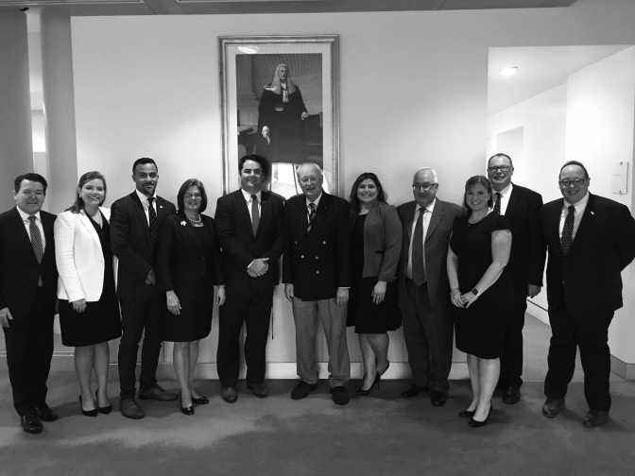
The Thirty-fifth Delegation from the United States of America at the Council Luncheon with the Hon Alan Ferguson, the Hon Michael Danby MP, Senator Dean Smith and Mr Bruce Edwards
Twenty-sixth Delegation from the People’s Republic of China
24 to 29 November 2018
Delegates
- Mr Zhang Zhaohui (Communist Youth League of China) Delegation Leader
Director, Youth Volunteer Action Guide Center, Central Committee of the Communist Youth League of China
- Mr Ma Nianhua (China Youth Daily)
Deputy Editor-in-Chief, China Youth Daily
- Mr Gu Xinqiang
(Ministry of Foreign Affairs)
Deputy Director, Department of North American and Oceanian Affairs, Ministry of Foreign Affairs
- Ms Qu Caiyun
(Chinese Academy of Social Sciences)
Assistant Professor, National Institute of International Strategy, Chinese Academy of Social Sciences
- Mr Ping Qingchao
(Beijing Wormhole Science and Technology Service Co., Ltd.)
General Manager, Home of startups: Beijing Wormhole Science and Technology Service Co., Ltd.
- Ms Pan Yingting (All-China Youth Federation) – Accompanying Officer
Program Officer, International Department, All-China Youth Federation
The Twenty-sixth Delegation from the People’s Republic of China travelled to Sydney and Canberra during the 6-day exchange.
Visit program
Sydney, New South Wales
- Dinner hosted by Mr Peter McCabe, Regional Communication and Stakeholder Manager NSW/ACT, John Holland Group (China 2015)
- Visit via Sydney Ferry to Taronga Zoo
- Aboriginal Cultural Tour at Barangaroo
- Rocks Markets and Discovery Museum
- Meeting with the Reserve Bank of Australia
- Visit to the Parliament of New South Wales
- Lunch hosted by the Hon John Ajaka MLC, President of the NSW Legislative Council
- Tour of and briefing from the City of Sydney Council
Canberra, Australian Capital Territory
- Dinner hosted by the Embassy of the People’s Republic of China in Australia
- Briefing on the Liberal Party of Australia by Mr Bruce Edwards, International Secretary (Japan 1992)
- Briefing by the Australian Electoral Commission by Ms Skye Rogers, Director, International Services Section
- Lunch hosted by Mr Brendan Smyth, Commissioner for International Engagement, Australian Capital Territory
- Briefing on the Australian Labor Party by Ms Erin Watt, National Organiser, Australian Labor Party (China 2015)
- Meeting at the Department of Foreign Affairs and Trade hosted by Ms Nancy Gordon, Assistant Secretary, China Economic and Engagement Branch, along with departmental officials
- Dinner hosted by Mr Andrew Wall MLA, Member for Brindabella, ACT Legislative Assembly, and attended by Ms Elizabeth Lee MLA, Member for Kurrajong and Ms Tara Cheyne MLA, Member for Kurrajong
- Briefing on The Nationals by Mr Jeff McCormack, Senior Adviser
- Meeting with Mr Julian Hill MP, Co-Chair of the China-Australia Parliamentary Friendship Group (Japan 2018)
- Briefing on the Australian Greens by Senator Peter Whish-Wilson, Senator for Tasmania
- Council Luncheon including Chairman the Hon Alan Ferguson and Council Members the Hon Mark Coulton MP, Mr Bruce Edwards and Ms Erin Watt
- Observe Question Time in the Senate and House of Representatives
- Meeting with Mr Milton Dick MP (China 2014)
- Courtesy call on the Hon Tony Smith MP, Speaker of the House of Representatives, Patron of the Australian Political Exchange Council
- Courtesy call on Senator the Hon Scott Ryan, President of the Senate, Patron of the Australian Political Exchange Council
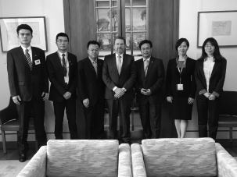
The Twenty-sixth Delegation from the People’s Republic of China meeting with the Hon Scott Ryan, President of the Senate and Patron of the Australian Political Exchange Council
Individual study tours for 2018–2019
Four young Australians participated in individual study tours to the United States and the United Kingdom in 2018–2019.
Mr Charles David ‘Sam’ McQuestin (Liberal Party of Australia) – United States of America
State Director, Tasmanian Branch, Liberal Party of Australia
14 to 21 October 2018
Mr McQuestin’s study tour aimed to gain a better understanding of modern election campaigns. Mr McQuestin met with the California Federation of Republican Women to understand the steps the group has taken to assist more women in being elected. He met with the congressional campaigns of Representative Steve Knight (California’s 25th District) to discuss fundraising techniques, Representative Jeff Denham (California’s 10th District) to discuss ground game co-ordination and Ms Diane Hartley (California’s 49th District) to discuss challenges that come with not being an incumbent member.
Mr McQuestin also met with technology companies involved in election campaigns. He met with representatives of Google to discuss the recent changes in political advertising standards rolled out since the 2016 Presidential Election and their potential impacts on the upcoming Australian election. He also met with I360, a Constituent Management Software Provider, and the Los Angeles Chapter of the New Majority Political Action Committee.
As the media landscape becomes increasingly fractured, direct contact with voters is becoming more and more important to all campaigns. This is particularly true in a non‑compulsory voting environment like California.
Common methods include door knocking, phone banking and shopping centre stall. Text banking has also become a more common practice in the United States.
Democrats in California established a campaign headquarters in San Francisco to co-ordinate direct voter contact operations and to provide a physical work base for volunteers. This facility was established some months prior to the midterm elections. Co-ordination functions appeared to be undertaken by paid professional staff while actual voter contact was made by a team of volunteers.
Speaking with volunteers at the ‘Red to Blue HQ’ it was clear that phone canvassing is considered to be one of the most effective measures available to connect with voters in a personal way. While the voter clearly does not have a personal relationship with the caller, the one on one delivery of a political message in this way is effective. This is especially important where voting is not compulsory.
An additional method utilised by the Democrats from this facility was the practice of peer-to-peer texting. Like phone banking this involved a volunteer personally contacting constituent and engaging them in a conversation aimed at delivering a political message. While this method is less personal than the use of phone calls it is less invasive and as a result dramatically increases the connection rate.
The identification of an encouragement of female candidates has been a challenge for a number of political parties across both the political divide and across the world, with different parties around the world having different approaches. This study tour provided an invaluable opportunity to examine other approaches.
Ms Sophie Greer (Australian Greens) – United Kingdom
Director, Greens WA
22 November to 12 December 2018
Ms Greer’s study tour aimed to improve her understanding of the following issues:
- What can the Australian Greens learn from recent electoral campaigns run by The Green Party, The Labour Party and other local progressive parties in the UK? This included focus on tactics for getting more people elected at the local level, lessons from campaigning in an environment with a ‘progressive’ labour party, a culture of divisive politics in the after-math of the European Union Membership Referendum and a discussion on what actors are contributing to their electoral victories, progress and losses.
- What can the Australian Greens learn about running campaigns with candidates aged under 30? How are campaigns messaged and how are they mobilising younger people to be engaged?
- How are progressive community campaigning and digital campaigning organisations changing the political landscape in the UK? What’s next for big organising, digital campaigning and how can the Australian Greens adopt some of these tactics and tools?
To understand these issues, Ms Greer sought to meet with and interview 8-12 issues campaigners, election organisers, candidates, elected representatives, and participate in activities run by Greens parties and local issues campaigns.
During the study tour to the United Kingdom, it was my intention to further our learning around three key areas. The first focused around what The Australian Greens could learn from recent electoral campaigns in the United Kingdom, including campaigning in an environment with a ‘progressive’ Labour party and a culture of divisive politics in the after-math of the European Union Membership Referendum. The second focus was around campaigns that have successfully mobilised and have been led by people under the age of 30. The third and last focus was on how digital campaigning within political parties and non-profit organisations are changing the political landscape in the UK.
This individual study tour had a key theme of Brexit, with all conversations coming back to the impact of the referendum to leave the European Union. This did present a challenge for fully exploring the key areas of this tour as there has been little progress within political parties or communication from the media on any other issue than Brexit. With that context, this study tour has enabled me to reflect on key areas of relevance for The Australian Greens including how the organisation would communicate and led progressive discourse through democratic events like the Brexit Referendum. Additionally, to enable our party to continue to include and amplify the voices of young people, we must continue to review the role of digital tools in our campaigns and membership processes.
Mr Robert Nardella (The Nationals) – United Kingdom
Chief of Staff, the Hon Dr David Gillespie MP
24 November to 24 December 2018
Mr Nardella’s study tour aimed to examine how the UK Conservative Party is responding to the ongoing events and challenges in the United Kingdom in the last 20 years. These include devolution of power to Scotland, Wales and Northern Ireland, a Scottish vote on independence, a national vote on leaving the European Union (Brexit) and a mosaic of social issues and challenges that appear to have impacted the overall body politic of the UK throughout this period.
He sought to consider the following questions:
- What changes, if any, are being made more broadly in the way they approach policy development and advocacy in order to remain relevant to their mainstream constituency and in reaching out to a broader base?
- Which political parties, political activity groups and organisations are challenging their voter and support base and what are some of the strategies being employed to address this?
Mr Nardella’s trip was designed to establish a broad overview of the Conservative Party’s involvement in regional or country areas, particularly their role and campaign activities in local government, and to study a number of areas outside of Greater London that have seen some extraordinary results for the Conservative Party. The activities and campaign strategies activities the Conservatives are using to engage young voters and country voters, whether through university associations or rural advocacy groups was also a key area of analysis.
The UK has undoubtedly been through a polarising, tense and frustrating period throughout the debate on Brexit. The very nature of that debate has portrayed Parliament probably in the worst possible light in the eyes of many Brits by failing to agree on an outcome that honours the result of the 2016 referendum.
Certainly, the Brexit debate has highlighted concerns that can arise when decisions are made too far away from the communities represented by decision-making institutions.
In Scotland, much of the Conservatives’ success has come from the popularity and approach delivered by a leader who is seen as less of a politician, and one who appears more in touch with grassroots thinking.
In areas where the Conservatives are doing well politically, they are very active in their community going street-to-street and door-to-door, to canvass local issues and concerns, they are developing policy manifestos that respond to those concerns and are heavily involved in all levels of government.
Reflecting on some of the positives and negatives of the governance structures within the UK, I believe there is an opportunity for Australia to look at how we might improve grassroots representation through further reform of federal, state and local government.
Ms Lyndal Howison (Australian Labor Party) – United Kingdom
Communications Manager, the Whitlam Institute
9 February to 9 March 2019
Ms Howison’s study tour aimed to examine what Australia can learn from the United Kingdom about civics education. Civics and citizenship is part of the Australian curriculum, but Australian students are not achieving strong results. The most recent ACARA report shows that only 37% of Year 10 students in Australia are rated as ‘proficient’ in the civics and citizenship curriculum. In the context of increasing threats to democracy and diminishing trust in our institutions, it is vital that Australia improves the knowledge and confidence of the next generation of citizens about their political system.
In the UK there is a large and well-established ecosystem of professional associations and charities that exist to promote civics and civic education, but Australia does not have an equivalent. Like Australia, the UK has a civics and citizenship curriculum, which has recently undergone some reform. Ms Howison’s study tour sought to understand whether these charities, associations and NGOs exist in the UK by necessity, because voting is not compulsory. She sought to answer the following questions:
- How do the non-school organisations interact and engage with schools to deliver civics education? Are they delivering the curriculum or providing additional value?
- Is effective civics education a prerequisite to generating the UK’s average of 65% discretionary turnout?
- What would improved education within and without schools achieve in Australia, which has 91% compulsory voter turnout? Would we see richer participation, or different results, if our civics education were more effective?
There is an inherent assumption in this report; citizenship education is valuable and necessary. We have compulsory voting in Australia, but we should not assume that young people will be able to acquire the skills and attitudes necessary for full and constructive participation in society and democracy without help.
It is reasonable to assert that citizenship education has the potential to support a healthy, connected society, and certainly this was an underlying intent of the earliest citizenship programs in England. Many young Australians will acquire some shared national values simply through their participation in our school system, but this should not be taken for granted. As we face turbulent times and the challenge of extremism, we are seeking a healthy balance. This means understanding of and celebration of difference, as well as espousal of shared values like the rule of law, gender equality, the shape of our current political systems and institutions, and how to enact change within them.
As technology continues to drive unprecedented change, including new definitions of privacy and employment, citizens will need to understand their rights and how to defend them. They will need to know how and why their data might be “harvested” by political or commercial actors, and how to manage this. Teaching these and similar topics calls for specialist education and resources. Citizenship education offers students a chance of proficiency in the skills they will need in the future.
Our school system can play a greater role to play in helping young people develop the skills needed to be agile in new media environments, as well as interested and invested in their political system, cognisant of their role as citizens, empowered to hold those in power to account and enact change.
One of the key benefits of citizenship education in a school system is the equitable provision of knowledge and skills to support both current and emerging forms of political expression. There are students in our system whose social background does not facilitate or encourage active citizenship. If we are aiming for inclusive democratic engagement and a shared sense of the worth of political participation, including the disadvantaged and marginalised, Australia needs effective and universal citizenship education.
Chronology of visits
Date | Tour details
23 to 29 July  2016 | Fifth Australian Delegation to the Republic of Korea  Led by Ms Nikki Boyd (Australian Labor Party)  State Member for Pine Rivers
10 to 16 September 2016 | Twentieth Delegation from the Socialist Republic of Vietnam  Led by Mr Nguyen Anh Tuan (Ho Chi Minh Communist Youth Union)  Secretary, Central Committee
8 to 14 October  2016 | Tenth Delegation from the Philippines  Led by the Hon Casimiro “Jun” A Ynares III (Nationalist People’s Coalition)  City Mayor, Antipolo City
7 to 11 November 2016 | Twenty-fourth Delegation from the People’s Republic of China  Led by Ms Wang Ting (All-China Youth Federation)  Deputy Secretary General, All-China Youth Federation
12 to 18 November 2016 | Ninth Australian Delegation to the Philippines  Led by Ms Cassandra Devine (Australian Labor Party)  Policy and Research Officer, Australian Council of Trade Unions
21 to 25 November 2016 | Eleventh Delegation from New Zealand  Led by Ms Fletcher Tabuteau MP (New Zealand First)  List Member
5 to 9 December 2016 | Eleventh Australian Delegation to New Zealand  Led by Mr Sam Duluk MP (Liberal Party of Australia)  Federal Member for Davenport
11 to 23 February 2017 | Thirty-second Australian Delegation to the United States of America  Led by Ms Emily Gore (Australian Labor Party)  Ministerial Adviser, Office of the Hon Susan Close MP
11 to 17 March 2017 | Twenty-fifth Australian Delegation to Japan  Led by Ms Emma McBride MP (Australian Labor Party)  Federal Member for Dobell
19 to 31 March 2017 | Thirty-third Delegation from the United States of America  Leadership shared between delegation members
13 to 19 May 2017 | Tenth Australian Delegation to the Philippines  Led by Ms Brook Curtin (Liberal Party of Australia)  Non-Executive Company Director
20 to 26 May 2017 | Twenty-first Delegation from the Socialist Republic of Vietnam  Led by Mr Nguyen Ngoc Luong (Ho Chi Minh Communist Youth Union)  Secretary of the Central Committee
17 to 23 June 2017 | Eleventh Delegation from the Philippines  Led by the Hon Bernard Faustion M Dy (Nationalist People’s Coalition)  Mayor, Cauayan City
15 to 27 July 2017 | Thirty-third Australian Delegation to the United States of America  Led by Ms Melanie Gibbons MP (Liberal Party of Australia)  State Member for Holsworthy, New South Wales
3 to 9 August 2017 | Sixteenth Delegation from Japan  Led by Mr Taskashi Uto (Liberal Democratic Party)  Member of the House of Councillors
5 to 11 August 2017 | Sixth Delegation from the Republic of Korea  Led by the Hon Shinhwan Oh (The Bareun Party)  Member of the 20th National Assembly
9 to 21 September 2017 | Thirty-fourth Delegation from the United States of America  Leadership shared between delegation members
16 to 22 September 2017 | Twenty-fifth Australian Delegation to the People’s Republic of China  Led by Mrs Hollie Hughes (Liberal Party of Australia)  Vice President, Country
17 to 20 October 2017 | Twenty-fifth Delegation from the People’s Republic of China  Led by Mr Guo Meijian (All-China Youth Federation)  Deputy Secretary General, All-China Youth Federation
4 to 10 November 2017 | Twenty-first Australian Delegation to the Socialist Republic of Vietnam  Led by Mrs Angie Drake (Australian Labor Party)  Senior Adviser, Office of Yvette Berry, MLA
24 February to  2 March 2018 | Twelfth Delegation from the Philippines  Led by Atty. Kristine Vanessa Chiong (Alayon - PDP)  Mayor, Naga City, Cebu
3 to 9 March 2018 | Twenty-sixth Australian Delegation to Japan  Led by Mr Timothy (Tim) Wilson MP (Liberal Party of Australia)  Federal Member for Goldstein
14 to 20 April 2018 | Sixth Australian Delegation to the Republic of Korea  Led by Mr Jon Krause MP (Liberal Party of Australia)  State Member for Scenic Rim, Queensland
12 to 18 May 2018 | Eleventh Australian Delegation to the Philippines  Led by Ms Imogen Sturni (Australian Labor Party)  Organiser, Australian Services Union
27 May to 1 June 2018 | Twelfth Delegation from New Zealand  Led by Mr Simon O’Connor (National Party)  Member of Parliament for Tāmaki
21 July to 1 August 2018 | Thirty-fourth Australian Delegation to the United States of America  Led by Ms Anika Wells (Australian Labor Party)  Lawyer, Maurice Blackburn Lawyers
5 to 10 August 2018 | Twelfth Australian Delegation to New Zealand  Led by Ms Sarah Coward (Australian Labor Party)  Fundraising & Business Communications Director, Australian Labor Party, NSW Branch
11 to 17 August 2018 | Seventeenth Delegation from Japan  Led by Mr Masakazu Hamachi (Komeito)  Member of the House of Representatives
1 to 7 September 2018 | Twenty-sixth Australian Delegation to the People’s Republic of China  Led by Mr Mathew (Mat) Howard (Australian Labor Party)  Senior Electorate Officer, Jo Haylen MP, Member for Summer Hill
8 to 14 September 2018 | Twenty-second Delegation from the Socialist Republic of Vietnam  Led by Mr Bui Quang Huy (Ho Chi Minh Communist Youth Union)  Secretary of the Central Committee of the Ho Chi Minh Communist Youth Union
13 to 24 October 2018 | Thirty-fifth Delegation from the United States of America  Leadership shared between delegation members
17 to 23 November 2018 | Twenty-second Australian Delegation to the Socialist Republic of Vietnam  Led by Ms Elisapeta Kikkert MLA (Liberal Party of Australia)  Member for Ginninderra, ACT Legislative Assembly
24 to 29 November 2018 | Twenty-sixth Delegation from the People’s Republic of China  Led by Mr Zhang Zhaohui (Communist Party of China)  Director, Youth Volunteer Action Guide Center, Central Committee of the Communist Youth League of China
23 February to 1 March 2019 | Twenty-seventh Australian Delegation to Japan  Led by Ms Ella Haddad MP (Australian Labor Party),  State Member for Clark, Tasmanian Parliament

Acknowledgements
The Council is able to offer developmental opportunities to young political leaders from Australia and overseas with the assistance and support of a number of individuals and organisations.
Former delegates
The Council wishes to thank all former delegates whose ongoing support contributes in a very positive and significant way to the experience of delegations visiting Australia. The assistance the Council receives from former delegates, in arranging appointments and briefings and sharing their knowledge and experience with incoming delegations, continues to enrich the program.
Supporting organisations
A number of activities are made possible through the support of private sector and other organisations.
The Council would like to thank the Presiding Officers of the Federal and State Parliaments, and participating embassy and consular officials around Australia for their continued enthusiastic support of the Council’s programs. The generous support of all state and territory governments continues to enhance the program.
The Council also wishes to thank its counterpart organisations for their continued assistance and cooperation in coordinating the Council’s exchange programs, and for being gracious hosts to the Council’s delegations. The Council’s programs would not be possible without the assistance of the following counterpart organisations:
China – All-China Youth Federation
Japan – the Ministry of Foreign Affairs
New Zealand – Office of the Speaker of the House of Representatives
Philippines – Philippine Center of Young Leaders in Governance
Republic of Korea – The Korea Foundation
Socialist Republic of Vietnam – International Youth Cooperation Development Center
United States of America – American Council of Young Political Leaders
Appendix A – Financial summary
Year | $
2016–2017
Commonwealth Appropriation | $902,000.80
Expenditure | $399,019.60
2017–2018
Commonwealth Appropriation | $914,277.96
Expenditure | $430,907.28
2018–2019
Commonwealth Appropriation | $926,999.60
Expenditure | $275,477.63

Notes – unexpended funds
1. The financial affairs of the Council are examined by the Australian National Audit Office as part of its annual audit of the financial statements of the Department of Finance.
2. Funds are set aside each financial year based on all exchange activities proceeding, however, a number of circumstances can prevent visits from taking place, such as elections in Australia and events in partnering countries.
Appendix B – Administrative overview
Chairman’s remuneration
The Chairman receives a sitting fee when the Council meets and when he is engaged in business on behalf of the Council, in accordance with the determinations made by the Remuneration Tribunal. Members of the Council do not receive any remuneration.
Staffing
A number of staff from the Ministerial and Parliamentary Services Division of the Department of Finance have supported the Council over the reporting period. As at 30 June 2019, the Council Secretariat staff were Mrs Sharon Forester – Director, Ms Suzy Domitrovic - Executive Officer and Ms Alex Famelis – Program Officer.
The Council extends its thanks for the work and commitment of former Secretariat staff, in particular, Mr Rick Corkhill and Ms Stacey Baker.
Freedom of information
One application (FOI 16/125) was received by the Council under the Freedom of Information Act 1982 during the reporting period.
Contact information
The Australian Political Exchange Council may be contacted through its Secretariat at:
Address: | Australian Political Exchange Council  One Canberra Avenue  FORREST ACT 2603  AUSTRALIA
Telephone: | (02) 6215 3248
E-mail: | auspol.exchange@finance.gov.au
Website: | www.polexchange.org.au

Australian Political Exchange Council
One Canberra Avenue
Forrest ACT 2600
AUSTRALIA
Phone: (02) 6215 3248
Email: auspol.exchange@finance.gov.au
www.polexchange.org.au

